SELF - STUDY REPORT

(A documented application for NAAC accreditation)

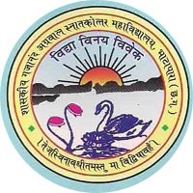

उत्तिष्ठ जागृत प्राप्य वरान्निबोधत

Arise, awake, stop not till the goal is reached.

GOVT G.N.A. P.G. COLLEGE BHATAPARA

AFFILIATED TO Pt. R. S. UNIVERSITY, RAIPUR
Submitted to
NATIONAL ASSESSMENT AND ACCREDITATION COUNCIL (NAAC) BANGALORE - 560 010 December 2015

SELF STUDY REPORT
SUBMITTED TO
NAAC
For Accreditation
2015-16
Submitted by

GOVT. G.N.A. POST GRADUATE COLLEGE,
BHATAPARA (493118)
District:Balodabazar-Bhatapara,Chhattisgarh, India.

Tel-07726220312 (O), Fax – 07726220312
Website:- www.gnapgcollege.com
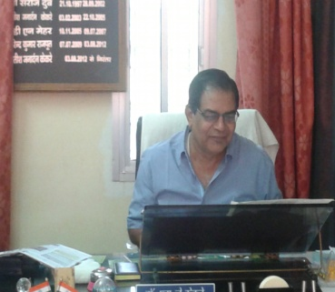
Preface

Govt. GNA PG college , Bhatapara is the only college in the block and covers about 100 nearby colleges. It is affiliated from Pt.R.S.S. University Raipur (CG).
The college has been established on 04 September 1964 as a private college by the donation of admirable amount for the college in great and loving memories of Shri Gajanand Agrawal by his sons and main stake holder Agrawal Brothers. The most complimentary part is the contribution of citizens of bhatapara for economical assistance . In 1975 this college has been taken over by state government and Registered under the section 2(f) and 12(b) as graduate college and promoted to Post graduate college in 2006 .
At present nearly 2000 students are enrolled here in different courses. As it has been serving in the field of Higher Education since last five decades. It has produced a variety of alumni in different fields. Enrollment graph of college is continuously raising and the priority of the college is to fulfill the requirement of the students, who mostly belong to poor families.
It is the first attempt of the college to submit the SSR report for accreditation & assessment to NAAC.

Place Principal
Bhatapara (C.G.) Dr. S.J.Kekre

Office of Principal
Govt. G.N.A. P.G. College, Bhatapara
Dist.- Balodabazaar-Bhatapara (C.G.)
PH: 07726-220312 Email : govtgnapgcollege@gmail.com
Ref. No. - ……./……./2015 Bhatapara, Date – /12/2015

Certificate of Compliance

This is to certify that Govt. G.N.A.P.G. College Bhatapara fulfils all norms.

- Stipulated by the affiliating University and/or
- Regulatory Council /Body [such as UGC, NCTE, AICTE, MCI, DCI, BCI, etc.] and
- The affiliation and recognition [ if applicable ] is valid as on 04/09/1964

In case the affiliation / recognition is conditional, then a detailed enclosure with regard to compliance of conditions by the institution will be sent.
It is noted that NAAC’s accreditation, if granted shall stand cancelled automatically ,once the institution loses its University affiliation or recognition by the regulatory council, as the case may be.
In case the undertaking submitted by the institution is found to be false then the accreditation given by NAAC is liable to be withdrawn. It is also agreeable that the undertaking given to NAAC will be displayed on the college website.

Date : Principal/Head of the Institution
Place : (Name and Signature with Office seal)

Office of Principal
Govt. G.N.A. P.G. College, Bhatapara
Dist.- Balodabazaar-Bhatapara (C.G.)
PH: 07726-220312 Email : govtgnapgcollege@gmail.com
Bhatapara, Date –/12/2015

DECLARATION

I certify that the data included in this Self-Study Report (SSR) is true to the best of my knowledge and belief. This SSR is prepared by the college after internal discussions, and no part thereof has been outsourced. I am aware that the Peer team will validate the information provided in this SSR during the visit.

Place: Bhatapara (C.G.) (Dr. S. J. Kekre) Date: /12/2015 PRINCIPAL
INDEX

PART – A
COVER PAGE…1-
PREFACE..
PAGE NO.

EXCUTIVE SUMMARY ……………………………………………...08-09
SWOC ANALYASIS ………………………………………………10
PHOTO GALLERY ………………………………………………11-23
PART – B

PROFILE OF THE INSTITUTION ………………………………….24-33

PART - C
CRITERIA WISE ANALYTICAL REPORT
CRITERION – I CURRICULAR ASPECTS………………………………..34-39
1.1 Curriculum Design and Development
1.2 Academic Flexibility
1.3 Curriculum Enrichment
1.4 Feedback System
CRITERION – II TEACHING–LEARNING AND EVALUATION….......44-58
2.1 Student Enrolment and profile
2.2 Catering to Student Diversity
2.3 Teaching Learning Process
2.4 Teacher Quality
2.5 Evaluation Process and Reform
2.6 Student Performance and Learning Outcome
CRITERION – III RESEARCH CONSULTANCYANDEXTENSION …..59-76
3.1 Promotion of Research
3.2 Resource Mobilization for Research
3.3 Research Facilities
3.4 Research Publications and Awards
3.5 Consultancy
3.6 Extension activities and institutional social responsibility (ISR)
3.7 Collaboration
CRITERION - IV INFRASTRUCTURE AND LEARNING RESOURCES………………………………………...……….74-84
4.1 Physical Facilities
4.2 Library as a Learning Resource
4.3 IT Infrastructure
4.4 Maintenance of Campus Facilities
CRITERION - V STUDENT SUPPORT AND PROGRESSION…………85-99
5.1Student Mentoring and Support
5.2 Student Progression
5.3 Student Participation and Activities

CRITERION - VI GOVERNANCE, LEADERSHIP AND MANAGEMENT…………………………………………..100-120
6.1 Institutional Vision and Leadership

6.2 Strategy Development and Deployment
6.3 Faculty Empowerment Strategies
6.4 Financial Management and Resource Mobilization
6.5 Internal Quality Assurance System
CRITERION - VII INNOVATION AND BEST PRACTICES………....121-125
7.1 Environment Consciousness
7.2 Innovations
7.3 Best Practices

EVALUATIVE REPORT OF THE DEPARTMENTS...126-185

ENCLOSER (ANNEXURE I - IV):

ANNEXURE- I……………………………………186

ANNEXURE-II………..……………….………….187

ANNEXURE-III……………...………….………..188

ANNEXURE-IV..........……………….……………189

===***===

EXECUTIVE SUMMERY
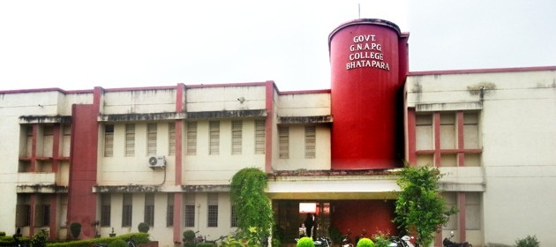

Govt. G.N.A. P.G. College, Bhatapara is one of the oldest and big institutes in Baloda- Bazar, Bhatapara District having potential to provide quality education. The institute has its basic infrastructure in terms of building. But it lacks infrastructure facilities like well equipped laboratory for conducting advances research. Most of the students of the institute belong to poor families and are always concerned with earning of their living therefore dropout rate of the institute is very high. It is necessary to prepare the students able to get the job and find their career goals after completing their studies from the college. The institute needs job oriented education here.
In order to enable the students to face the cut throat competition of the world, the institute is trying to provide their students capable of doing their own employment through small steps. The institute needs to start new PG courses , some research projects and some vocational training in order to increase the employability of the students. Institute wishes to be the centre of excellence and recognized nationally for providing quality higher education and research training.
In order to keep pace with the latest technology, the institute needs to develop its academic, infrastructure and research facilities, departmental libraries, smart class room and audio visual aids to make the institute a world class institute.
College takes part in syllabus/curriculum reforms through their faculty member who are in board of studies in Pt. Ravishankar Shukla University,Raipur and some autonomous college also.
For admission students are get informed by admission rules and process through Broacher, local news paper and notice board .Admission is done on the basis of merit along with reservation policy of the state government.′At the beginning of the session students are addressed by the head of the institution and some faculty members also to adjust themselves in college atmosphere and aware from the institutional activities.
All faculty members take their classes in proper time as per time table made by committee. They also maintain daily diary. They deliver their lecture by chalk duster , demonstration ,OHP or whichever needed .Feed back is taken from students to serve according to them.
This institution have 16 regular faculty members out of which 09 have taken doctorate degree and college has 01 research centre and 02 registered research supervisor,02 members are pursuing for Ph.D. In Past 02 academic sessions 09 faculty had been sent for orientation programme.
College has separate one building for science and one building for arts and commerce. There is a separate building for Library also. Very soon college will provide the facility of e-library to their students. Construction of girls’ hostel and indoor sports hall is completed in the campus. Total campus area of the college is 9.46 acre.
Main purpose of the institution is to serve for students , therefore college always work for betterment of its students to make them fit for life in outer world and arrange short programmes like spoken English class, vedic maths class , NET coaching etc. Cultural and litrary activities are also part of curriculum to improve their personality.
It can become a centre of excellence and prove a milestone in providing a very high quality education for the student .
Specific Objectives:-
- To get autonomy up to2030.
- To get high quality research facilities.
- To provide employment opportunities to students.
- To motivate and aware the students towards the education.
- To provide campus facilities for teaching and non-teaching staff.
- To provide modern equipped laboratory to students.

Expected Result:-
- In 2030 college should be autonomous.
- College will be established as a good research centre.
- Most of the students will get employment opportunity through industries & will be successful entrepreneur.

SWOC Analysis
Strength | Weakness
- College is enrolled under 12B of the UGC act.  - Basic infrastructure available ,college has one old building and one new building.  - Large no. of enthusiastic students ,come from rural areas.  - Qualified & dedicated faculties  - Basic lab facilities are available for students of various streams.  - A wide range of text books available in library for students & faculties.  - Multiple student scholarship is available to support undergraduate and postgraduate students.  - College has its own web-site. | - Infrastructure of old building is deteriorating  - Students come from rural and remote area.  - Poor transportation facility  - Lack of boy’s and girl’s hostel  - Lack of staff quarters, hospital & boundary wall  - Lack of modern and highly equipped lab  - Lack of intercom facilities , E-class and auditorium with ICT facility  - Less number of permanent faculty .  - Lack of eco friendly system  - Inadequate student teacher ratio.
Opportunity | Challenges
- P.G. in Botany,Zoology,Physics,Home-Science,History,English can be opened as these are popular subjects.  - BCA,MCA can be opened as job-oriented courses.  - Guest lecturers in different subjects can be organized to increase collaboration and ideas between different colleges  - Vocational courses in Physics, Home-Science, Botany, Zoology and Commerce can be initiated.  - Basic facilities can be provided to the students with the help of Janbhagidari & other local sources  - Botanical Garden can be developed with the help of Industries  - Enhancement of modern technology  8.Collaboration with nearby industries. | - Provision of basic facilities for students, like girl’s common room, well shaded cycle stand, ICT facility for all students and valuable reference books for students.  - Heavy work load on permanent faculty.  - Anti-social elements  - Safety measures  - Lack of communication skill in students.  - Diversity of students

PHOTO GALLERY

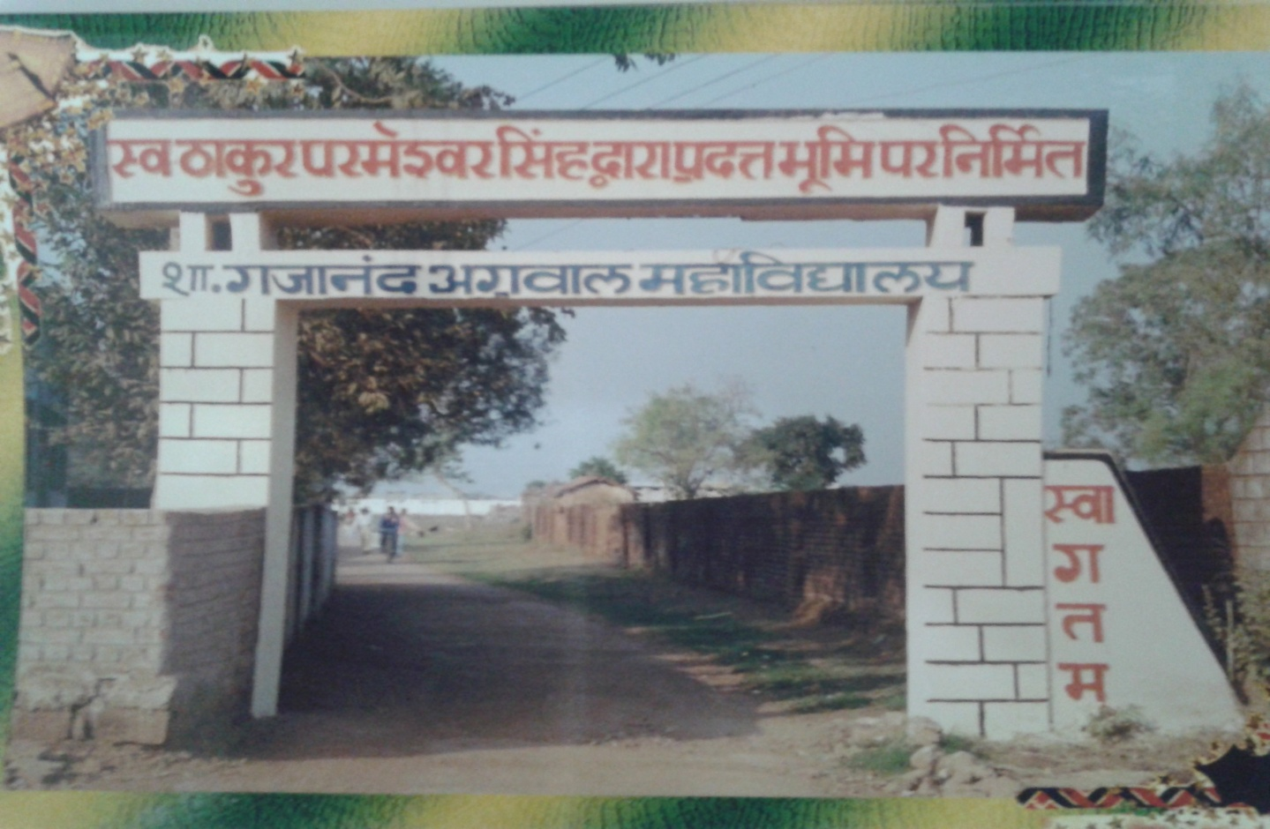
Entrance gate of the college

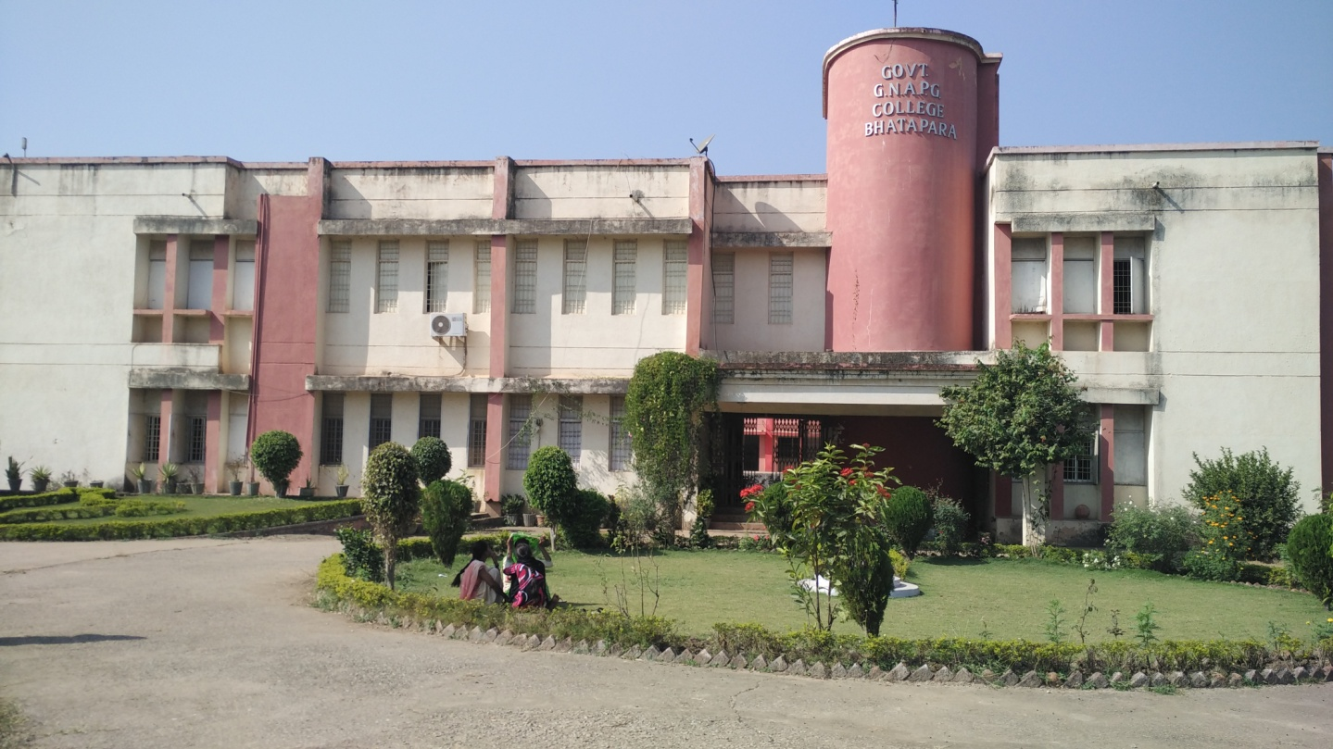
Building of the college

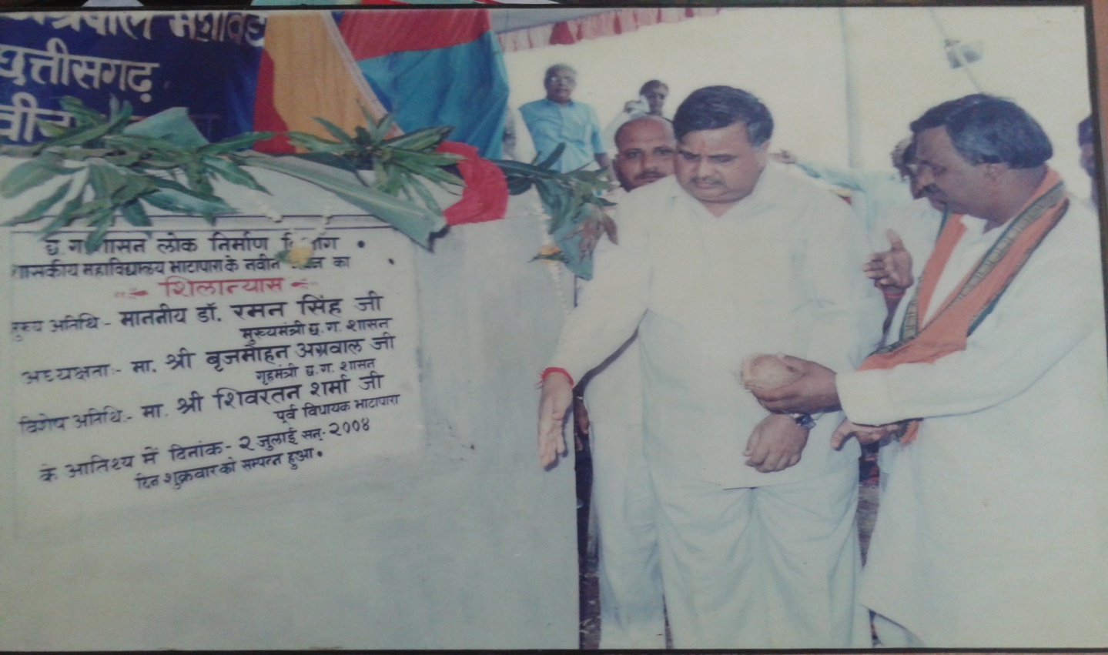
Opening ceremony of new Building.

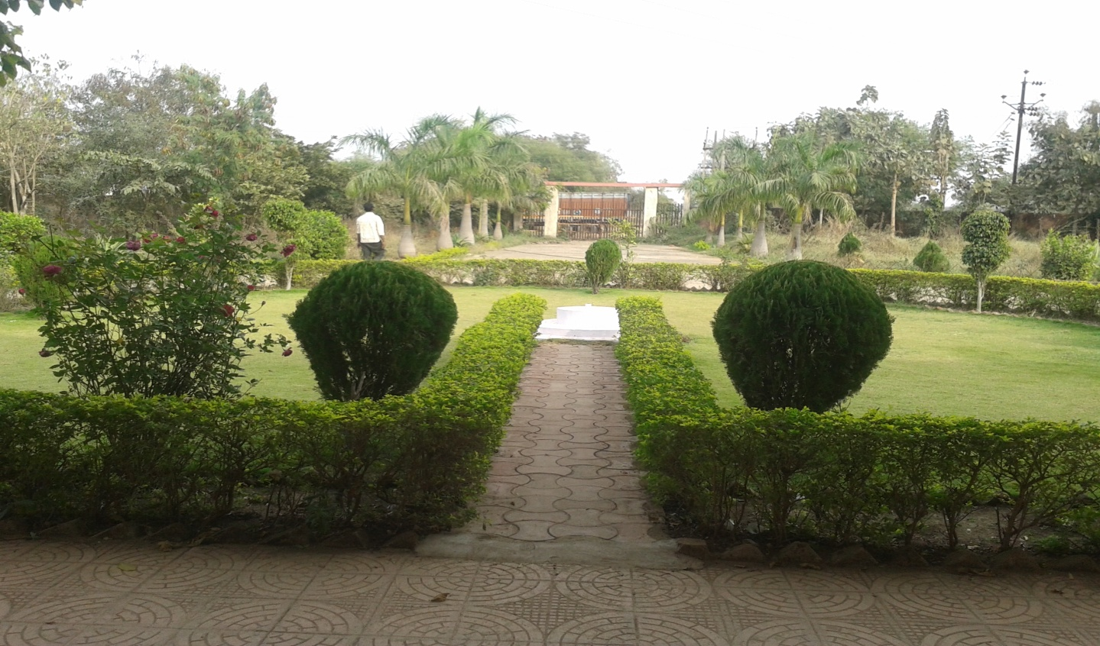
Lush Garden in the college

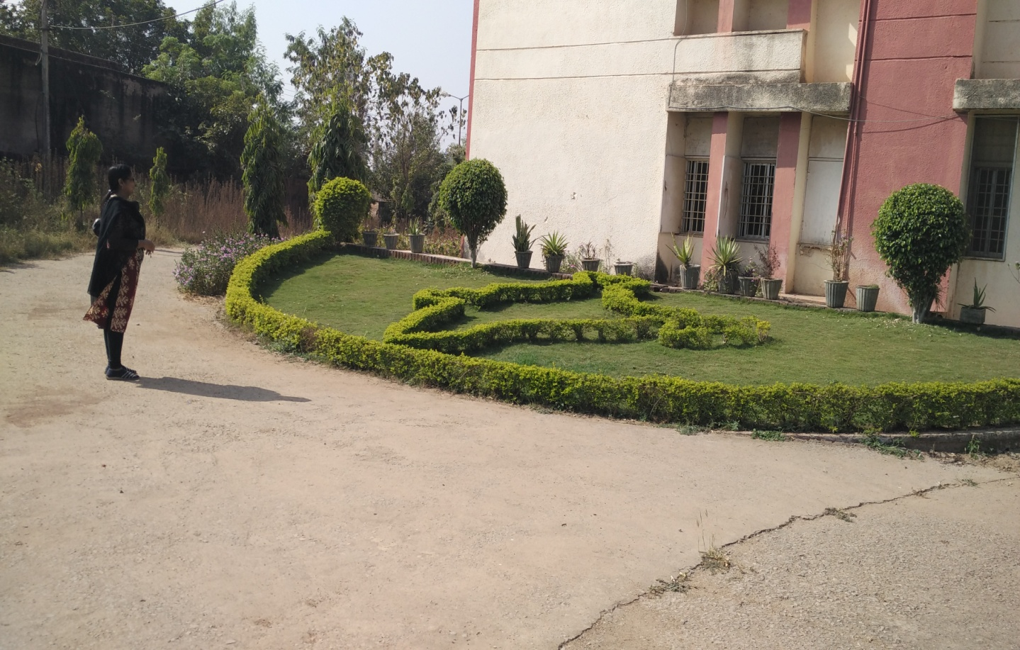
Creative Garden in the college

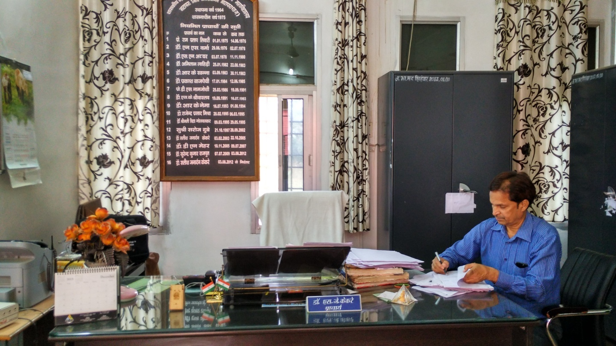
Principal Chamber
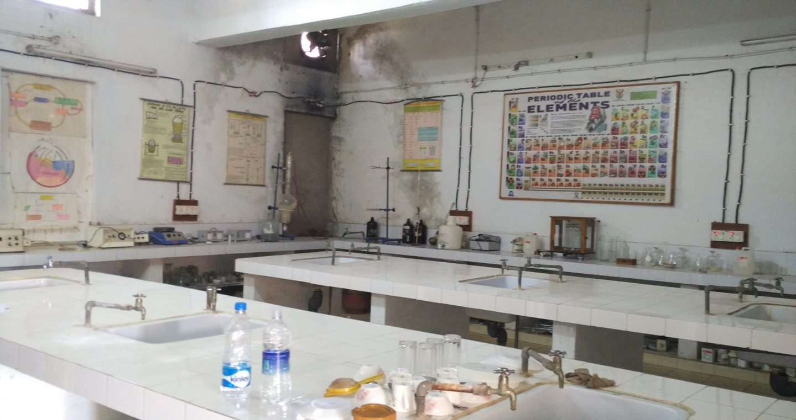
PG Chemistry Laboratory

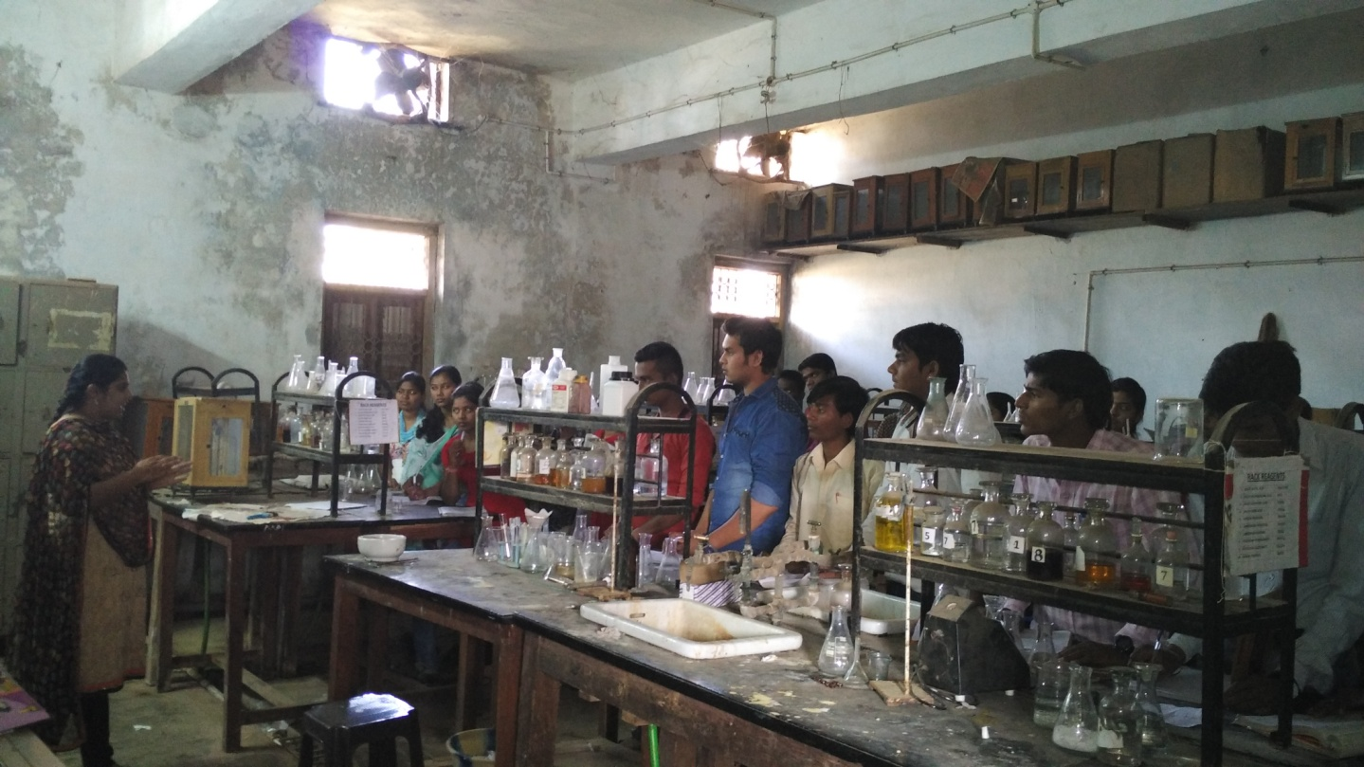
UG Chemistry Laboratory

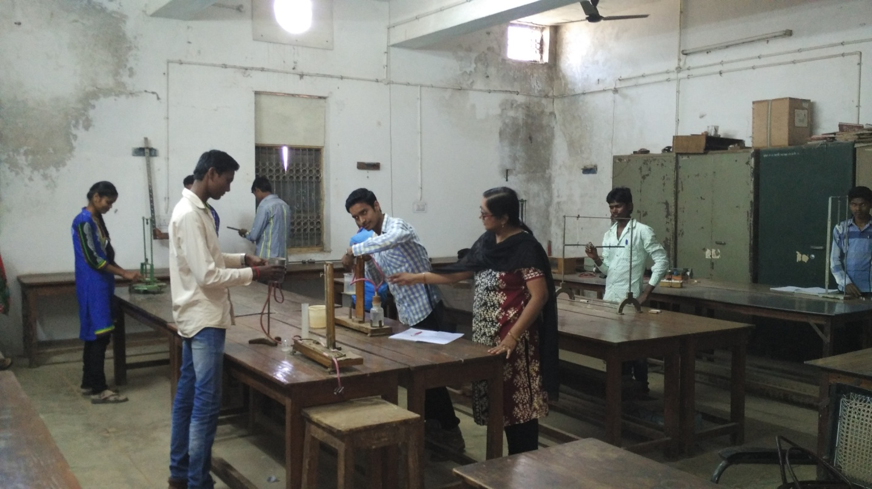
Physics Laboratory

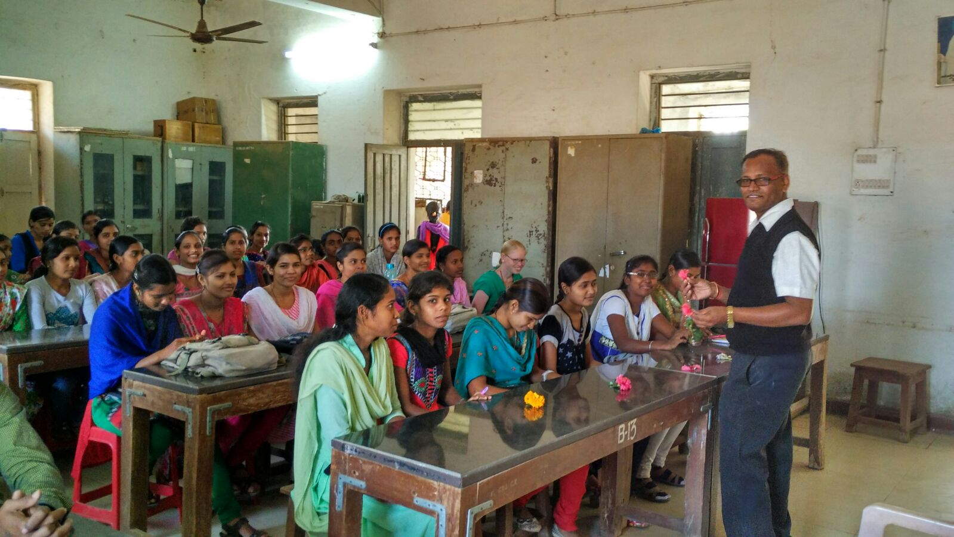
Botany Laboratory

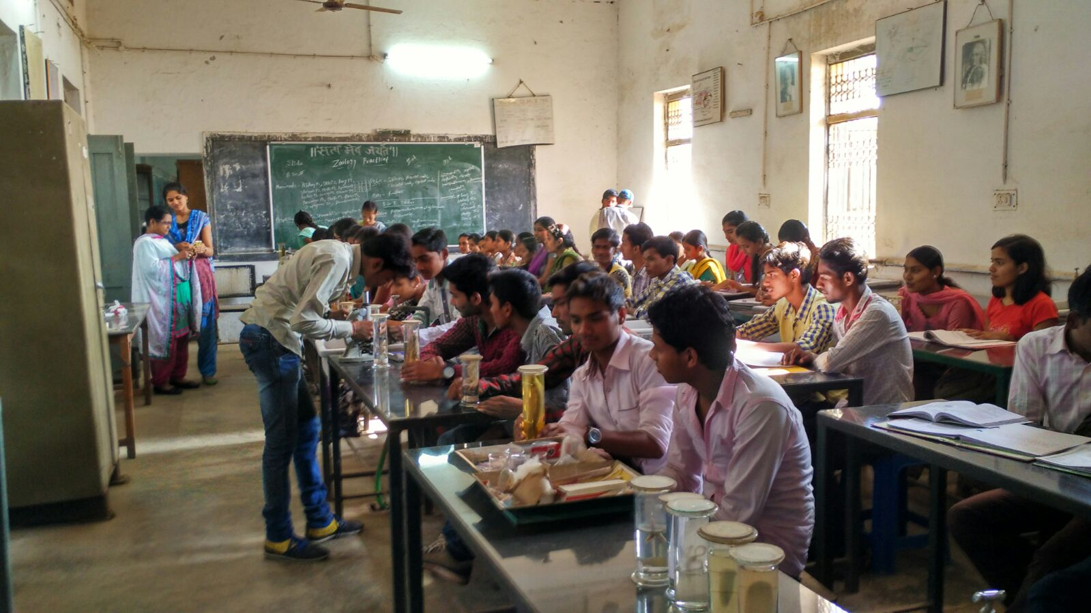
Zoology Laboratory

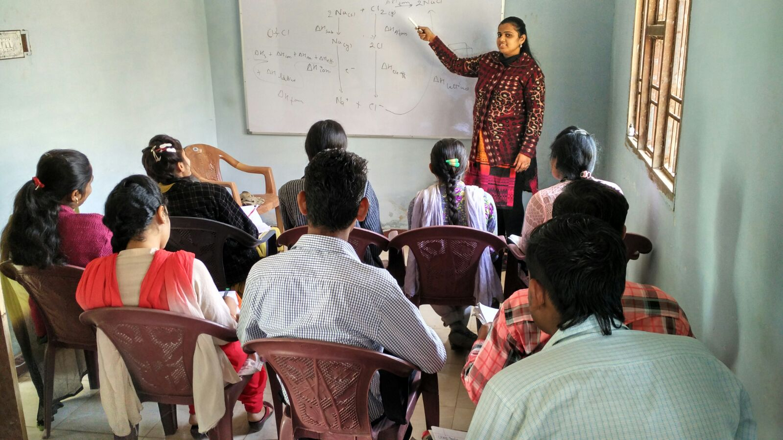
NET Coaching classes

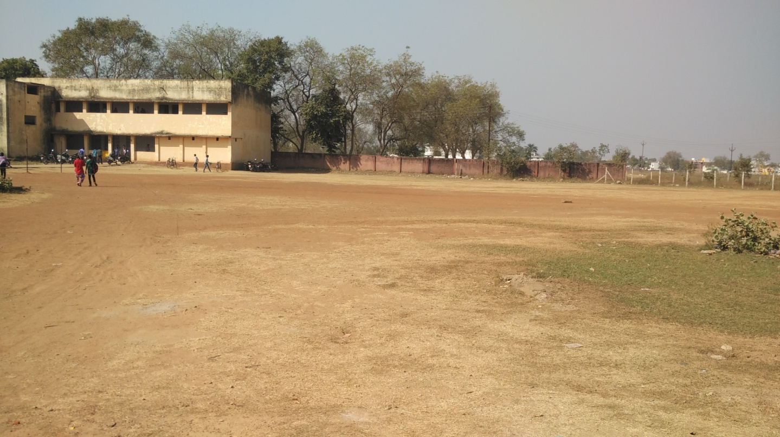
Play Ground

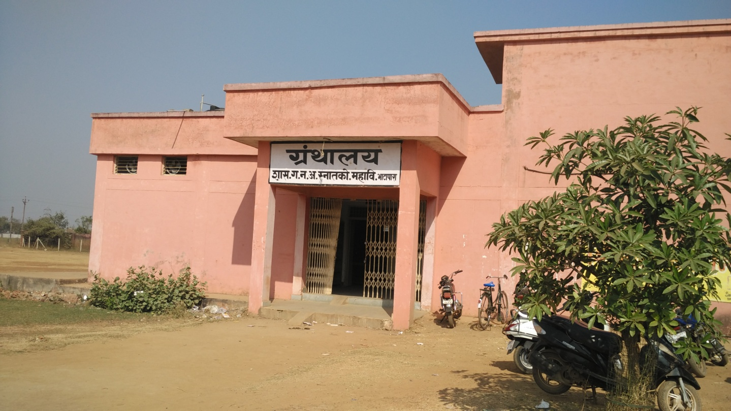
Library in the college

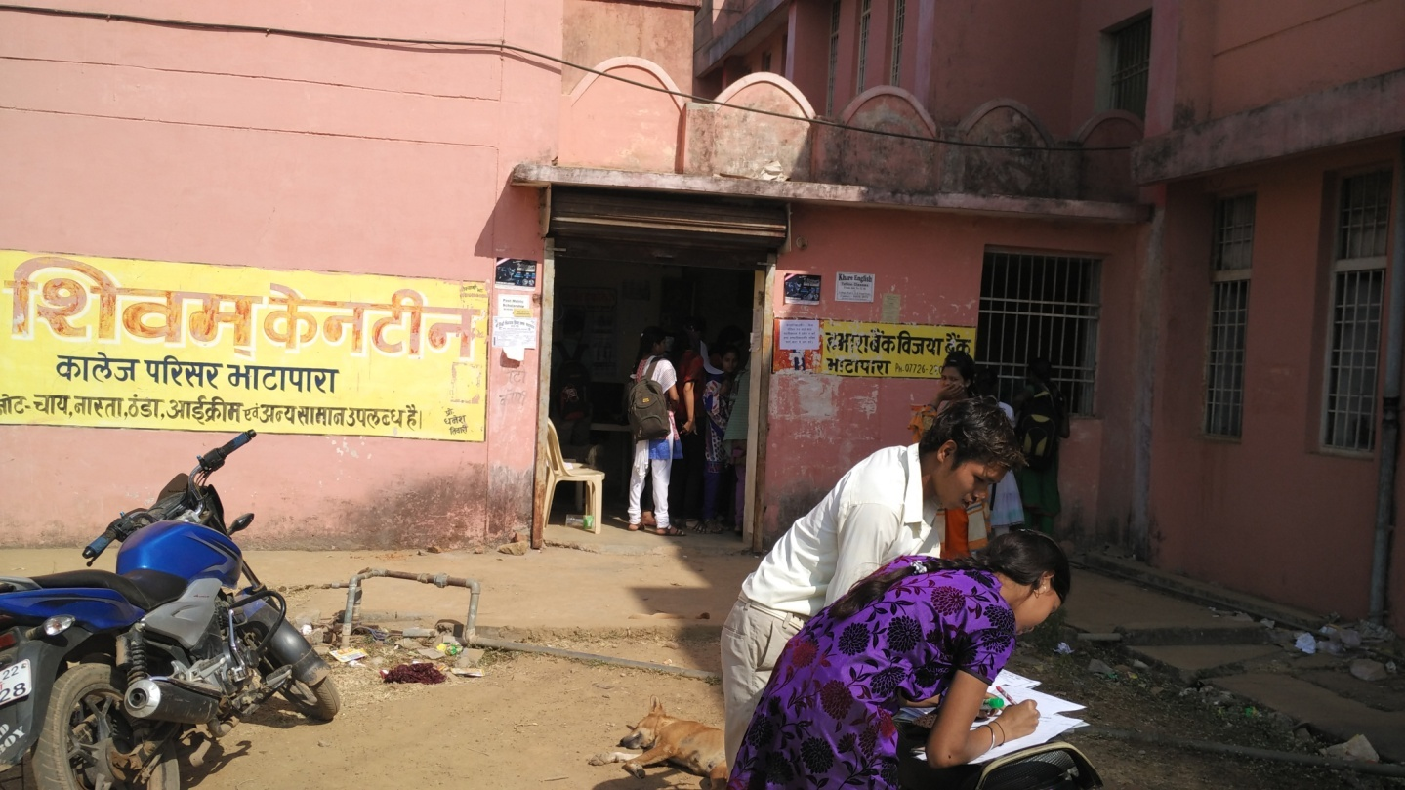
College canteen

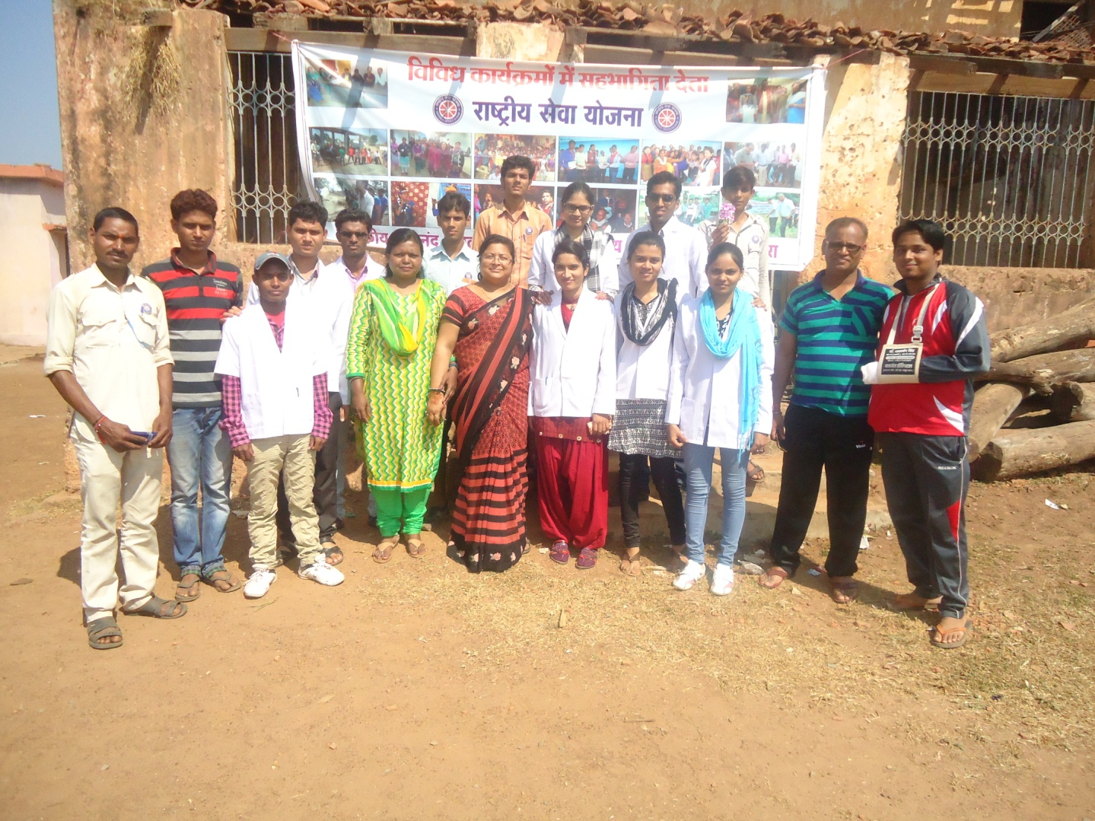
NSS Camp.

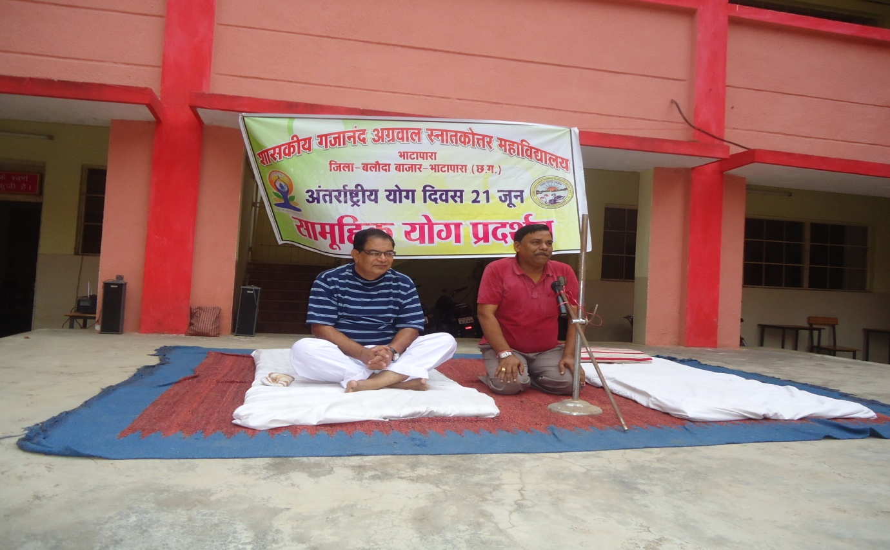
21 June International yoga day .

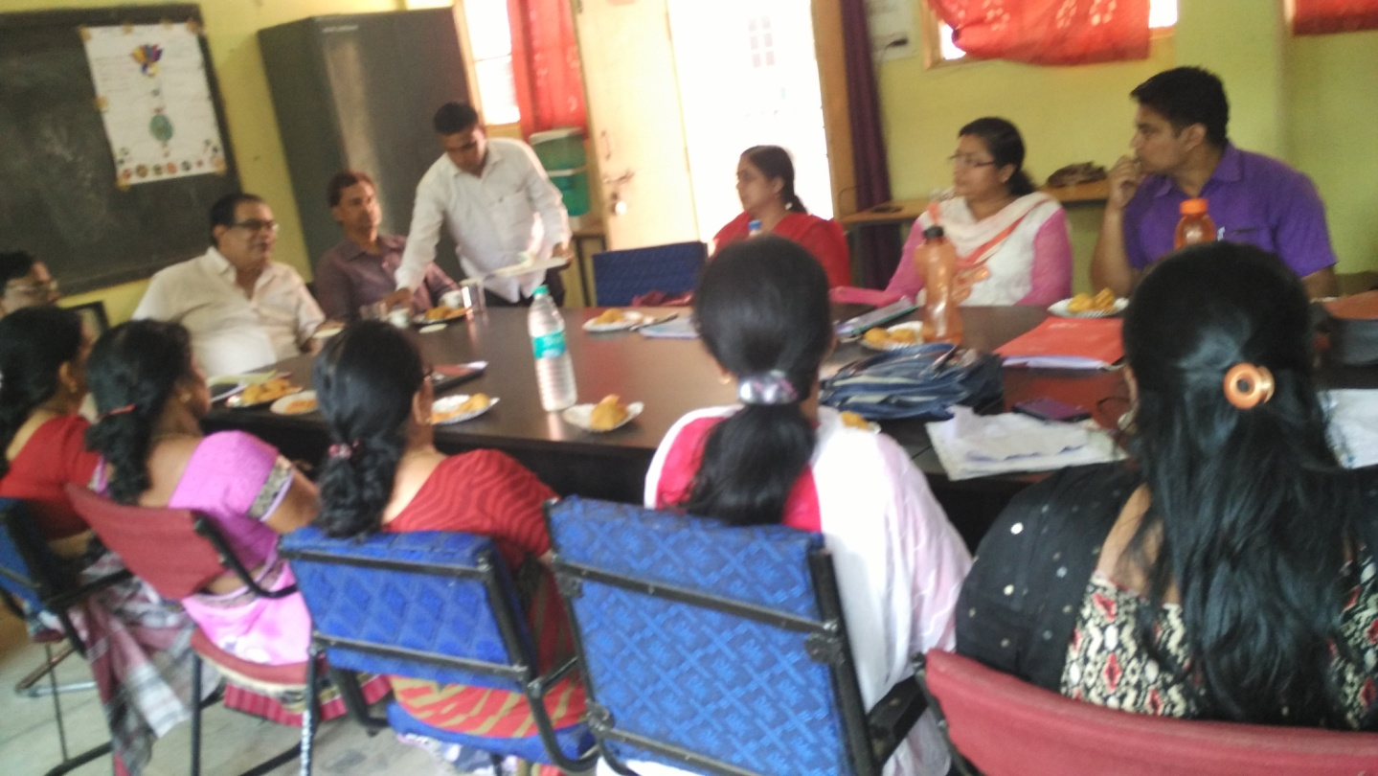
Staff council meeting.

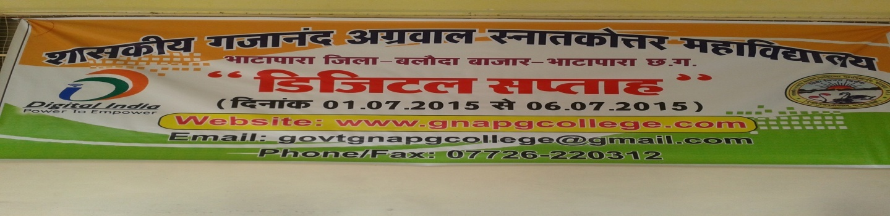

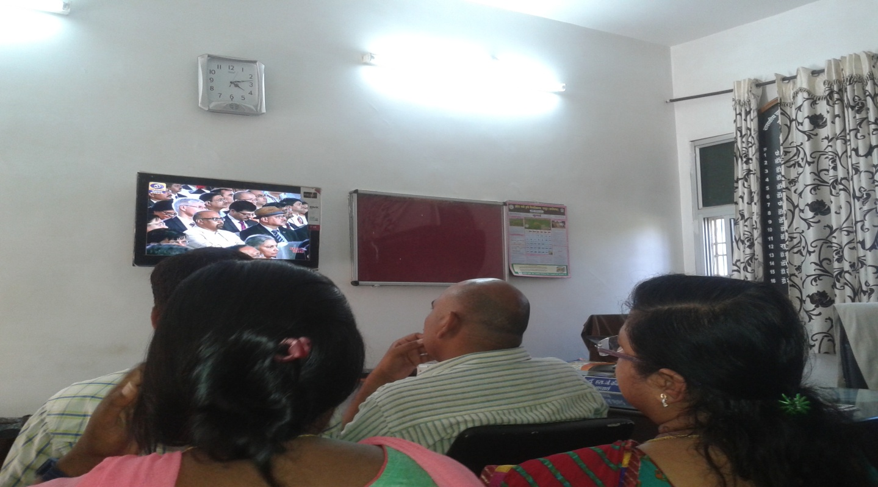
Digital week.

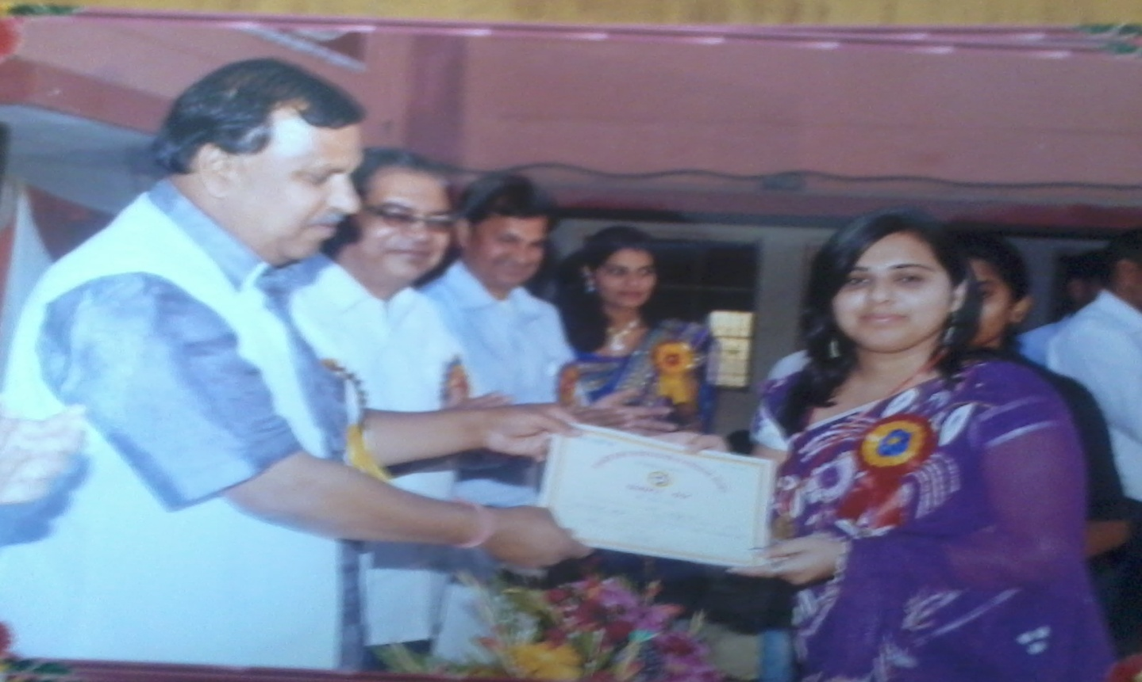
Prize Distribution to Gold medalist Student.

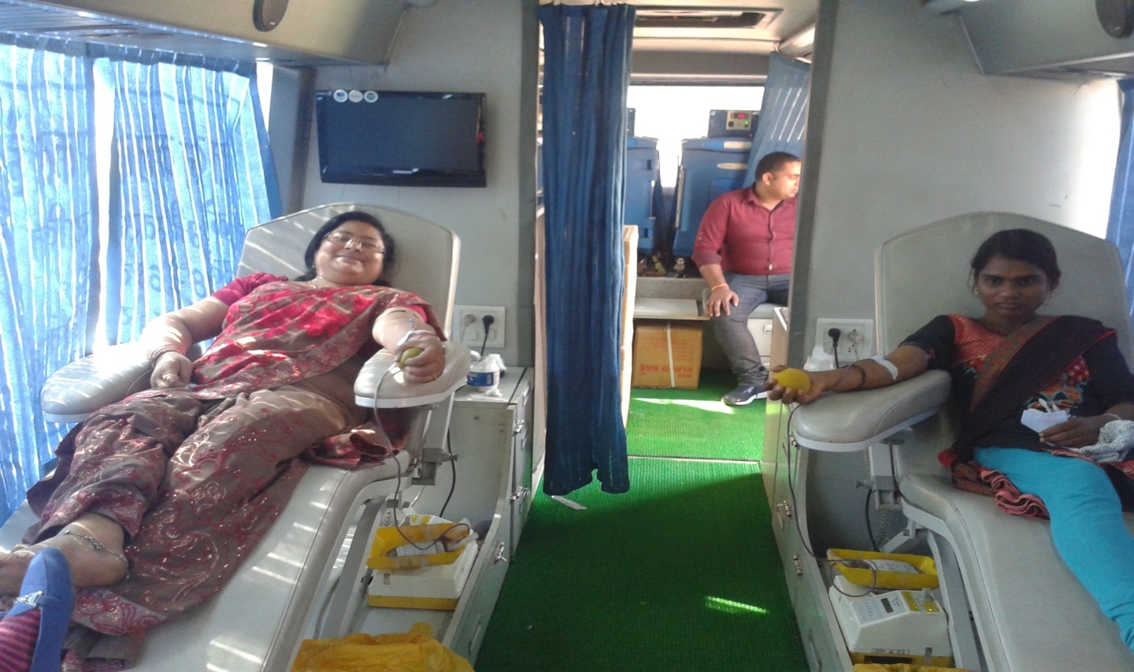
Blood Donation Camp by the Institute

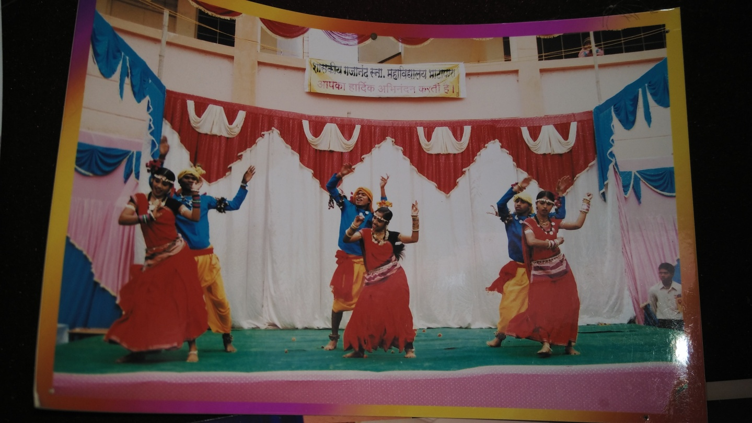
Cultural Activities

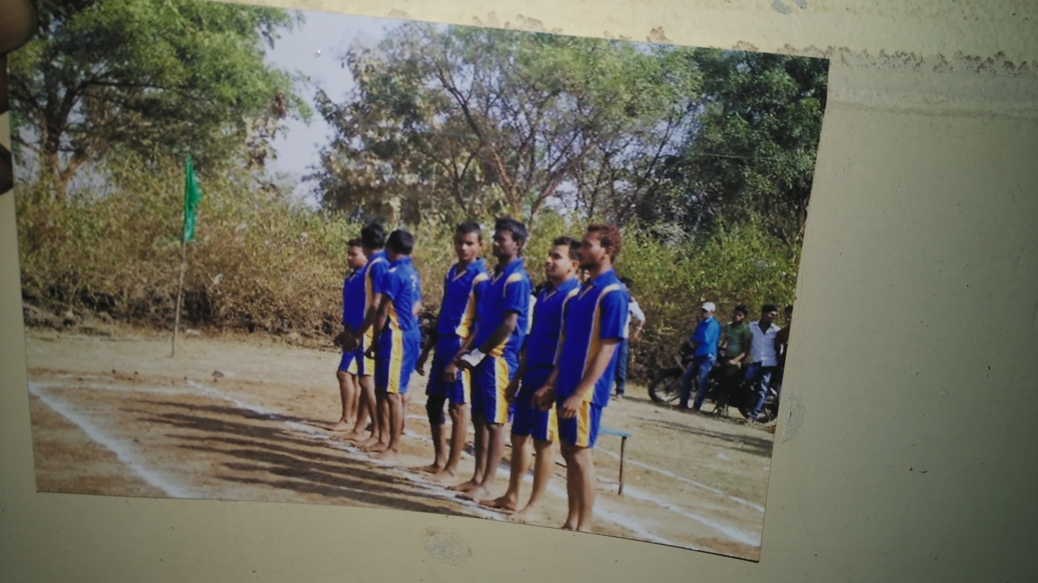
Sports Activities

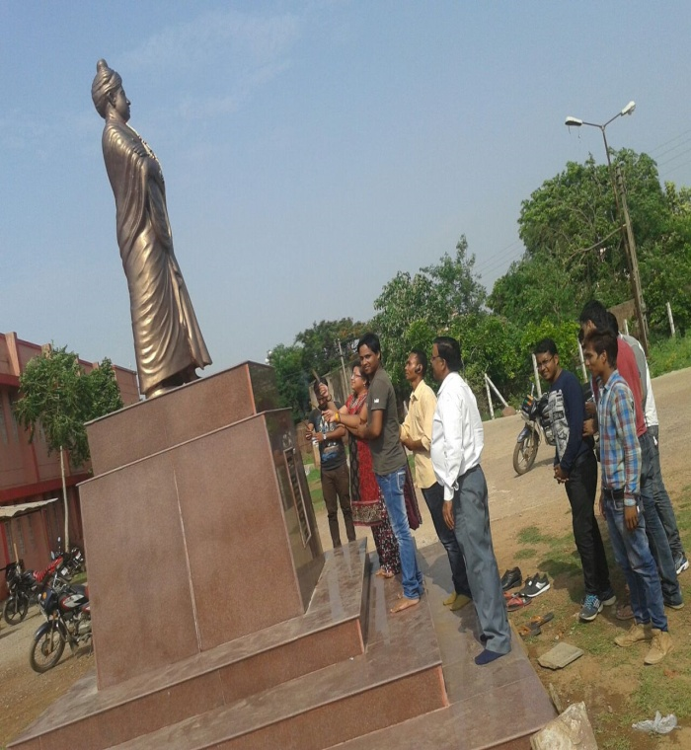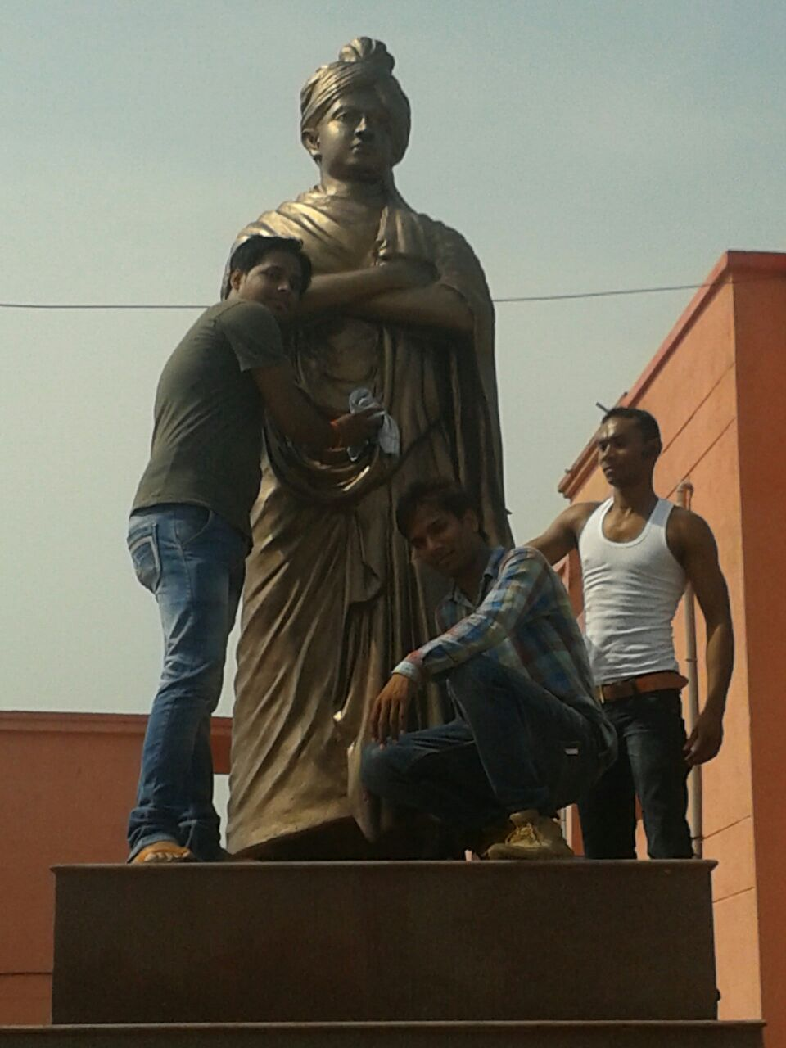

Self motivated activities by students

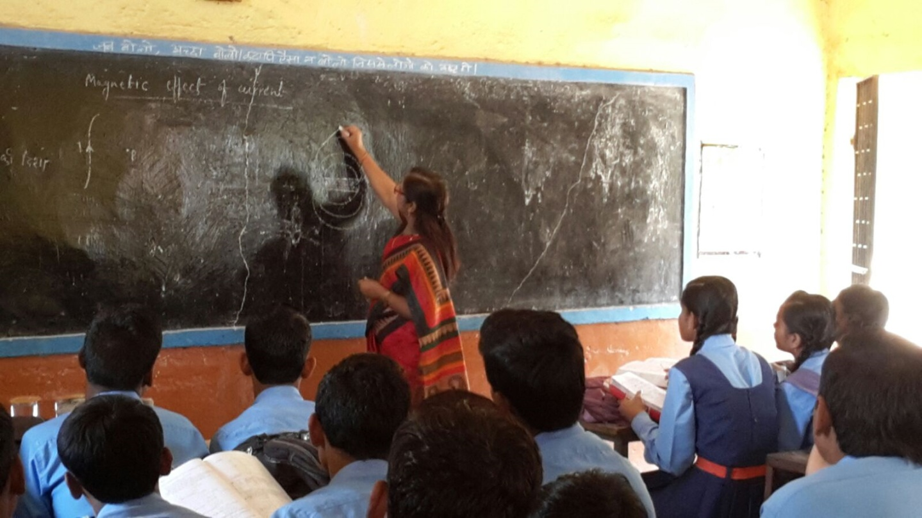

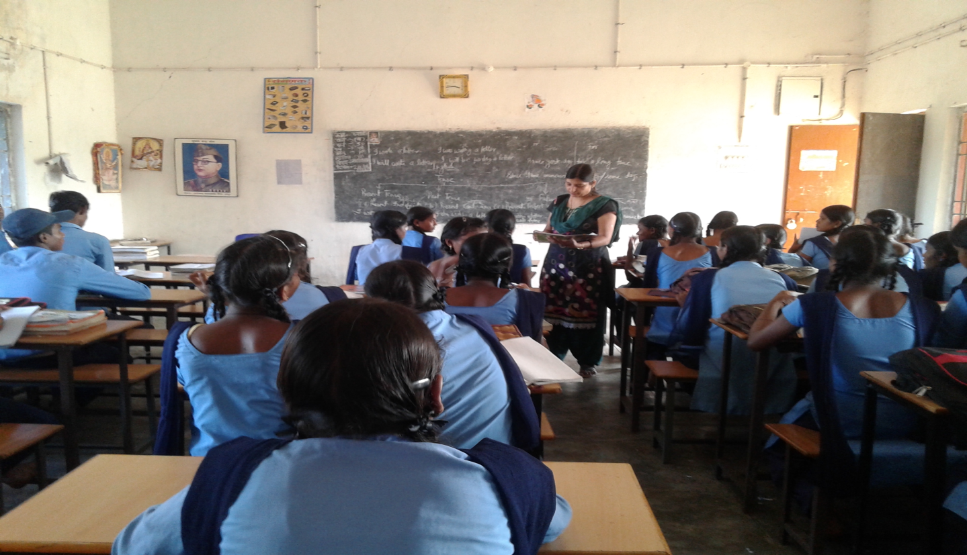
Teaching in schools by faculties as a social responsibility.
SECTION B :

1. Profile of the Affiliated / Constituent College

1. Name and Address of the College:

Name : | GOVT.G.N.A.P.G. COLLEGE BHATAPARA
Address : | SANT MATA KARMA WARD BHATAPARA
City :BHATAPARA | Pin : 493118 | State : CHHATTISGARH
Website : | www.gnapgcollege.com

2. For Communication:

Designation | Name | Telephone  with STD code | Mobile | Fax | Email
Principal | Dr. S.J.Kekre | O:07726220312  R:07712429043 | 8236082415 | 07726220312 | govtgnapgcollege@gmail.com
Vice Principal |  | O: R:
Steering Committee Co-ordinator | Dr. Raginee Pandey | O:07726220312  R:07712429043 | 9425213726 |  | drraginee67@gmail.com

√
3. Status of the Institution: Affiliated College Constituent College
Any other (specify)

4. Type of Institution:
a. By Gender
i. | For Men
ii.  iii. | For Women  Co-education | √
b. By Shift
i. Regular
ii. Day √
iii. Evening

5. It is a recognized minority institution?

Yes
No √

If yes specify the minority status (Religious/linguistic/ any other) and provide documentary evidence.

√
√
6. Sources of funding: Government
Grant-in-aid Self-financing Any other

7. a. Date of establishment of the college: 04/09/1964 (dd/mm/yyyy)
b. University to which the college is affiliated /or which governs the college (If it is a constituent college) PT. RAVISHANKAR SHUKLA UNIVERSITY

c. Details of UGC recognition:

Under Section | Date, Month & Year  (dd-mm-yyyy) | Remarks(If any)
i. 2 (f) | 1985
ii. 12 (B) | 1985

(Enclose the Certificate of recognition u/s 2 (f) and 12 (B) of the UGC Act)

d. Details of recognition/approval by statutory/regulatory bodies other than UGC (AICTE, NCTE, MCI, DCI, PCI, RCI etc.)

Under Section/  clause | Recognition/Approval details Institution/Department Programme | Day, Month and Year  (dd-mm-yyyy) | Validity | Remarks
i.
ii.
iii.
iv.

(Enclose the recognition/approval letter)

8. Does the affiliating university Act provide for conferment of autonomy (as recognized by the UGC), on its affiliated colleges?

Yes No √

If yes, has the College applied for availing the autonomous status?

Yes No

9. Is the college recognized

a. by UGC as a College with Potential for Excellence (CPE)?

Yes No √

If yes, date of recognition: …………………… (dd/mm/yyyy)

b. for its performance by any other governmental agency?

√
Yes No

If yes, Name of the agency …………………… and

Date of recognition: …………………… (dd/mm/yyyy)

10. Location of the campus and area in sq.mts:

Location * | Rural (Semi Urban)
Campus area in sq. mts. | 38283.25776 M²
Built up area in sq. mts. | 7136 M²
(* Urban, Semi-urban, Rural, Tribal, Hilly Area, Any others specify)

11. Facilities available on the campus (Tick the available facility and provide numbers or other details at appropriate places) or in case the institute has an agreement with other agencies in using any of the listed facilities provide information on the facilities covered under the agreement.
• Auditorium/seminar complex with infrastructural facilities √ Sanctioned
• Sports facilities
∗ play ground √
∗ swimming pool
∗ gymnasium Building completed

• Hostel

∗ Boys’ hostel Nil

i. Number of hostels ii. Number of inmates
iii. Facilities (mention available facilities)

∗ Girls’ hostel √ exits

- Number of hostels 01 (which is not in function due to safety reason)
ii. Number of inmates
iii. Facilities (mention available facilities)

∗ Working women’s hostel - Nil

i. Number of inmates

ii. Facilities (mention available facilities)

• Residential facilities for teaching and non-teaching staff (give numbers available — cadre wise) - Nil
• Cafeteria — √ Small tea shop

• Health centre – Private health check ups
First aid, Inpatient, Outpatient, Emergency care facility, Ambulance first aid Health centre staff –

Qualified doctor | Full time | Part-time
Qualified Nurse | Full time | Part-time
√

√
• Facilities like banking, post office, book shops Extension counter of - Bank

• Transport facilities to cater to the needs of students and staff - Nil

• Animal house - Nil

• Biological waste disposal (√)

•Generator or other facility for management/regulation of electricity and voltage √ )

- Generator for solar panel is installed and applied for solar panel.

• Solid waste management facility - E garbage management

• Waste water management

• Water harvesting - proposed & applied

12. Details of programmes offered by the college (Give data for current academic year)

S. No. | Programme  Level | Name of the  Programme/  Course | Duration | Entry  Qualification | Medium of instruction | Sanctioned/  approved  Student  strength | No. of students admitted
 | Under-Graduate | B.A.  B.COM  B.SC | Annual | 12th | H/E | 425  210  250 | 425  200  250
 | Post-Graduate | M.A. HINDI  M.A.SOCIOLOGY  M.A. ENGLISH  M.A.POLI. SCIENCE  M.A. ECOMOMICS  M.COM  M.SC. MATHS  M.SC.CHEMISTRY | Semester | UG | H/E | 50  25  30  50  50  50  25  30 | 25  11  28  15  19  30  25  30
 | Integrated Programmes PG | NA | NA | NA | NA | NA | NA
 | Ph.D. | NA | NA | NA | NA | NA | NA
 | M.Phil. | NA | NA | NA | NA | NA | NA
 | Ph.D | NA | NA | NA | NA | NA | NA
 | Certificate courses | NA | NA | NA | NA | NA | NA
 | UG Diploma | NA | NA | NA | NA | NA | NA
 | PG Diploma | PGDCA | semester | UG |  | 60 | 49
 | Any Other (specify and provide details) | NA | NA | NA | NA | NA | NA

13. Does the college offer self-financed Programmes?

Yes √ No

If yes, how many? 01

14. New programmes introduced in the college during the last five years if any?

Yes | √ | No |  | Number | 03

15. List the departments: (respond if applicable only and do not list facilities like Library, Physical Education as departments, unless they are also offering academic degree awarding programmes. Similarly, do not list the departments offering common compulsory subjects for all the programmes
like English, regional languages etc.)

Faculty | Departments  (eg. Physics, Botany, History etc.) | UG | PG | Research
Science | Physics, Botany, Zoology,  Chemistry, Maths. | √  √ | √
Arts | History, English, Hindi, Pol.science, Ecomomics, Sociology, Hindi litreture | √ | √ | √ Hindi
Commerce | Commerce | √ | √
Any Other  (Specify) | PGDCA |  | √

16. Number of Programmes offered under (Programme means a degree course like BA, BSc, MA, M.Com…)
a. annual system √ 03

b. semester system √ 09
c. trimester system
17. Number of Programmes with

a. Choice Based Credit System Nil

b. Inter/Multidisciplinary Approach B.com Computer

c. Any other (specify and provide details)

6. Does the college offer UG and/or PG programmes in Teacher Education?

Yes No √

If yes,
a. Year of Introduction of the programme(s)………………… (dd/mm/yyyy)

and number of batches that completed the programme b. NCTE recognition details (if applicable)
Notification No.: …………………………………… Date: …………………………… (dd/mm/yyyy)
Validity:………………………..

c. Is the institution opting for assessment and accreditation of Teacher Education
Programme separately? Yes No √

19. Does the college offer UG or PG programme in Physical Education?

Yes No √

If yes,

a. Year of Introduction of the programme(s)………………. (dd/mm/yyyy)

and number of batches that completed the programme b. NCTE recognition details (if applicable)
Notification No.: …………………………………… Date: …………………………… (dd/mm/yyyy) Validity:……………………
c. Is the institution opting for assessment and accreditation of Physical Education
Programme separately? Yes No

20. Number of teaching and non-teaching positions in the Institution:

Positions | Teaching faculty |  |  | Non-teaching staff | Technical staff
 | Professor | Associate  Professor | Assistant  Professor
Sanctioned by the UGC / University / State Government  Recruited | 08  02 |  | 24  14 | 21  18 | 05  05
Yet to recruit | 06 |  | 10 | 03 | Nil
Sanctioned by the Management/ society or other authorized bodies Recruited |  |  | 04 | 04
Yet to recruit
*M-Male *F-Female

21. Qualifications of the teaching staff:

Highest qualification | Professor |  | Associate  Professor |  | Assistant  Professor |  | Total
 | Male | Female | Male | Female | Male | Female
Permanent teachers
D.Sc./D.Litt.
Ph.D. | 02 | - | - | - | 02 | 05 | 09
M.Phil. | - | - | - |  | 01 | 04 | 05
PG | - | - | - | - | 02 | - | 02
Temporary teachers
Ph.D. | - | - | - | - | - | 04 | 04
M.Phil. | - | - | - | - | - | - | -
PG | - | - | - | - | - | 04 | 04
Part-time teachers
Ph.D. | - | - | - | - | - | - | -
M.Phil. | - | - | - | - | - | - | -
PG | - | - | - | - | 03 | 03 | 06

22. Number of Visiting Faculty /Guest Faculty engaged with the College. 08

23. Furnish the number of the students admitted to the college during the last four academic years.

Categories | Year 1  2012-13 |  | Year 2  2013-14 |  | Year 3  2014-15 |  | Year 4  2015-16
 | Male | Female | Male | Female | Male | Female | Male | Female
SC | 171 | 133 | 184 | 163 | 208 | 208 | 221 | 237
ST | 52 | 63 | 74 | 87 | 84 | 120 | 85 | 128
OBC | 347 | 431 | 400 | 479 | 480 | 599 | 497 | 667
General | 94 | 173 | 92 | 177 | 104 | 199 | 131 | 219
Others | - | - | - | -

24. Details on students enrollment in the college during the current academic year:

Type of students | UG | PG | M. Phil. | Ph.D. | Total
Students from the same  state where the college is located | 1790 | 395 | NA | NA | 2185
Students from other states of India | - | - | - | - | -
NRI students | - | - | - | - | -
Foreign students | - | - | - | - | -
Total | 1790 | 395

25. Dropout rate in UG and PG (average of the last two batches) UG 50% PG 00
26. Unit Cost of Education

(Unit cost = total annual recurring expenditure (actual) divided by total number of students enrolled )

(a) including the salary component Rs.11975.0

(b) excluding the salary component Rs.307.0

27. Does the college offer any programme/s in distance education mode (DEP)?

Yes No √

If yes,

a) is it a registered centre for offering distance education programmes of another
University

Yes No √

b) Name of the University which has granted such registration.

-

c) Number of programmes offered -

d) Programmes carry the recognition of the Distance Education Council.

Yes No √

28. Provide Teacher-student ratio for each of the programme/course offered

29. Is the college applying for

Accreditation : Cycle 1 √ Cycle 2 Cycle 3 Cycle 4

Re-Assessment: √

(Cycle 1refers to first accreditation and Cycle 2, Cycle 3 and Cycle 4 refers to re- accreditation)

30. Date of accreditation* (applicable for Cycle 2, Cycle 3, Cycle 4 and re-assessment only)

Cycle 1: ……………… (dd/mm/yyyy) Accreditation Outcome/Result….….... Cycle 2: ……………… (dd/mm/yyyy) Accreditation Outcome/Result……..... Cycle 3: ……………… (dd/mm/yyyy) Accreditation Outcome/Result…….....
* Kindly enclose copy of accreditation certificate(s) and peer team report(s) as an annexure.

31. Number of working days during the last academic year.

195 days

32. Number of teaching days during the last academic year
(Teaching days means days on which lectures were engaged excluding the examination days)

188 days

33. Date of establishment of Internal Quality Assurance Cell (IQAC) IQAC 03/07/2015 (dd/mm/yyyy)
34. Details regarding submission of Annual Quality Assurance Reports (AQAR) to
NAAC.

AQAR (i) ……………… (dd/mm/yyyy) AQAR (ii) ……………… (dd/mm/yyyy) AQAR (iii) ……………… (dd/mm/yyyy) AQAR (iv) ……………… (dd/mm/yyyy)
35. Any other relevant data (not covered above) the college would like to include. (Do
not include explanatory/descriptive information)

PART B - CRITERIA WISE INPUT

CRITERION I: CURRICULAR ASPECTS

1.1 Curriculum Planning and Implementation

    - State the vision, mission and objectives of the institution, and describe how these are communicated to the students, teachers, staff and other stakeholders.
- Vision – The vision of the college is to get excellence in education along with moral values.
- Mission –
- To give education at its excellence to the students.
- To spread the knowledge valuable for students in various dimension.
- To provide education based on moral values.
- To impart knowledge to students along with guidance for their career orientation.
- Objectives –
- To give education to all students of all category of the society.
- The best services for society and corporal life.
- To develop better skills in student for competing the Job opportunities.
- Both gender are given equal opportunities in each field.
- Value based education and environmental cleanliness drive is basic for excellence in education.
The objectives, vision, mission are easily available and known to the common people, along with students and stakeholders through prospectus, college magazine. Website, alumni association, parents teacher meetings and Display periodically on notice boards in the college campus.

    - How does the institution develop and deploy action plans for effective implementation of the curriculum? Give details of the process and substantiate through specific example(s).
- The institute develops the infrastructure by the funds received by the university/ UGC / Janbhagidari samiti. The curriculum provided by the university is implemented according date wise and as per directors given by the university through correspondence.

    - What type of support (procedural and practical) do the teachers receive (from the University and/or institution) for effectively translating the curriculum and improving teaching practices?
- The university arranges for the orientation/ refresher courses/ some schools / Workshops and seminars and the teachers were updated by participation in the courses. Being a government institution we can contribute in curriculum only through our faculty members who are in the board of studies of university.

    - Specify the initiatives taken up or contribution made by the institution for effective curriculum delivery and transaction on the Curriculum provided by the affiliating University or other statutory agency.
- The initiative taken by the institutes are –
- Faculty members use ICT based teaching method for effective curriculum delivery.
- Daily interaction with students and weekly doubt removal session.
- Power point presentations are given by the students.
- Group discussion and seminars for students.

    - How does the institution network interact with beneficiaries such as industry, research bodies and the university in effective operationalisation of the curriculum?
- The institute is a government operated body then also the institute is trying its best to benefit and welfare of the students by tying-up with various industries, research bodies and private sectors to give best opportunities to the students for effective operationalisation of the curriculum.

1.1.6 What are the contributions of the institution and/or its staff members to the development of the curriculum by the University?(number of staff members/departments represented on the Board of Studies, student feedback, teacher feedback, stakeholder feedback provided, specific suggestions etc.
- The curriculum of the institute is design by the board of studies formed by the university in which there is a member from our institute. Discusses the curriculum with the board of studies based on the requirement and suggestion of students. The curriculum is revised annually and updated as per needs. Feed back is taken regularly from the students, Alumni’s twice in the year and implemented.

1.1.7 Does the institution develop curriculum for any of the courses offered (other than those under the purview of the affiliating
university)by it? If ‘yes’, give details on the process (’Needs Assessment’, design, development and planning) and the courses for which the curriculum has been developed.
- No, The institute does not run any such course.

1.1.8 How does institution analyze/ensure that the stated objectives of curriculum are achieved in the course of implementation?
- The institute analyzes that the stated objective of curriculum are achieved or not by -
- Various committees made and duties provided to each committee.
- Committees have to give their report on completion.
- Staff council meeting are held monthly.

1.2 Academic Flexibility

1.2.1 Specifying the goals and objectives give details of the certificate/diploma/ skill development courses etc., offered by the institution.
- The institute is trying to provide diploma/certificate courses for the students and already applied in the university.
- For skill development courses our faculty member has arranged a mushroom cultivation training programme for students by contacting a nearby agriculture college.

1.2.2 Does the institution offer programmes that facilitate twinning
/dual degree? If ‘yes’, give details.
- In future the institute will try to start twinning / dual degree programmes in the form of add on/skill development/ certificate courses.

1.2.3 Give details on the various institutional provisions with reference to academic flexibility and how it has been helpful to students in terms of skills development, academic mobility, progression to higher studies and improved potential for employability. Issues may cover the following and beyond:
• Range of Core / Elective options offered by the University and those opted by the college
- The range of core covers UG degrees in all the three streams along with eight PG degrees.
• Choice Based Credit System and range of subject options
- NA
• Courses offered in modular form
- NA
• Credit transfer and accumulation facility
- NA
• Lateral and vertical mobility within and across programmes and courses
- NA
• Enrichment courses
- Three Enrichment courses are running in the institution.
- PGDCA
- Computer application in commerce
- Spoken English.

1.2.4 Does the institution offer self-financed programmes? If ‘yes’, list them and indicate how they differ from other programmes, with reference to admission, curriculum, fee structure, teacher qualification, salary etc.
- Yes, the institute offers a self financed programme PGDCA, Computer application in commerce.
- The admission procedure follows the merit basis.
- Curriculum from university is implemented.
- Fee structure as per decided by the committee assigned.
- The teachers Qualification should be MCA/ BE in computer Application.
- Salary as decided by the committee.
1.2.5 Does the college provide additional skill oriented programmes, relevant to regional and global employment markets? If ‘yes’ provide details of such programme and the beneficiaries.
- No, The institute does not run any such programme at present.

1.2.6 Does the University provide for the flexibility of combining the conventional face-to-face and Distance Mode of Education for students to choose the courses/combination of their choice” If
‘yes’, how does the institution take advantage of such provision for the benefit of students?
- NA

1.3 Curriculum Enrichment

1.3.1 Describe the efforts made by the institution to supplement the University’s Curriculum to ensure that the academic programmes and Institution’s goals and objectives are integrated?
- The institute is trying to develop some skill in students and analyzes the stated objective of curriculum are achieved or not by
- Various committees formed.
- Committees have to give their report on completion.
- By evaluation of the report.
- Staff council meeting are held monthly.

1.3.2 What are the efforts made by the institution to enrich and organize the curriculum to enhance the experiences of the students so as to cope with the needs of the dynamic employment market?
- A suggestion box is provided for the students so that they may keep their problems.
- Periodic meetings are held with the students council.
- Feedback form is regularly made filled by the students and student council.
- Complaints and suggestions are sorted on preference basis.

1.3.3 Enumerate the efforts made by the institution to integrate the cross cutting issues such as Gender, Climate Change, Environmental Education, Human Rights, ICT etc., into the curriculum?
- Gender – Equal opportunity is given to female in all fields. Percentage of reservation is preferred in admission.
- Environmental Education – A subject is added in the curriculum of under graduate students and they are also awared about environment by extension lectures and project.
- Human Rights – Seminars and invited lectures are arranged to aware the students about human rights e.g. a district judge delivered his speech on ” vidhik saksharta divas”
- ICT – ICT method based teaching and presentations using ICT method by the students.

1.3.4 What are the various value-added courses/enrichment programmes offered to ensure holistic development of students?
- moral and ethical values
- By extension lectures and lectures of faculty members.

- employable and life skills
- Short terms training courses in computers and livelihood skills.

- better career options
- Invited talks from different industrial sectors/offices / industries arranged by carrier and counseling cell of the institute.

- community orientation
- NSS Camp of the institute teaches the students how to orient different types of community.
1.3.5 Citing a few examples enumerate on the extent of use of the feedback from stakeholders in enriching the curriculum?
- The ideas from the feedback of stakeholders are implemented in interior decoration of the infrastructure, renovation programmes for furnitures and demolition programme of the garbage.

1.3.6 How does the institution monitor and evaluate the quality of its enrichment programmes?
- By feedback obtained from the students/ stakeholders.

1.4 Feedback System

1.4.1 What are the contributions of the institution in the design and development of the curriculum prepared by the University?
- The institute does not design its own curriculum, it only follows n implements the curriculum provided by the university. One of the professors of the institute is a member in the board of studies in the university and gives his valuable suggestions for necessary changes on behalf of the staff members of the institutes.

1.4.2 Is there a formal mechanism to obtain feedback from students and stakeholders on Curriculum? If ‘yes’, how is it communicated to the University and made use internally for curriculum enrichment and introducing changes/new programmes?
- A general mechanism is followed by the faculty member by the institute i.e. to get filled feedback form by the students, stakeholders and alumni and make use of the suggestions, comments in the curriculum of the institutes.

1.4.3 How many new programmes/courses were introduced by the institution during the last four years? What was the rationale for introducing new courses/programmes?)
- Three new programmes were introduced in the institute for welfare of the students.
- PGDCA- from 2012-2013 onwards PGDCA has been started with 30 students, in which semester system is followed and is running successfully.
- Computer application in commerce – From 2009-2010 additional subject in the form of computer application is has been added for commerce students.
- Spoken English classes – from 2014-2015 spoken English classes are taken one by one of the faculty member on it own trials for the students of all streams.

CRITERION II: TEACHING - LEARNING AND EVALUATION

2.1 Student Enrollment and Profile

2.1.1 How does the college ensure publicity and transparency in the admission process?
- Initially institute publishes the information regarding admission date in the local news paper and college notice board. Then committees are formed for admission in different course. Committee releases the category wise list of selected candidates on merit basis considering the rules of reservation as declared by the government then list is displayed bon the notice board as well as in website of the college. Thus college ensures the publicity and transparency in admission process.

2.1.2 Explain in detail the criteria adopted and process of admission (Ex. (i) merit (ii) common admission test conducted by state agencies and national agencies (iii) combination of merit and entrance test or merit, entrance test and interview (iv) any other)
to various programmes of the Institution.
- Admission in undergraduate classes is done by the committee appointed, which make the category wise list on selected candidates on the basis of merit checked and verified by the coordinator. List signed by the Principal is displayed on the notice board as well as in the website.
Same procedure is adopted for post graduate classes.

2.1.3 Give the minimum and maximum percentage of marks for admission at entry level for each of the programmes offered by the college and provide a comparison with other colleges of the affiliating university within the city/district.

Year | PG | Category
 |  | UR |  | SC |  | ST |  | OBC
 |  | Max. | Min. | Max. | Min. | Max. | Min. | Max. | Min.
2015-16 | M.A.HINDI | 64.38 | 45.83 | 55 | 46.27 | 48.33 | 48.33 | 58.94 | 48.72
 | M.A.ECONOMICS | 56.83 | 53.5 | 57.38 | 49.67 | 53 | 51.33 | 58.88 | 42.83
 | M.A.POLITICAL SCIENCE | 51.62 | 45.5 | 53.11 | 40.72 | 44.39 | 43.4 | 58.66 | 44.72
 | M.A.COMMERCE | 62.22 | 45.67 | 46.56 |  | 65.89 | 48.61 | 62.11 | 43.78
 | M.SC.CHEMISTRY | 58.77 | 53.3 | 64.11 | 49.22 | 56.6 | 49.94 | 57 | 47
 | M.SC.MATHS | 72.22 | 48.44 | 49.5 |  | 49.5 | 48.89 | 60.11 | 47.56
 | M.A.ENGLISH | 57.05 | 43 | 55.22 | 48.11 | 54.67 | 54.67 | 66.98 | 45.88
 | M.A.SOCIOLOGY | 61 | 50.44 | 48.16 | 44.77 | 48.66 | 45.55 | 60.22 | 44.55
2014-15 | M.A.HINDI | 63.05 | 45.94 | 55.22 | 48.4 | 55.71 | 52.33 | 57.38 | 48
 | M.A.ECONOMICS | 54.27 | 46.55 | 57.27 | 45.39 | 55 | 55 | 62.66 | 43.77
 | M.A.POLITICAL SCIENCE | 55.45 | 48.25 | 56.15 | 48.25 | 58.15 | 50.12 | 60.12 | 45.5
 | M.COMMERCE | 62.94 | 42.61 | 62.15 | 45.5 | ** | ** | 78.18 | 52.11
 | M.SC.CHEMISTRY | 63.77 | 59.89 | 62.88 | 58.5 | 61 | 51.64 | 63.94 | 51.38
 | M.SC.MATHS | 66.5 | 49.61 | ** | ** | ** | ** | 61 | 44.44
 | M.A.ENGLISH | 70.23 | 52.33 | 54.61 | 50.38 |  |  | 58.66 | 49.16
 | M.A.SOCIOLOGY | 53.22 | 50.66 | 50.11 | 48.11 | ** | ** | 53.55 | 47.61

2.1.4 Is there a mechanism in the institution to review the admission process and student profiles annually? If ‘yes’ what is the outcome of such an effort and how has it contributed to the improvement of the process?
- Yes, before the admission started meeting of admission committee is held to make the admission hassle free and without irregularities. From the current academic year we introduced (included) a column for the courses of interest which the candidate wants in the college for his/her livelihood(earning). Thus we will able to know the percentage of students for a particular stream and can process further for adding the course as vacation or add on course.

2.1.5 Reflecting on the strategies adopted to increase/improve access for following categories of students, enumerate on how the admission policy of the institution and its student profiles demonstrate/reflect the National commitment to diversity and inclusion
∗ SC/ST
∗ OBC
∗ Women
∗ Differently abled
∗ Economically weaker sections
∗ Minority community
∗ Any other
- Institute follows the admission policy declare by the state government.
- For SC/ST and OBC category 12%, 32% and 15% reservation are given. Books and stationary are also distributed to SC/ST category students as per government scheme. In 2011-2012 remedial classes were conducted from the grant obtained from UGC.
- Women - 30% seats are reserved at the time of admission in all category.
- Differently abled- 2% seats are reserved under this category.
- Any other- Outstanding performance in sports and extracurricular activities are given weightage. For general category students who are from family, staff members collected the amount to provide the financial assistance to them if required.

Number of students admitted at UG level during last four years (2011-2016)
Categories | Year 1 (2011-2012) |  | Year 2 (2012-2013) |  | Year 3 (2013-2014) |  | Year 4 (2014-2015) |  | Year 5 (2015-2016)
 | Male | Female | Male | Female | Male | Female | Male | Female | Male | Female
SC | 125 | 120 | 140 | 118 | 154 | 142 | 208 | 208 | 184 | 199
ST | 42 | 43 | 49 | 57 | 70 | 77 | 84 | 120 | 77 | 109
OBC | 298 | 331 | 304 | 370 | 328 | 395 | 480 | 599 | 406 | 538
General | 86 | 148 | 82 | 141 | 76 | 140 | 104 | 199 | 116 | 161
Total | 551 | 642 | 575 | 686 | 628 | 754 | 876 | 1126 | 783 | 1007
G.TOTAL | 1193 |  | 1261 |  | 1382 |  | 2002 |  | 1790

Number of students admitted at PG level during last four years (2011-2016)
Categories | (2011-2012) |  | (2012-2013) |  | (2013-2014) |  | (2014-2015) |  | (2015-2016)
 | Male | Female | Male | Female | Male | Female | Male | Female | Male | Female
SC | 15 | 12 | 31 | 15 | 30 | 21 | 30 | 36 | 37 | 38
ST | 4 | 3 | 3 | 6 | 4 | 10 | 10 | 13 | 8 | 19
OBC | 36 | 48 | 43 | 61 | 72 | 84 | 90 | 122 | 91 | 129
General | 16 | 43 | 12 | 32 | 16 | 37 | 21 | 49 | 15 | 58
Total | 71 | 106 | 89 | 114 | 122 | 152 | 151 | 220 | 151 | 244
G.TOTAL | 177 |  | 203 |  | 274 |  | 371 |  | 395

2.1.6 Provide the following details for various programmes offered by the institution during the last four years and comment on the trends. i.e. reasons for increase / decrease and actions
initiated for improvement.

Programmes |  | 2013-2014 |  |  | 2014-2015 |  |  | 2015-2016
 |  | No.of application | No.of students admitted | Demand Ratio | No.of application | No.of students admitted | Demand Ratio | No.of application | No.of students admitted | Demand Ratio
UG | Maths Group | 200 | 103 | 1:1.94 | 186 | 100 | 1:1.86 | 186 | 119 | 1:1.57
 | Bio Group | 319 | 150 | 1:2.12 | 349 | 151 | 1:2.31 | 322 | 177 | 1:1.82
 | Commerce Group | 175 | 162 | 1:1.08 | 239 | 204 | 1:1.18 | 222 | 175 | 1:1.27
 | Art Group | 649 | 427 | 1:1.51 | 752 | 428 | 1:1.76 | 729 | 462 | 1:1.58
Post Graduate | Mathematics | 25 | 17 | 1:1.5 | 27 | 21 | 1:1.28 | 80 | 29 | 1:2.75
 | Chemistry | 46 | 29 | 1:1.59 | 101 | 31 | 1:3.25 | 133 | 39 | 1:3.41
 | Political | 17 | 15 | 1:1.14 | 38 | 28 | 1:1.36 | 20 | 16 | 1:1.25
 | Hindi litreture | 52 | 36 | 1:1.45 | 59 | 47 | 1:1.26 | 38 | 25 | 1:1.52
 | Sociology | 11 | 8 | 1:1.37 | 9 | 13 | 1:0.69 | 16 | 13 | 1:1.24
 | English | * | Not open |  | 15 | 13 | 1:1.16 | 36 | 28 | 1:1.28
 | Economics | 25 | 20 | 1:1.25 | 31 | 20 | 1:1.55 | 27 | 17 | 1:1.58
 | PGDCA | 95 | 49 | 1:1.94 | 130 | 50 | 1:2.6 | 83 | 48 | 1:1.73
 | Commerce | 24 | 24 | 1:1 | 29 | 29 | 1:1 | 32 | 29 | 1:1.10

- Every year number of applications for admission in almost all courses is continuously increasing. Considering this fact more courses needed to be started.

2.2 Catering to Student Diversity

2.2.1 How does the institution cater to the needs of differently- abled students and ensure adherence to government policies in this regard?
- Institution adopts the govt. policies for differently abled students. Ramp is made for the convenience of differently abled students and arrange their classes on the ground floor. Seating arrangement in the examination for them is also due in the ground floor. They are motivated to participate in extracurricular activities also. They need not to pay examination fee during study.

2.2.2 Does the institution assess the students’ needs in terms of knowledge and skills before the commencement of the programme? If ‘yes’, give details on the process.
- This academic year a new column is introduced in admission form & student profile forms student are asked for the skill/ coaching course which they want in this institution, so that college can take step to initialize these courses, for their.

2.2.3 What are the strategies adopted by the institution to bridge the knowledge gap of the enrolled students (Bridge/Remedial/ Add-on/Enrichment Courses, etc.) to enable them to cope with the programme of their choice?
- From the grant obtained by UGC, remedial classes were organized
for weaker students in 2011 an 2012. However faculty member give their assistance for weaker students time to time.

2.2.4 How does the college sensitize its staff and students on issues such as gender, inclusion, environment etc.?
- Institute organizes programme for plantation every year through NSS. No polythene Programme is also run by the college in campus. Legal provisions for women were told in the programme by district magistrate. Women cell is also formed in the college to solve the women problem. Students are not differentiated in the college on the basis of gender.

2.2.5 How does the institution identify and respond to special educational/learning needs of advanced learners?
- Advance learners are identified through various tests. They are provided advance study materials and reference books by teachers. Prizes are also given to the students having good academic records.

2.2.6 How does the institute collect, analyze and use the data and information on the academic performance (through the programme duration) of the students at risk of drop out (students from the disadvantaged sections of society, physically challenged, slow learners, economically weaker sections etc. who may discontinue their studies if some sort of support is not provided)?
- On the basis of attendance marks obtained in the test and interaction in the classroom weak students are indentified. They are given advice for how to study and how to write the answers in examination so that they can pass the examination and can stay in main stream.

2.3 Teaching-Learning Process

2.3.1 How does the college plan and organize the teaching, learning and evaluation schedules? (Academic calendar, teaching plan, evaluation blue print, etc.)
- Syllabus and academic calendar are provided by the university. According to that institute makes its own academic calendar including examinations, holidays, annual function etc.
Apart from calendar time table is made by central time table committee, which is splitted into faculty wise time table further. Then faculty prepare daily diary and plan for teaching the whole course.
PG students are given assignment, presentation tasks and seminar etc.
Daily diary is signed & verified by the principal.
From last year continuous & pre final examination are also organized by the college.

2.3.2 How does IQAC contribute to improve the teaching –learning process?
- Through the faculty members IQAC takes the feedback from students and advise the faculty to mould their teaching according to students.

2.3.3 How is learning made more student-centric? Give details on the support structures and systems available for teachers to develop skills like interactive learning, collaborative learning and independent learning among the students?
- Teaching learning is made more student centric by adopting interactive method. Most of the students belong to Hindi medium so bilingual teaching is done by faculty members. Senior students are asked to make power point presentation and give seminars.
In some departments senior PG students teach some topics to their juniors so that they can be interact more and quite familiar to them participatory learning activities which give rise to contribute to personality development are –
- Department societies
- NSS
- Sports
- Cultural events
- Seminars & presentation.

2.3.4 How does the institution nurture critical thinking, creativity and scientific temper among the students to transform them into life-long learners and innovators?
- Critical thinking is nurtured in students by poster and chart making competition, Laboratory work, presentation et Different competitions are held in the college to develop the creativity in students.

2.3.5 What are the technologies and facilities available and used by the faculty for effective teaching? Eg: Virtual laboratories, e-learning - resources from National Programme on Technology Enhanced Learning (NPTEL) and National Mission on Education through Information and Communication Technology (NME-ICT), open educational resources, mobile education, etc.
- Internet and Wi-Fi is available for students to use technology. College is going to provide facility of E-library also through N- list for students to build competency in them

2.3.6 How are the students and faculty exposed to advanced level of knowledge and skills (blended learning, expert lectures, seminars, workshops etc.)?
- Faculty members are permitted to attend workshops and participate in seminars continuously without affecting the teaching classes to upgrade their knowledge so that the student may get benefitt from expert lectures organized in the college to groom their personality and knowledge.

2.3.7 Detail (process and the number of students \benefitted) on the academic, personal and psycho-social support and guidance services (professional counseling/mentoring/academic advise) provided to students?

Type of Guidance service | Detail | No. of Guest Lectures | No. of candidates benefited
Academic – | - Chemistry  - Physics  - Maths  - English | 03  02  01  01 | 200  200  50  50
Personal Guidance - | - Mushroom cultivation  - Soil Testing | 01  - | 25  60
Social support | - Health check up in NSS | - | 50

2.3.8 Provide details of innovative teaching approaches/methods adopted by the faculty during the last four years? What are the efforts made by the institution to encourage the faulty to adopt new and innovative approaches and the impact of such innovative practices on student learning?
- Group discussion, Seminars, power point presentation audio visual teaching are some innovative methods of teaching adopted by the faculty during past years. Use of internet is also being taught to the students. Under the scheme of state government tablets are distributes to the students so that they can adopt new approaches.

2.3.9 How are library resources used to augment the teaching- learning process?
- Text books and reference books are available which are timely issued to the students and faculty to make teaching-learning smooth.

2.3.10 Does the institution face any challenges in completing the curriculum within the planned time frame and calendar? If ‘yes’, elaborate on the challenges encountered and the institutional approaches to overcome these.
- Yes, this is a government institution, so many responsibilities are given by the state government time to time, for example election duties, inspection duty etc. performance of the duty is done along with the teaching and extra classes are taken to cover the syllabus.

2.3.11 How does the institute monitor and evaluate the quality of teaching learning?
- Continuous observations are made by the head of the institution to evaluate the teaching and he takes feedback from the students and suggests the faculty for improvement in teaching method, If required.

2.4 Teacher Quality

2.4.1 Provide the following details and elaborate on the strategies adopted by the college in planning and management (recruitment and retention) of its human resource (qualified and competent teachers) to meet the changing requirements of the curriculum?

Highest Qualification | Professor (promoted) |  | Associate professor |  | Assistant professor |  | Total
 | Male | Female | Male | Female | Male | Female
Permanent teachers
D.Sc./D.Litt. | 0 | 0 | NA | NA | 0 | 0 | 0
Ph.D. | 2 | 0 | NA | NA | 2 | 5 | 9
M. Phil. | ** | ** | NA | NA | 1 | 4 | 5
PG | ** | ** | NA | NA | 2 | 0 | 02
Temporary teachers/ Guest Teachers
Ph.D. | ** | ** | NA | NA | 0 | 4 | 4
M. Phil. | ** | ** | NA | NA | 0 | 0 | 0
PG | ** | ** | NA | NA | 0 | 4 | 4
Part-time teachers/ Contractual teachers
Ph.D. | ** | ** | NA | NA | 0 | 0 | 0
M. Phil. | ** | ** | NA | NA | 0 | 0 | 0
PG | ** | ** | NA | NA | 3 | 3 | 6
2.4.2 How does the institution cope with the growing demand/ scarcity of qualified senior faculty to teach new programmes/ modern areas (emerging areas) of study being introduced (Biotechnology, IT, Bioinformatics etc.)? Provide details on the efforts made by the institution in this direction and the outcome during the last three years.
- New programmes of emerging areas could not be introduced in the institution yet. Only PGDCA course is running in the college under self financing scheme.

2.4.3 Providing details on staff development programmes during the last four years elaborate on the strategies adopted by the institution in enhancing the teacher quality.

a) Nomination to staff development programmes

Academic Staff Development Programmes | Number of faculty nominated
Refresher courses | 01
HRD programmes | Nil
Orientation programmes | 09
Staff training conducted by the university | Nil
Staff training conducted by other institutions | 01
Summer / winter schools, workshops, etc. | 01

c) Percentage of faculty –

∗ invited as resource persons in Workshops / Seminars / Conferences organized by external professional agencies

∗ participated in external Workshops / Seminars / Conferences recognized by national/ international professional bodies

∗ presented papers in Workshops / Seminars / Conferences conducted or recognized by professional agencies

* invited as resource persons in Workshops / Seminars / Conferences  organized by external professional agencies – | 37.5%
* participated in external Workshops / Seminars / Conferences recognized by  national/ international professional bodies- | 75%
* presented papers in Workshops / Seminars / Conferences conducted or  recognized by professional agencies – | 94%
* teaching experience in other universities / national institutions and others- | 4 %
* industrial engagement- | Nil
* international experience in teaching- | Nil

2.4.4 What policies/systems are in place to recharge teachers? (eg: providing research grants, study leave, support for research and academic publications teaching experience in other national institutions and specialized programmes industrial engagement etc.)
- One of the faculty member is on study leave granted for his research work by UGC. In place of him one guest lecturer is selected according to the guidelines of the UGC on minimum basic pat scale.
- One more faculty member has applied for study leave.
- Two minor research projects are also sanctioned by UGC.
They institute provide and facilitate for the grants and study leaves by supporting the faculty leave and relieve them from the duties.

2.4.5 Give the number of faculty who received awards / recognition at the state, national and international level for excellence in teaching during the last four years. Enunciate how the institutional culture and environment contributed to such performance/achievement of the faculty.
- Nil

2.4.6 Has the institution introduced evaluation of teachers by the students and external Peers? If yes, how is the evaluation used for improving the quality of the teaching-learning process?
- Feedback about teachers are taken from students. According to their feedback teachers are suggested to improve their teaching- learning process.

2.5 Evaluation Process and Reforms

2.5.1 How does the institution ensure that the stakeholders of the institution especially students and faculty are aware of the evaluation processes?
- Students are made aware of the process of admissions and evaluation through broacher. They are again told about the college rules and examination in the induction programme.
2.5.2 What are the major evaluation reforms of the university that the institution has adopted and what are the reforms initiated by the institution on its own?
- Institution follows the evaluation process guided by the university.
- UG level – Unit tests are conducted after completing each unit. Pre annual examinations are also conducted by the college to prepare the student for annual exam.
- PG level- Unit tests and seminars are conducted by the college as internal assessment for each semester.

2.5.3 How does the institution ensure effective implementation of the evaluation reforms of the university and those initiated by
the institution on its own?
- NA

2.5.4 Provide details on the formative and summative assessment approaches adopted to measure student achievement. Cite a few examples which have positively impacted the system.
- Projects, assignments and presentations are some formative assessments for students which is done is the institution. Summative assessment is also done through internal class test and pre annual examination.

2.5.5 Detail on the significant improvements made in ensuring rigor and transparency in the internal assessment during the last four years and weightages assigned for the overall development of students (weightage for behavioral aspects, independent learning, communication skills etc.
- Answer copies are shown to student maintain transparency. The tests are not only in pen paper mode but also in the form of group discussion, short seminar, viva to grow confidence, independent learning and communication skills.

2.5.6 What are the graduate attributes specified by the college/ affiliating university? How does the college ensure the attainment of these by the students?
- After being graduate a student should possess some qualities like decision making, leadership, effective communication, moral values and ethics. To develop this qualities in student various programme were conducted by the institution.
- Career option workshop by professor Mishra, SADMAP Bhopal MP.
- Programme on interview skills and communications skills by retired professor Dr. B.P.J.Rao Usmania University Hydrabad.
- Personality development programme by professor R.G.Bhave.
- Legal awareness programme.

2.5.7 What are the mechanisms for redressal of grievances with reference to evaluation both at the college and University level?
- There is a complaint box in our college campus for students to place their complaint and grievance, so that their complaint can be resolved by the committee meant for it.

2.6. Student performance and Learning Outcomes

2.6.1 Does the college have clearly stated learning outcomes? If ‘yes’ give details on how the students and staff are made aware of these?
- Yes, The learning outcomes are clearly stated in college magazine and broacher. At the time of induction students are made aware about these information through message on display boards. This way the institution makes the student aware of the qualities the same must possess.

2.6.2 Enumerate on how the institution monitors and communicates the progress and performance of students through the duration of the course/programme? Provide an analysis of the students results/achievements (Programme/course wise for last four years) and explain the differences if any and patterns of achievement across the programmes/courses offered.
2.6.3 How are the teaching, learning and assessment strategies of the institution structured to facilitate the achievement of the intended learning outcomes?
- Student are awarded in the annual function for achievement in different fields.

2.6.4 What are the measures/initiatives taken up by the institution to enhance the social and economic relevance (student placements, entrepreneurship, innovation and research aptitude
developed among students etc.) of the courses offered?
- For the first time institution organized a placement programme for nearby industry. Apart from this training programme for entrepreneurship were also organized by the institute. To get in the field of research and academic contribution NET coaching is also started in the institution
CRITERION III: RESEARCH, CONSULTANCY AND EXTENSION

3.1 Promotion of Research

    - Does the institution have recognized research center/s of the affiliating University or any other agency/organization?
- The college has a basic infrastructure and UG/PG laboratory and library, which provides a platform for the research work. There are eight PG courses running in the institution. PG course in two subjects have been approved recently. There are two PG courses in science, Maths & Chemistry, five in arts ; Hindi, Political Science, Sociology English & Economics, one in commerce . There is only one research center registered in hindi.

    - Does the Institution have a research committee to monitor and address the issues of research? If so, what is its composition? Mention a few recommendations made by the committee for implementation and their impact.
- There is a Research Advisory Committee which directs research activity
Date of establishment – (07.04.2015)
Chair person – Principal ( Dr.S.J.Kekre)
Co-ordinator - Professor (Dr. O.P.Chandrakar)
Member–Dr.N.K.Verma, Dr.Vatsala Mishra, Shri Jitendra Yadav
On recommendation of RAC, the college the has taken initiative to apply for the MRP through its faculty .

3.1.3 What are the measures taken by the institution to facilitate smooth progress and implementation of research schemes/ projects?

§ autonomy to the principal investigator

§ timely availability or release of resources

§ adequate infrastructure and human resources

§ time-off, reduced teaching load, special leave etc. to teachers

§ support in terms of technology and information needs

§ facilitate timely auditing and submission of utilization certificate to the funding authorities

§ any other
- All

    - What are the efforts made by the institution in developing scientific temper and research culture and aptitude among students?
- College is trying to develop scientific temper and research culture among students by Visiting the research centre, organizing Seminars & Extension activities, MRP, going through concerned journals.

3.1. 5 Give details of the faculty involvement in active research (Guiding student research, leading Research Projects, engaged in individual/collaborative research activity, etc.
S.n. | Name of the Faculty | Research scholar Awarded | Research scholar Registered
1 | Dr. S.J.Kekre | 22 | Nil
2 | Dr. O.P.Chandrakar | 03 | 05
3 | Dr. N. K. Verma | 05 | 03

The college is a recognized research centre for subjects – Hindi. The faculty members are trying to lead the research work by their publication of research paper in different journal. The faculty members are actively involved in supervising research work leading to Ph.D. degree affiliated to Pt.R.S.U., Dr. C.V.Raman University Kota Bilaspur.

3.1.6 Give details of workshops/ training programmes/ sensitization programmes conducted/organized by the institution with focus on capacity building in terms of research and imbibing research culture among the staff and students.
- 1. National seminar on “Sustainable development of environment” dated 26-27 February 2011
2. National seminar on “Lok sahitya ke vividh aayam” dated 27- 28 February 2011
Two seminars have been sanctioned by UGC in the year2014 and 2015.

3.1.7 Provide details of prioritized research areas and the expertise available with the institution.

Faculty Department Research area
- Dr. S.J.Kekre Department of Hindi Probes
- Dr.O.P.Chandrakar Department of Commerce Income Tax
- Dr.N.K.Verma Department of Hindi Lok- Sahitya

3.1.8 Enumerate the efforts of the institution in attracting researchers of eminence to visit the campus and interact with teachers and students?
- The institution invites eminent professor and researcher to deliver lectures and organizes training programs, workshops for the benefit of student and teachers.

3.1.9 What percentage of the faculty has utilized Sabbatical Leave for research activities? How has the provision contributed to improve the quality of research and imbibe research culture on the campus?
- One faculty member is on sabbatical leave for research activities. The faculty member who are interested to take part in research programme are given duty leave facility according to rule by govt.UGC.

3.1.10 Provide details of the initiatives taken up by the institution in creating awareness/advocating/transfer of relative findings of research of the institution and elsewhere to students and community (lab to land)
- To rise the research thinking and vision invitation provide permission to different training programme organized at the own level.

3.2 Resource Mobilization for Research

3.2.1 What percentage of the total budget is earmarked for research?
Give details of major heads of expenditure, financial allocation and actual utilization.
- Sanctioned project & seminar as proposed applied.

3.2.2 Is there a provision in the institution to provide seed money to the faculty for research? If so, specify the amount disbursed and the percentage of the faculty that has availed the facility in the last four years?
- UGC , CG cost

3.2.3 What are the financial provisions made available to support student research projects by students?
- Nil

3.2.4 How does the various departments/units/staff of the institute interact in undertaking inter-disciplinary research? Cite examples of successful endeavors and challenges faced in organizing interdisciplinary research.
- Nil

3.2.5 How does the institution ensure optimal use of various equipment and research facilities of the institution by its staff and students?
- Nil

3.2.6 Has the institution received any special grants or finances from the industry or other beneficiary agency for developing research facility? If ‘yes’ give details.

3.2.7 Enumerate the support provided to the faculty in securing research funds from various funding agencies, industry and other organizations. Provide details of ongoing and completed projects and grants received during the last four years.

Nature of the  Project | Duration  Year  From To | Title of the project | Name of the funding agency | Total Grant |  | Total grant received till date
 |  |  |  | Sanctioned | Received
Minor projects  - Dr. Mahendra Sarva (Department of History.) | 2 years | Chhattisgarh me samajik, Dharmik Andolan : Ek aitehasik anushilan. | UGC | - | - | -
- Dr. Jitendra yadav (Department of Botany.) | 02 Years | How extra income generate with the help of cultivation of moringa. | UGC | - | - | -
- Dr. L.N.Verma ( Department of Commerce.) | 10-01-2012 to 09-10-2013 | A study on socio-economic aspects of train hawkers between Raipur- Bilaspur in Chhattisgarh | UGC | 1,20000.00 | 99161.00 | 52000.00
Major projects | - | - | - | - | - | -
Interdisciplinary projects | - | - | - | - | - | -
Industry sponsored | - | - | - | - | - | -
Students’  research projects | - | - | - | - | - | -
Any other  (specify) | - | - | - | - | - | -

3.3 Research Facilities

3.3.1 What are the research facilities available to the students and research scholars within the campus?
- Yes, our institute has Hindi research centre and in other department has no research facility. But to conduct MRP projects and seminars institution is continuously trying to take the research facility.

3.3.2 What are the institutional strategies for planning, upgrading and creating infrastructural facilities to meet the needs of researchers especially in the new and emerging areas of research?
- The future plans include
Conference cum seminar hall
E-library
Access to advanced journals for research work.
Interdisciplinary collaboration. For subject broadness.

3.3.3 Has the institution received any special grants or finances from the industry or other beneficiary agency for developing research facilities?? If ‘yes’, what are the instruments / facilities created during the last four years.
- NA

3.3.4 What are the research facilities made available to the students and research scholars outside the campus / other research laboratories?

3.3.5 Provide details on the library/ information resource center or any other facilities available specifically for the researchers?
- Library and Internet.

3.3.6 What are the collaborative research facilities developed/ created by the research institutes in the college. For ex. Laboratories, library, instruments, computers, new technology etc.
- The institute is in process to apply for inflibnet access through N-list for faculty members and research scholars.

3.4 Research Publications and Awards

3.4.1 Highlight the major research achievements of the staff and students in terms of
- Patents obtained and filed (process and product)
- Nil

- Original research contributing to product improvement
- Nil

- Research studies or surveys benefiting the community or improving the services
- Minor research project is completed on “ A study on socio-economics aspects of train hawkers between Raipur- Bilaspur chhattisgarh.”
- Research inputs contributing to new initiatives and social development
- Minor research project is in progress on NRrhlx<+ esa lkekftd& /kkfeZd vkUnksyu & ,d ,srsgkfld vuq”khyuA

    - Does the Institute publish or partner in publication of research journal(s)? If ‘yes’, indicate the composition of the editorial board, publication policies and whether such publication is listed in any international database
- NO.

3.4.3 Give details of publications by the faculty and students:
- Publication per faculty

Faculty | Publication
Department of Political Science | Dr. Nisha Sharma  National Seminar attended  - Trend of voting behavior in Indian democratic system 2015, jktuhrh esa ;qok oxZ dh Hkwfedk  - Environment, Ecology and Remote sensing 2011.  - Yoga – Society and Health 2015  - Right to information 2011  - Politics of coalition and accommodating regional aspiration.  Publication  - Remark – efgyk vkj{k.k fo/ks;d ,d jktuhfrd fo”ys’k.k twu 2014  - J`a[kyk & Political trends in global warming & carbon credit climate change and view poin of the super power, Aug 2014
Department of Zoology | Ms. Uma Gupta  National Seminar  - Conservation of plant diversity (global issues)  - Internship programme in education.  Publication  - ^ Ik;kZoj.k f”k{kk ,d vfuok;Z vko”;drk & ,d v/;;u  In new age researchers a quarterly multidisciplinary peer-reviewed research journal.
Department of English | Mrs. Nidhi Gupta  National  - Arvind adiga’s Novel last man is the Tower : A depiction of Harsh Realities of Mumbai Life published in “ Indian journal of socio – legal studies” Corruption the main theme in  - Arvind adiga’s Novel between the assassinations published in “research link”.  - Need of tools in developing communication skills. Published in “Chhattisgarh law journal.”  - Indian women writing in the era a globalization published in “research journal.”  Paper presentation  - “Modern man and transcendence in the poetry of eliot and Tennyson “  - “Need of tools developing communication skills.”  - “ impact of internship”
Department of Chemistry | Dr. Preeti Soni  List of Publication  - “Studies on the effect of micro-nutrients on nutrient uptake and amino-acid contents in Soybean plant”. Research Journal of Chemistry and Environment, Indore ( M.P.)  - “Amelioration of acidic soil by fly ash for trace elements uptake and better crop yield and increased protein contents in chick pea(Cicer areitinum)”. Asian Journal of chemistry , Sahibabad (Ghaziabad).  - “Application of fly ash in agriculture”. Souvenir of the All india level seminar on advances in chemistry research at Govt.Art’s Com.&Sc.college Kota Bilaspur(CG.)  - “Amelioration of acidic soil by fly ash for trace elements uptake like Zn, Mo etc. for better crop yield and protein contents in Phaseolous mungo.” Souvenir of the all India level seminar on advances in chemistry research, at Govt.art’s com.& Science College Kota bilaspur (C.G.)  - “Utilization of bottom ash in agriculture, Proceedings of the national symposium on “ combating pollutants accumulation in Eco-system for sustainable agriculture at Allahabad agriculture institute, Allahabad.  - “Effect of micro-Nutrients in chick pea plant”. Proceedings of silver jubilee national seminar of techno-Economic Evaluation of fermented Bio-based products: Vision 2020 at Guru Ghasidas University, Bilaspur.  - “Trace Element uptake and better yield in cicer arientinum by the use of fly-ash in acidic soil”. , proceedings of the 6th Chhattisgarh young scientist Congress Guru Ghasidas university Bilaspur.
Department of Physics | Dr. Raginee Pandey  - Elastic deformation of rare earth doped strontium aluminate micro crystal by induced machano luminescence.  - Thin fill deposition during poly atomic organic gas plasma decomposition.  Dr. Vikash Gulhare  - Effect of deformation on the thermoluminescence of barium sulphate , phosphorous. (journal)  - Lyoluminescence of gama irradiated sodium bromide samples.  - Similaraties in mechano, thermo and Lyoluminescence Gama irradiate sodium chloride.  - Mechanoluminescence of gama irradiated Sm and Eu Doped calcium sulphate phosphorous  - Impulsive excitation of mechanoluminescence Characterisation of gama irradiated coumpunds. Mg(VO3)2:Ce phosphorous.  - Lyoluminescence in MgSO4 : DY3+Phosphorous  - Lyoluminescence and photoluminescence in KNASo4: Tb3+Phosphorous.  - luminescence studies in K2Ca2 (So)3 : Eu phosphorous.
Department of Botany | Dr. Diksha Khare  - Seasonal variation in the Atmopheric mycoflora over barleria prionitis.  - Studies of leaf surface mycoflora of barleria prionitis L.  - Seasonal diversity of aspergillus, alternair and curvularia : A Aeromycoflor study over barleria prionitis L.  - Studies of Aeromycoflora of Cassia tora L.  - Screening of leaf surface mycoflora over barleria prionitis prionitis Linn : A seasonal study.
Department of History | Dr. Mahendra Sarva  - fljiqj dkyhu lekt esa ukfj;ks dh n”kk  - NRRkhlx<+ dk iz;kx & jkfte  - Ek/;izkUr ds fo/kku ifj’kn esa gFkdM+h dkaM dh xwat  - }S/k“kklu esa Lora= dkaxzsl ny dh Hkwfedk  - e/;izkar esa xBca/ku ljdkj  - e/;izkar dk izFke fuokZpu ,oa dk;Zdky  - Lora=rk dh ukf;dk MkW jk/kk ckbZ  - “kSo mikluk dk izkphu dasnz flgkok  - NRrhlx<+ eas lkekftd vkanksyu dk dsanz & nkek[ksM++k
Department of Economics | Dr. Shashi Kiran Kujur  jk’Vªh; “kks/k laxks’Bh &  - vuqlwfpr tutkfr ds vkfFkZd fodkl ij ctV dk izHkko ¼dY;k.k Lukrd egkfo|ky; fHkykbZ uxj N-x-½  - vkfFkZd fodkl esa lekos”kh fosdkl dh vko”;drk ¼vFkZ”kkL= v/;;u “kkyk Ika j-“k- “kq-fo-fo- jk;iqj N-x-½  - dkedkth efgyk,a ,oa lekt ¼ “kk. lR;ukjk;.k vxz- dyk okf.kT; egkfo|ky; dksgdk&usojk jk;iqj N-x-½  - Hkkjr dh iapo’khZ; ;kstukvkas esa lkoZtfud O;; dk Lo:Ik ¼”kk- dyk ,oa okf.kT; egkfo|ky; /ke/kk N-x- ½  - Ñf’k for ds {ks= esa cSafdax dk ;ksxnku ¼ N-x- vkfFkZd ifj’kn VI okf’kZd ½  - NRrhlx<+ esa efgyk fodkl ;kstukvksa ds izfr efgykvksa eas tkx:drk dk losZ{k.k ¼ “kk- feuhekrk dU;k egkfo|ky; cykSnkcktkj½  - Xkzkeh.k {ks= esa Hkkjrh; lekt esa O;kIr dqjhfr;ksa dk v/;;u ¼”kk- egk- cjikyh ] ftyk dksjck N-x- ½
Department of Hindi | Dr. N.K.Verma  jk’Vªh; “kks/k laxks’Bh &  - fgUnh jaxeap vkSj mldk Hkfo’; ¼”kk-foKku egkfo|ky; nqxZ N-x- 1995 ½  - Hkkjrh; Hkk’kkvkas esa vfHkO;Dr ,drk vkSj fgUnh ¼”kk- foyklk egkfo|ky; fcykliqj 1996½  - vkt dh fgUnh dgkuh essa oxhZ; psruk ¼ “kk- N= “kky egkfo|ky; NRkjiqj 1999½  - ledkyhu fgUnh dfork vkSj jk’Vªh; ifjn`”; ¼ “kk- fnfXot; egkfo|ky; jktukanxk¡o 2000½  - fgUnh lkfgR; ys[ku dh leL;k,a vkSj pqukSfr;ka ¼ “kk- LukRkdksRrj egkfo|ky; fcykliqj 2000½  - Lkedkyhu fgUnh dfork esa O;ax ¼”kk- fcyklk egkfo|ky; fcykliqj 2002½  - Lkedkyhu fgUnh dfork esa ukjh ¼ “kk- Mh- Ckh- xYlZ dkWyst jk;iqj 2002½  - Iknqeyky iqUukyky c[“kh ds fuca/kksa esa Hkkjrh;rk dh rkyk”k ¼ LakLÑfr foHkkx N-x- “kklu 2004½  - “kks’k.k eqDr lkekt ds ltZd & eqfDrcks/k ¼ laLd`fr foHkkx N-x- “kklu 2004½  - “kkBksRrjh xhrksa es ledkyhu lUnHkZ ¼ “kk- fcyklk egkfo|ky; fcykliqj 2005½  - Lekdkyhu Hkkjrh; dforkvksa es ,drk o v+[k.Mrk ¼”kk- egkfo|ky; “kgMksy 2005½  - MkW- c[“kh th ds fuca/kks esa Hkkjrh;rk dh ryk”k ¼ jpuk e-iz-lkfgR; ifj’kn 2009 ½  - “kks’k.k eqDr lekt ds Loiu n`’Vk eqfDrcks/k ¼ }hiygjh fgUnh lkfgR; ifj’kn iksVZ Cys;j vaMeku 2009½  - yksdxkFkk iaMokuh ¼”kk- fnfXot; dkWyst jktukanx¡ko 2012½  - Ykksd lkfgR; ds fofo/k vk;ke ¼”kk-xtk- vxz- egkfo|ky; HkkVkIkkjk N-x-½  - tuoknh dkO; ijEijk vkSj dsnkjukFk vxzoky dh dfork ¼ bafnjk dyk laxhr fo”ofo|ky; [kSjkx<+ 2014½  - yksdxhrksa es vfHkO;Dr yksdthou ¼Lokeh LkR; Lo:ik LkjLorh dkWyst fHkykbZ 2014½  varjkZ’Vªh; “kks/k laxks’Bh &  - lkfgR; dk lkekftd ljksdkj vkSj ys[kd dh ihM+k ¼ukxiqj fo”ofo|ky; ukxiqj 2015½  - lkfgR; dk lkekftd ljksdkj vkSj ys[kdh; nkf;Ro ¼Ukkxiqj fo”ofo|ky; ukxiqj 2015 ½
Department of Commerce | Dr. O.P.Chandrakar  - Role of Bank in economic development of India. ( Govt. Indrajeet singh college 2014)  - Role of technical innovation in business activities.( Pt.H.S.S.M. Raipur 2015)

- Number of papers published by faculty and students in peer reviewed journals (national / international)

Name of Faculty | Publication in National Journal | Publication in International Journal.
Dr. N.K.Verma | 25 | 02
Dr. Diksha Khare | 04 | 01
Ms. Uma Gupta | 01 | -
Mrs. Nidhi Gupta | 03 | -
Dr. Mahendra Sarva | 09 | -

- Number of publications listed in International Database (for Eg: Web of Science, Scopus, Humanities International Complete, Dare Database - International Social Sciences Directory, EBSCO host, etc.)

- Monographs - NA
- Chapter in Books – NA
- Books Edited – NA
- Books with ISBN/ISSN numbers with details of publishers- NA
- Citation Index – NA
- SNIP- NA
- SJR- NA
- Impact factor-NA
- h-index- NA
3.4.4 Provide details (if any) of
- research awards received by the faculty
- Nil
- recognition received by the faculty from reputed professional bodies and agencies, nationally and internationally
- Nil
- incentives given to faculty for receiving state, national and international recognitions for research contributions.
- Nil

3.5 Consultancy

3.5.1 Give details of the systems and strategies for establishing institute-industry interface?
- Through the N.S.S camp programme of the institute experts are invited for talks of different fields where the students get enlighten and benefited along with various field activities.
- The blood donation camp and medical health check up camps by the institutes also give interfaces for students.

3.5.2 What is the stated policy of the institution to promote consultancy? How is the available expertise advocated and publicized?
- The carrier and counseling cell of the institute provides the consultancy and expertise to the students.

3.5.3 How does the institution encourage the staff to utilize their expertise and available facilities for consultancy services?
- The institute provide duty leave for advance training, learning, attending workshop/Seminar, research work according to the government norms.

3.5.4 List the broad areas and major consultancy services provided by the institution and the revenue generated during the last
four years.
- NA

3.5.5 What is the policy of the institution in sharing the income generated through consultancy (staff involved: Institution) and its use for institutional development?
- NA

3.6 Extension Activities and Institutional Social Responsibility
(ISR)

3.6.1 How does the institution promote institution-neighbourhood- community network and student engagement, contributing to good citizenship, service orientation and holistic development of students?
The institute promotes different types of extension activities as-
- Environmental awareness programmes by NSS.
- Blood donation camp.
- Legal literacy programme by nss in village and by the institute .
- Different types of awareness for villagers in NSS camp.
- Aids awareness programme.
- Soil testing camp for Farmers.
- Plantation in the institute.

3.6.2 What is the Institutional mechanism to track students’ involvement in various social movements / activities which promote citizenship roles?
- The institute mechanism to track students involvement through various committies and NSS camp of the institute conducts various development programmes as plantation, red cross society,and by visting different areas of village and do certain works as cleanliness, makin small roads ,small bridges over the nallahs, cleaning the rivers etc.

3.6.3 How does the institution solicit stakeholder perception on the overall performance and quality of the institution?
- The institute solicits stakeholder perception by meetings with alumis and parents association and present before them all plannings and methodology to follow the planning and take their views and suggestions to improve the performance and quality of the institution.

3.6.4 How does the institution plan and organize its extension and outreach programmes? Providing the budgetary details for last four years, list the major extension and outreach programmes and their impact on the overall development of students.
- The institute implements the academic calendar formulated by the higher education and pt.r.s.s.university, and not free to plan and organize its extension and outreach programme.But the NSS camp of the institute organizes various programmes and also the faculty members arranges programmes departmentwise.

3.6.5 How does the institution promote the participation of students and faculty in extension activities including participation in NSS, NCC, YRC and other National/ International agencies?
- The institute promotes the participation of students and faculty in extension activities by timely and equally distribution of duties as in NSS fullday duty was given to each faculty member and all of them introduces a certain programme in the camp along with the camp programmes. The students also actively participates in all the programmes of the college. Some students are a member of different committies also.

3.6.6 Give details on social surveys, research or extension work (if any) undertaken by the college to ensure social justice and empower students from under-privileged and vulnerable sections of society?
- The institute ensures social justice and empower students by making them aware and knowledgeable by make them to participate in the special lectures arrange for them.

3.6.7 Reflecting on objectives and expected outcomes of the extension activities organized by the institution, comment on how they complement students’ academic learning experience and specify
the values and skills inculcated.
- The institute aims to help the students to develop in all fields as knowledge,values and skill development as by a lecture on personality development the students are complimented to develop their personality overall and learn the skill of developing and be more presentable to the outer world.
3.6.8 How does the institution ensure the involvement of the community in its reach out activities and contribute to the community development? Detail on the initiatives of the institution that encourage community participation in its activities?
- The institute ensures the involvement of the community in its reachout activities by the alumni and parents association which serves as a bridge between the institute and community. The active involvement of both the association helps the institute to understand the problems of the community and also suggestions for the development of the community.

3.6.9 Give details on the constructive relationships forged (if any) with other institutions of the locality for working on various outreach and extension activities.
- No, the institute does not had such facility.

3.6.10 Give details of awards received by the institution for extension activities and/contributions to the social/community development during the last four years.
- The NSS camp of the institute performs a good work in the development of community and are awarded with certificates of district and state level . In sports also different prizes of state and national level have been awarded.

3.7 Collaboration

3.7.1 How does the institution collaborate and interact with research laboratories, institutes and industry for research activities. Cite examples and benefits accrued of the initiatives - collaborative research, staff exchange, sharing facilities and equipment, research scholarships etc.
- The Institute is government aided institute so the faculty of the institute can apply for their research activities in research laboratories and collaboration only to UGC, C-Cost, Higher education. As one minor research project funded by UGC has been completed. One more research projects, two seminars also have been sanctioned by UGC. One faculty member is on research fellowship leave approved by UGC.
3.7.2 Provide details on the MoUs/collaborative arrangements (if any) with institutions of national importance/other universities/ industries/Corporate (Corporate entities) etc. and how they have contributed to the development of the institution.
- NA
3.7.3 Give details (if any) on the industry-institution-community interactions that have contributed to the establishment / creation/up-gradation of academic facilities, student and staff support, infrastructure facilities of the institution viz. laboratories / library/ new technology /placement services etc.
- The institute has only community interactions in the form of alumni , parents association and jan-bhagidari samiti which contributed an important role in creation upgradation of academic facilities and all over development of the institute.

3.7.4 Highlighting the names of eminent scientists/participants who contributed to the events, provide details of national and international conferences organized by the college during the
last four years.
- During the last four years the scientist came in the institute for invited lectures and national conferences are as –
- Dr. S.K. Pandey (v.c. of pt.r.s/s.university)
- Dr K.N. Bapat (add. Director higher education)
- Dr. S.K.Chatterjee (principal, govt. college Dhamtari)
3.7.5 How many of the linkages/collaborations have actually resulted in formal MoUs and agreements ? List out the activities and beneficiaries and cite examples (if any) of the established linkages that enhanced and/or facilitated -

a) Curriculum development/enrichment b) Internship/ On-the-job training
c) Summer placement

d) Faculty exchange and professional development e) Research
f) Consultancy g) Extension
h) Publication

i) Student Placement

j) Twinning programmes

k) Introduction of new courses l) Student exchange
m) Any other

3.7.6 Detail on the systemic efforts of the institution in planning, establishing and implementing the initiatives of the linkages/ collaborations.

Any other relevant information regarding Research, Consultancy and Extension which the college would like to include.
- There is no direct such linkage/collaboration with other institution. But to develop research and innovative vision in students and faculty national seminars, research centre in hindi, NSS creative programmes are organized by the institute time to time. Job oriented and skill development programmes are also organized through other consultancy.

CRITERION IV: INFRASTRUCTURE AND LEARNING RESOURCES

4.1 Physical Facilities

4.1.1 What is the policy of the Institution for creation and enhancement of infrastructure that facilitate effective teaching
and learning?
- The institute plans and ensure the availability of infrastructure as per rules , strength of students and requirement of faculty members.The institute efforts continuously for the optimum use of sources for effective teaching and learning as-
- The enriched library with free internet access.
- Clean and e-classrooms.
- Conference-cum-seminar hall.
- Healthy environment
4.1.2 Detail the facilities available for

- Curricular and co-curricular activities – classrooms, technology enabled learning spaces, seminar halls, tutorial spaces, laboratories, botanical garden, Animal house, specialized facilities and equipment for teaching, learning and research etc.
- Yes , the institute has well developed classrooms,seminar hall,tutorial spaces,laboratories,projectors for e-classes, botanical garden is proposed.

b) ames, gymnasium, auditorium, NSS, NCC, cultural aExtra –curricular activities – sports, outdoor and indoor gctivities, Public speaking, communication skills development, yoga, health and hygiene etc.
- In extra curricular activities –the institute has sports both outdoor and indoor games,gymnasium is proposed,auditorium is present in which aor social gatherings are held ,annually cultural activities are organized. Every Saturday yoga classes are organized for students and faculty, for health and hygiene messages are on the display board to aware the students.

4.1.3 How does the institution plan and ensure that the available infrastructure is in line with its academic growth and is optimally utilized? Give specific examples of the facilities developed/augmented and the amount spent during the last four years (Enclose the Master Plan of the Institution / campus and indicate the existing physical infrastructure and the future planned expansions if any).
- The infrastructure of the institute includes a main building, a building specially as science block with well equipped laboratories and classrooms for science students which totally is in line with its academic growth as a new building with larger area has been build up …….. (last four year data and master plan )

4.1.4 How does the institution ensure that the infrastructure facilities meet the requirements of students with physical disabilities?
- the institute ensures to meet the requirement physically disabled students ramp facility has been developed, and proper seating arrangement in classes.

4.1.5 Give details on the residential facility and various provisions available within them:
• Hostel Facility – Building is ready but yet not possessed by the institute.
• Recreational facilities – Nil
• Computer facility – A well developed computer classes, with 50 computer and Wi-Fi for students and faculty members and basic computer classes for students.
• Facilities for medical emergencies – A part time Doctor with a separate room as “Medical” is provided for medical emergencies.
• Library facility – Separate building for library is available with reading space, news corner and internet access for the students.
• Internet and Wi-Fi facility – Yes, wi-fi internet facility is provided to the students.
• Recreational facility- Girls common room equipped with recreational facility.
• Constant supply of safe drinking water is available.
• security – shift wise day duty and night duty as per schedule for class four employee.

4.1.6 What are the provisions made available to students and staff in terms of health care on the campus and off the campus?
- Only awareness programmes with little medical facility is available in terms of health care in the campus.

4.1.7 Give details of the Common Facilities available on the campus
–spaces for special units like IQAC, Grievance Redressal unit, Women’s Cell, Counselling and Career Guidance, Placement Unit, Health Centre, Canteen, recreational spaces for staff and students, safe drinking water facility, auditorium, etc.
- Separate spaces have been provided for special units like, IQAC. Grievance Redressal unit, Women’s Cell, Counselling and Career Guidance, Placement Unit, Health Centre, Canteen, recreational spaces for staff and students, safe drinking water facility, auditorium, etc.

4.2 Library as a Learning Resource

4.2.1 Does the library have an Advisory Committee? Specify the composition of such a committee. What significant initiatives have been implemented by the committee to render the library, student/user friendly?
- Yes

4.2.2 Provide details of the following:
∗ Total area of the library (in Sq. Mts.)
- Total area of the Library- 300 Sq. Mts.
∗ Total seating capacity
- Total Seating capacity – 10
∗ Working hours (on working days, on holidays, before examination days, during examination days, during vacation)
- Working hours 9.30-430 PM (working days and also during including vacation)
∗ Layout of the library (individual reading carrels, lounge area for browsing and relaxed reading, IT zone for accessing e-resources)

4.2.3 How does the library ensure purchase and use of current titles, print and e-journals and other reading materials? Specify the amount spent on procuring new books, journals and e-resources during the last four years.
- Books are purchased on the recommendation of the Book Purchase committee (Headed by the Principal) which considers the indent of books sent by the Heads of different Departments.
- Total No. of Text Books 9800
- Thesis 10
- Reference Books 150
- Journal – Nil
- e-resource- Nil
- Any other –Nil

Library holdings | Year -1 |  | Year - 2 |  | Year - 3 |  | Year - 4
 | Number | Total  Cost | Number | Total  Cost | Number | Total  Cost | Number | Total  Cost
Text books
Reference Books
Journals/ Periodicals
e-resources
Any other
(specify)

4.2.4 Provide details on the ICT and other tools deployed to provide maximum access to the library collection?
∗ OPAC - Nil
∗ Electronic Resource Management package for e-journals - Nil
∗ Federated searching tools to search articles in multiple databases – Nil
∗ Library Website – Nil
∗ In-house/remote access to e-publications- Nil
∗ Library automation – Nil
∗ Total number of computers for public access – Nil
∗ Total numbers of printers for public access – Nil
∗ Internet band width/ speed 2mbps 10 mbps 1 gb
(GB ) – Nil
∗ Institutional Repository – Nil
∗ Content management system for e-learning – Nil
∗ Participation in Resource sharing networks/consortia (like
Inflibnet) – Nil

4.2.5 Provide details on the following items:
∗ Average number of walk-ins
- Average No. of walk-ins 80 (including reading room)
∗ Average number of books issued/returned
- Average no. of books issued / returned 70 book per day
∗ Ratio of library books to students enrolled
- Ratio of library books to students enrolled --------
∗ Average number of books added during last three years
- Average no. of books added during last three years- 2000
∗ Average number of login to opac (OPAC)
- Nil
∗ Average number of login to e-resources
- Average no. of login to e-resources
∗ Average number of e-resources downloaded/printed
- Nil
∗ Number of information literacy trainings organized
- Nil
∗ Details of “weeding out” of books and other materials
- Details of “weeding out” of books and other materials-------

4.2.6 Give details of the specialized services provided by the library

∗ Manuscripts – Nil
∗ Reference – Nil
∗ Reprography – Nil
∗ ILL (Inter Library Loan Service) – Nil
∗ Information deployment and notification (Information
Deployment and Notification) – Nil
∗ Download – Nil
∗ Printing – Nil
∗ Reading list/ Bibliography compilation – Nil
∗ In-house/remote access to e-resources – Nil
∗ User Orientation and awareness – Nil
∗ Assistance in searching Databases – Nil
∗ INFLIBNET/IUC facilities – Nil

4.2.7 Enumerate on the support provided by the Library staff to the students and teachers of the college.
- The Library staff assists students in searching of books os their interest.
- Assistance is provided in maintaining Departmental Library.

4.2.8 What are the special facilities offered by the library to the visually/physically challenged persons? Give details.
- Nil

4.2.9 Does the library get the feedback from its users? If yes, how is it analyzed and used for improving the library services. (What strategies are deployed by the Library to collect feedback from users? How is the feedback analyzed and used for further improvement of the library services?)
- The Library has drop box where students put their suggestions which in turn, are proposed by the member of Library Committee takes appropriate action in collaboration with the IQAC. The Committee Analyses the information and takes corrective / Import measure, if needed.
4.3 IT Infrastructure

4.3.1. Give details on the computing facility available (hardware and software) at the institution.
• Number of computers with Configuration (provide actual number with exact configuration of each available system)
- A computer Lab is available for students with a total of 50 systems.
• Computer-student ratio
- 20:1

• Stand alone facility

• LAN facility

• Wifi facility
- Wi-Fi facility is available.

• Licensed software

• Number of nodes/ computers with Internet facility
- 35 Computers with internet facility.

• Any other

4.3.2 Detail on the computer and internet facility made available to the faculty and students on the campus and off-campus?
- As per time schedule, weekly.

4.3.3 What are the institutional plans and strategies for deploying and upgrading the IT infrastructure and associated facilities?
- The institution is planning for – E-classroom for all, video-conferencing for faculty members.

4.3.4 Provide details on the provision made in the annual budget for procurement, upgradation, deployment and maintenance of the computers and their accessories in the institution (Year
wise for last four years)
- Annual Budget – ( Last four years)
- Procurement –
- Upgradation –
- Deployment –
- Maintenance -

4.3.5 How does the institution facilitate extensive use of ICT resources including development and use of computer-aided teaching/ learning materials by its staff and students?
- The faculty members prepare the own ppt. for E-classes and seminars by students through ppt. computer aided teaching and training is provided for the students.

4.3.6 Elaborate giving suitable examples on how the learning activities and technologies deployed (access to on-line teaching
- learning resources, independent learning, ICT enabled classrooms/learning spaces etc.) by the institution place the student at the centre of teaching-learning process and render the role of a facilitator for the teacher.
- The faculty members prepare learning materials and gather resource by internet and provide the students in pdf forms. Classes are taken over by presentation medium through projectors, teachers also promote students to learn through internet ad presentations preparation.

4.3.7 Does the Institution avail of the National Knowledge Network connectivity directly or through the affiliating university? If so, what are the services availed of?
- The institute is a run by stage govt. and affiliated by Pt.R.S.S.University Raipur. So no direct connectivity through university to avail of the national Knowledge Network.

4.4 Maintenance of Campus Facilities

4.4.1 How does the institution ensure optimal allocation and utilization of the available financial resources for maintenance and upkeep of the following facilities (substantiate your statements by providing details of budget allocated during last
four years)?
- The institute ensure optional allocation and utilization of the available financial resource for maintenance of the following facilities as – ( last four years.)

 |  | Budget Allocated | Expenditure
a. | Building | 80 Lakh – women hostel  70 Lakh sports hall | 80 Lakh  70 Lakh
b. | Furniture | 3,99,914.00 | 3,99,914.00
c. | Equipment | 8,00,000.00 | 8,00,000.00
d. | Computers | 11,02,500.00 | 9,73,088.00
e. | Vehicles | - | -
f. | Any other | 48,717.00 | 48,717.00

4.4.2 What are the institutional mechanisms for maintenance and upkeep of the infrastructure, facilities and equipment of the
college?
- The institute has formed a committee for maintenance and upkeep of infrastructure and equipment of the college. The institute maintains by following points –
- Girls and Staff sanitary facility.
- Girls common room.
- Drinking water.
- Cycle Stand.
- Maintenance and reporting of Equipments.
4.4.3 How and with what frequency does the institute take up calibration and other precision measures for the equipment/ instruments?
- The institute is govt. aided institute, so minimum steps are taken for precision measures of the equipment/ instruments.

4.4.4 What are the major steps taken for location, upkeep and maintenance of sensitive equipment (voltage fluctuations, constant supply of water etc.)?

Any other relevant information regarding Infrastructure and
Learning Resources which the college would like to include.
- The measure steps are –
- Proper electricity connection.
- Stabilizers are used with the instruments.
- 2- Phase connections for.
- 24*7 water supply by generator system.

CRITERION V: STUDENT SUPPORT AND PROGRESSION

5.1 Student Mentoring and Support

5.1.1 Does the institution publish its updated prospectus/handbook annually? If ‘yes’, what is the information provided to students through these documents and how does the institution ensure its commitment and accountability?
- Being Affiliated to Pt. R.S.S.U. Raipur we follow the prospectus published annually by the university on starting the academic session. College also publisher prospectus with admission form in which we provide entire information about the college, admission rules, seats available, course in difficult streams of U.G. & P.G.
- The college also informs the students about various rural information through its website www.govtgnapgcollege.com
- During admission students can interact with staff thrugh the admission committee.
- All information relating to day to day activities are displayed on the notice board.

5.1.2 Specify the type, number and amount of institutional scholarships / freeships given to the students during the last four years and whether the financial aid was available and disbursed on time?
- As a government college we provide so many types of scholarships under various schemes of government to the students .
S.No. | Type of Scholarship | Category | No.of Student Received Scholaship
 |  |  | 2009-10 | 2010-11 | 2011-12 | 2012-13 | 2013-14 | 2014-15
01 | Post matric Scholarship | OBC | 97 | 93 | 90 | 220 | 316 | 220
 |  | SC | 39 | 28 | 41 | 104 | 130 | 115
 |  | ST | 13 | 10 | 16 | 38 | 64 | 109
02 | BPL Scholarship | POOR | 333 | 412 | 433 | 432 | 463 | 439
03 | Minority Scholarship | MINOR | 01 | 02 | 03 | 05 | 06 | 5
04 | Central Scholarship | Marrit | 03 | 04 | 05 | 00 | 03 | 10

S.No. | Type of Scholarship | Category | No.of Student Received Scholaship
 |  |  | 2009-10 | 2010-11 | 2011-12 | 2012-13 | 2013-14 | 2014-15
01 | Post matric Scholarship | OBC | 90414 | 104851 | 84860 | 451519 | 641722 | 1115354
 |  | SC | 77173 | 59988 | 136825 | 443301 | 532435 | 906139
 |  | ST | 22976 | 20205 | 47779 | 155762 | 229396 | 441060
02 | BPL Scholarship | POOR | 607000 | 839000 | 1238000 | Allotment is not received | 1459000 | 1437100
03 | Minority Scholarship | MINOR | 4850 | 9700 | 18000 | 19665 | 23539 | 0
04 | Central Scholarship | Marrit | 30000 | 40000 | 50000 | 00 | 30000 | 100000

5.1.3 What percentage of students receive financial assistance from state government, central government and other national agencies?
- The students which are eligible for financial assistance from state government , central government and merit scholarship and they receive it according to chart enclosed.

S.N. |  | 2011-12 | 2012-13 | 2013-14 | 2014-15
1 | Total No.of students in college | 1370 | 1464 | 1656 | 2002
2 | No.of students received financial assitance | 588 | 599 | 982 | 898
3 | Percentage of students (%) | 42.91 | 40.91 | 59.29 | 44.85

5.1.4 What are the specific support services/facilities available for

- Students from SC/ST, OBC and economically weaker sections

- Students with physical disabilities

- Overseas students

- Students to participate in various competitions/National and International

- Medical assistance to students: health centre, health insurance etc.

- Organizing coaching classes for competitive exams

- Skill development (spoken English, computer literacy, etc.,)

- Support for “slow learners”

- Exposures of students to other institution of higher learning/ corporate/business house etc.

- Publication of student magazines

- Students from SC/ST , OBC and economically weaker sections-
- Students from SC/ST,OBC and economically weaker sections are given due weight at the time of admission and financial assistance as per the government norms and rules.
- Student with physical disabilities –
- During the time of admission they praised due weightage and also praised financial assistance and best resources available in the college.
- Overseas students –
Nil.
- Students to participate in various competition / National and international –
- Students participate in various competitions both cultural and sports at state and National level.
- Medical assistance to students –
- We have a red cross (health) committee, Students insurance committee & N.S.S. which works towards creating health awareness among the students.
- We arrange lectures on health awareness, also conducted blood donation drivers, health checkup, eye checkup camps in the college campus.
- First aid Box is available in the college.
- Purified drinking water is praided.
- We do attention towards the cleanliness and lightness in the campus.
- Organizing Coaching classes for competitive exams-
- We organized spoken coaching classes for students for competitive exams exams specially for NET/SLET .
- Skill Development –
- We organized spoken English classes and computer classes for students as skill development programme.
- Support for “Slow learners”
- For slow learners we arrange extra classes and give special attention by personal interaction and also give notes.
- Exposures of students to other institution of higher learning/corporate/ business etc.
- We encourage students to visit other institution for assignment and project work. Such as we have given special training about mushroom cultivation at KVK bhatapara to the science Students.
- We also encouraged for training programme in banking sector and electricity organized by NGO. Under “ Kaushal Vikas Karyakram” .
- Publication of student magazines –
The college magazine “ Smarika” publishers activity of students and faculty members. This year we have celebrated “Golden Jublee year” so we have also published articles of formers students and alumnees.

5.1.5 Describe the efforts made by the institution to facilitate entrepreneurial skills, among the students and the impact of the efforts.
- We have the committee conducts career counseling programmes for the students. Faculties from various fields are invited to interact with the students. Various magazines, news- papers, journals are available in the library reading room.

5.1.6 Enumerate the policies and strategies of the institution which promote participation of students in extracurricular and co- curricular activities such as sports, games, Quiz competitions, debate and discussions, cultural activities etc.
∗ additional academic support, flexibility in examinations

∗ special dietary requirements, sports uniform and materials

∗ any other
- Additional academic support, flexibility in examination –
- We promote students to participate in extracurricular and co-curricular activities for this we arrange various competitions like sports, games, Quiz, Debate, fine art, cultural activities for students.
- College provides gold medals and prizes to the students for their extra-ordinary achievements in the field of academic & other extracurricular activities and sports.
- Special dietary requirements –
- Sports uniform and materials for games and sports kits provided by the college.
- Special dietary supplements are also provided during the reports events at university state and National Level.
- Any other –
- Gold medals and prizes are given to extra-ordinary students.

5.1.7 Enumerating on the support and guidance provided to the students in preparing for the competitive exams, give details on the number of students appeared and qualified in various competitive exams such as UGC-CSIR- NET, UGC-NET, SLET, ATE / CAT / GRE / TOFEL / GMAT / Central /State services, Defense, Civil Services, etc.
- NET Coaching in college campus is being provided from the current year.

5.1.8 What type of counselling services are made available to the students (academic, personal, career, psycho-social etc.)
- We had career guidance and counseling cell.
- Faculty members interact with students and giving them information about the future opportunities.
- We also invite experts from various fields to guide students.

5.1.9 Does the institution have a structured mechanism for career guidance and placement of its students? If ‘yes’, detail on the
services provided to help students identify job opportunities and prepare themselves for interview and the percentage of students selected during campus interviews by different employers (list the employers and the programmes).
- The giving guidance is provided by faculty members for different competitive exams specially for NET/ SET.
- First time in the institution placement programme was organized.
Year | Student selected NET | Student selected in SET
2011-12 | NA | NA
2012-13 | NA | 02
2013-14 | 02 | NA
2014-15 | NA | NA

5.1.10 Does the institution have a student grievance redressal cell? If yes, list (if any) the grievances reported and redressed during the last four years.
- Yes college has a grievance cell works under professor incharge.
- The cell receives grievance from students and sorted out at the earliest.
- We have a suggestion and complaint Box located in front of principal’s office.

5.1.11 What are the institutional provisions for resolving issues pertaining to sexual harassment?
- Yes there is a committee to look into the matters of sexual harassment, it monitors and take necessary measures to prevent sexual harassment in the college campus.

5.1.12 Is there an anti-ragging committee? How many instances (if any) have been reported during the last four years and what action has been taken on these?
- Yes the college has anti ragging committee which conducts meetings time to time with students.
- During the last four years not any instances have been reported.

5.1.13 Enumerate the welfare schemes made available to students by the institution.
- For the issues of students welfare we have various committees such as scholarships, stationary distribution/ Student insurance/ Quality improvement and valuation / health committee etc. They monitor and gives information to the students regarding their welfare.

5.1.14 Does the institution have a registered Alumni Association? If
‘yes’, what are its activities and major contributions for institutional, academic and infrastructure development?
- Yes college has an alumni association which contributors for the development of the college by their suggestions.

5.2 Student Progression

5.2.1 Providing the percentage of students progressing to higher education or employment (for the last four batches) highlight
the trends observed.
- We have not accurate official data. Nearly 25% students take up employment immediately after graduation. Some students take time after graduation to prepare for entrance and competitive examinations of various higher education.

Student progression | 2011-12  Approx. | 2012-13 | 2013-14 | 2014-15
UG To PG | 20% | 30% | 40% | 40%
PG To M.Phil | NA | NA | NA | NA
PG To Ph.D | NA | NA | NA | NA
Employed | NA | NA | NA | NA
Campus Selection Other | NA | NA | NA | NA

5.2.2 Provide details of the programme wise pass percentage and completion rate for the last four years (cohort wise/batch wise as stipulated by the university)? Furnish programme-wise details in comparison with that of the previous performance of the same institution and that of the Colleges of the affiliating university within the city/district.
- The result of college is best in the university in compared to other affiliated colleges copy of result.

परीक्षा परिणाम की जानकारी
महाविद्यालय का नाम - शा.स.जी.एन.ए.स्ना.महाविद्यालय |  |  |  |  |  |  | जिला - बलौदाबाजार-भाटापारा
क्र. | कक्षा का नाम | सत्र 2011-12 |  |  | सत्र 2012-13 |  |  | सत्र 2013-14
 |  | सम्मिलित | उत्तीर्ण | प्रतिशत | सम्मिलित | उत्तीर्ण | प्रतिशत | सम्मिलित | उत्तीर्ण | प्रतिशत
1 | 2 | 3 | 4 | 5 | 6 | 7 | 8 | 9 | 10 | 11
1 | बी.ए. प्रथम | 340 | 181 | 53.24 | 340 | 61 | 17.94 | 404 | 187 | 46.29
2 | बी.ए. द्वीतीय | 221 | 43 | 19.46 | 222 | 97 | 43.69 | 113 | 67 | 59.29
3 | बी.ए. तृतीय | 113 | 102 | 90.27 | 103 | 93 | 90.29 | 169 | 144 | 85.21
4 | बी.कॉम प्रथम | 130 | 18 | 13.85 | 144 | 28 | 19.44 | 139 | 76 | 54.68
5 | बी.कॉम द्वीतीय | 57 | 49 | 85.96 | 31 | 28 | 90.32 | 53 | 35 | 66.04
6 | बी.कॉम तृतीय | 27 | 15 | 55.56 | 74 | 33 | 44.59 | 35 | 24 | 68.57
7 | बी.एस.सी. प्रथम | 113 | 53 | 46.90 | 140 | 35 | 25.00 | 227 | 58 | 25.55
8 | बी.एस.सी. द्वीतीय | 61 | 39 | 63.93 | 65 | 41 | 63.08 | 70 | 40 | 57.14
9 | बी.एस.सी. तृतीय | 48 | 33 | 68.75 | 45 | 38 | 84.44 | 65 | 56 | 86.15
10 | एम.ए. प्रथम(सेम.)हिंदी | 28 | 24 | 85.71 | 30 | 30 | 100.00 | - | - | -
11 | एम.ए. प्रथम(सेम.)राजनीती शास्त्र | 15 | 13 | 86.67 | 12 | 12 | 100.00 | - | - | -
12 | एम.ए. प्रथम(सेम.)समाज शास्त्र | - | - | - | 6 | 5 | 83.33 | - | - | -
13 | एम.ए. प्रथम(सेम.)अर्थशास्त्र | 14 | 13 | 92.86 | 19 | 19 | 100.00 | - | - | -
14 | एम.ए. द्वीतीय(सेम)हिंदी | 22 | 22 | 100.00 | 25 | 23 | 92.00 | 28 | 28 | 100.00
15 | एम.ए. द्वीतीय(सेम)राजनीती शास्त्र | 6 | 5 | 83.33 | 14 | 12 | 85.71 | 12 | 12 | 100.00
16 | एम.ए. द्वीतीय(सेम)समाज शास्त्र | - | - | - | - | - | - | 5 | 5 | 100.00
17 | एम.ए. द्वीतीय(सेम)अर्थशास्त्र | 15 | 14 | 93.33 | 14 | 14 | 100.00 | 19 | 19 | 100.00
18 | एम.ए. तृतीय(सेम)हिंदी | 20 | 20 | 100.00 | 23 | 23 | 100.00 | - | - | -
19 | एम.ए. तृतीय(सेम)राजनीती शास्त्र | 5 | 5 | 100.00 | 10 | 9 | 90.00 | - | - | -
20 | एम.ए. तृतीय(सेम)समाज शास्त्र | - | - | - | - | - | - | - | - | -
21 | एम.ए. तृतीय(सेम)अर्थशास्त्र | 13 | 13 | 100.00 | 16 | 15 | 93.75 | 1 | 1 | 100.00
22 | एम.ए. चतुर्थ(सेम)हिंदी | 25 | 25 | 100.00 | 23 | 22 | 95.65 | 22 | 21 | 95.45
23 | एम.ए. चतुर्थ(सेम)राजनीती शास्त्र | 8 | 8 | 100.00 | 6 | 6 | 100.00 | 9 | 9 | 100.00
24 | एम.ए. चतुर्थ(सेम)समाज शास्त्र | - | - | - | - | - | - | - | - | -
25 | एम.ए. चतुर्थ(सेम)अर्थशास्त्र | 18 | 17 | 94.44 | 15 | 15 | 100.00 | 15 | 15 | 100.00
26 | एम. कॉम. प्रथम(सेम.) | 10 | 10 | 100.00 | 13 | 10 | 76.92 | 3 | 3 | 100.00
27 | एम. कॉम. द्वीतीय(सेम) | 19 | 17 | 89.47 | 8 | 8 | 100.00 | 11 | 11 | 100.00
28 | एम. कॉम. तृतीय(सेम | 19 | 16 | 84.21 | 9 | 9 | 100.00 | - | - | -
29 | एम. कॉम. चतुर्थ(सेम) | 22 | 22 | 100.00 | 19 | 18 | 94.74 | 8 | 8 | 100.00
30 | एम.एस.सी. प्रथम(सेम.)रसायन | 18 | 13 | 72.22 | 28 | 12 | 42.86 | 14 | 8 | 57.14
31 | एम.एस.सी. द्वीतीय(सेम)रसायन | 14 | 12 | 85.71 | 19 | 12 | 63.16 | 30 | 18 | 60.00
32 | एम.एस.सी. तृतीय(सेम)रसायन | 15 | 12 | 80.00 | 18 | 17 | 94.44 | - | - | -
33 | एम.एस.सी. चतुर्थ(सेम)रसायन | 13 | 12 | 92.31 | 11 | 11 | 100.00 | 11 | 10 | 90.91
34 | एम.एस.सी. प्रथम(सेम.) गणित | - | - | - | 17 | 13 | 76.47
35 | एम.एस.सी. द्वीतीय(सेम)गणित | - | - | - | - | - | - | - | - | -
36 | एम.एस.सी. तृतीय(सेम)गणित | - | - | - | - | - | - | - | - | -
37 | एम.एस.सी. चतुर्थ(सेम)गणित | - | - | - | - | - | - | - | - | -
38 | पी.जी.डी.सी.ए. प्रथम(सेम.) | 30 | 25 | 83.33 | 53 | 44 | 83.02 | - | - | -
39 | पी.जी.डी.सी.ए. द्वीतीय(सेम) | - |  |  | 28 | 27 | 96.43 | - | - | -
40 | अन्य विषय | - | - | - | - | - | - | - | - | -

5.2.3 How does the institution facilitate student progression to higher level of education and/or towards employment?
- The institution provides information regarding higher education and employment opportunities to the students through various carrier guidance counseling cell to facilitate student progression.
5.2.4 Enumerate the special support provided to students who are at risk of failure and drop out?
- Faculty members have personal contact with the failure & drop out students. We try to understand students problems & give best solution to them.
- If there is financial problem, financial aid is provided to the students.
- In care of other family problems we provide proper guidance and encourage them.

5.3 Student Participation and Activities

5.3.1 List the range of sports, games, cultural and other extracurricular activities available to students. Provide details of participation and program calendar.
- Students participate in sports, games, cultural and extracurricular activities organized by the college and university.
List of extracurricular activities –
- Participation in cultural activities at University level.
- Participation in NSS programme.
- Sports – Athletics, Basketball, Netball, Volleyball, Chess, Judo, Table tennis, Cricket, Kho-kho, Kabaddi.

5.3.2 Furnish the details of major student achievements in co- curricular, extracurricular and cultural activities at different levels: University / State / Zonal / National / International, etc. for the previous four years.
- Our students participate in all in collegiate competition conducted by the university.
- Our students also represent the college at state level competition. They also participated in youth festival organized by university.
- We also conduct inter college cultural & sport competitions.
- One student selected for National camp of NSS in 2015-16.

S.n. | Year | Name of the Games | No.of student Represented State level
1 | 2011-12 | Basket ball | 01
 |  | Net ball | 04
 |  | Judo | 02
 |  | Athletics | 01
2 | 2012-13 | Basketball/Netball | 03
 |  | Judo | 01
3 | 2013-14 | Netball | 02
 |  | Basket ball | 01
 |  | Volleyball | 01
4 | 2014-15 | Judo | 01
 |  | Netball | 01
5 | 2015-16 | Judo | 02
 |  | Chess | 01
 |  | Netball | 02

5.3.3 How does the college seek and use data and feedback from its graduates and employers, to improve the performance and quality of the institutional provisions?
- Feedback from the students and employers in collected by the institution and necessary improvements are recommended by the expert committee.
5.3.4 How does the college involve and encourage students to publish materials like catalogues, wall magazines, college magazine, and other material? List the publications/ materials brought out by the students during the previous four academic sessions.
- We have various guidance committees which encourage and guide the students to publish their articles in the college magazine “Smarika”.
- Students also forms charter and posters on various topics of various fields like on AIDS, Child bhrun hatya, Girl child Shiksha and also on study articles.
5.3.5 Does the college have a Student Council or any similar body?
Give details on its selection, constitution, activities and funding.
- Yes college have a student council, constitution of which is conducted according to university norms & programme by election basis.
5.3.6 Give details of various academic and administrative bodies that have student representatives on them.
- Various academic & administrative bodies that have student representatives are enclosed -

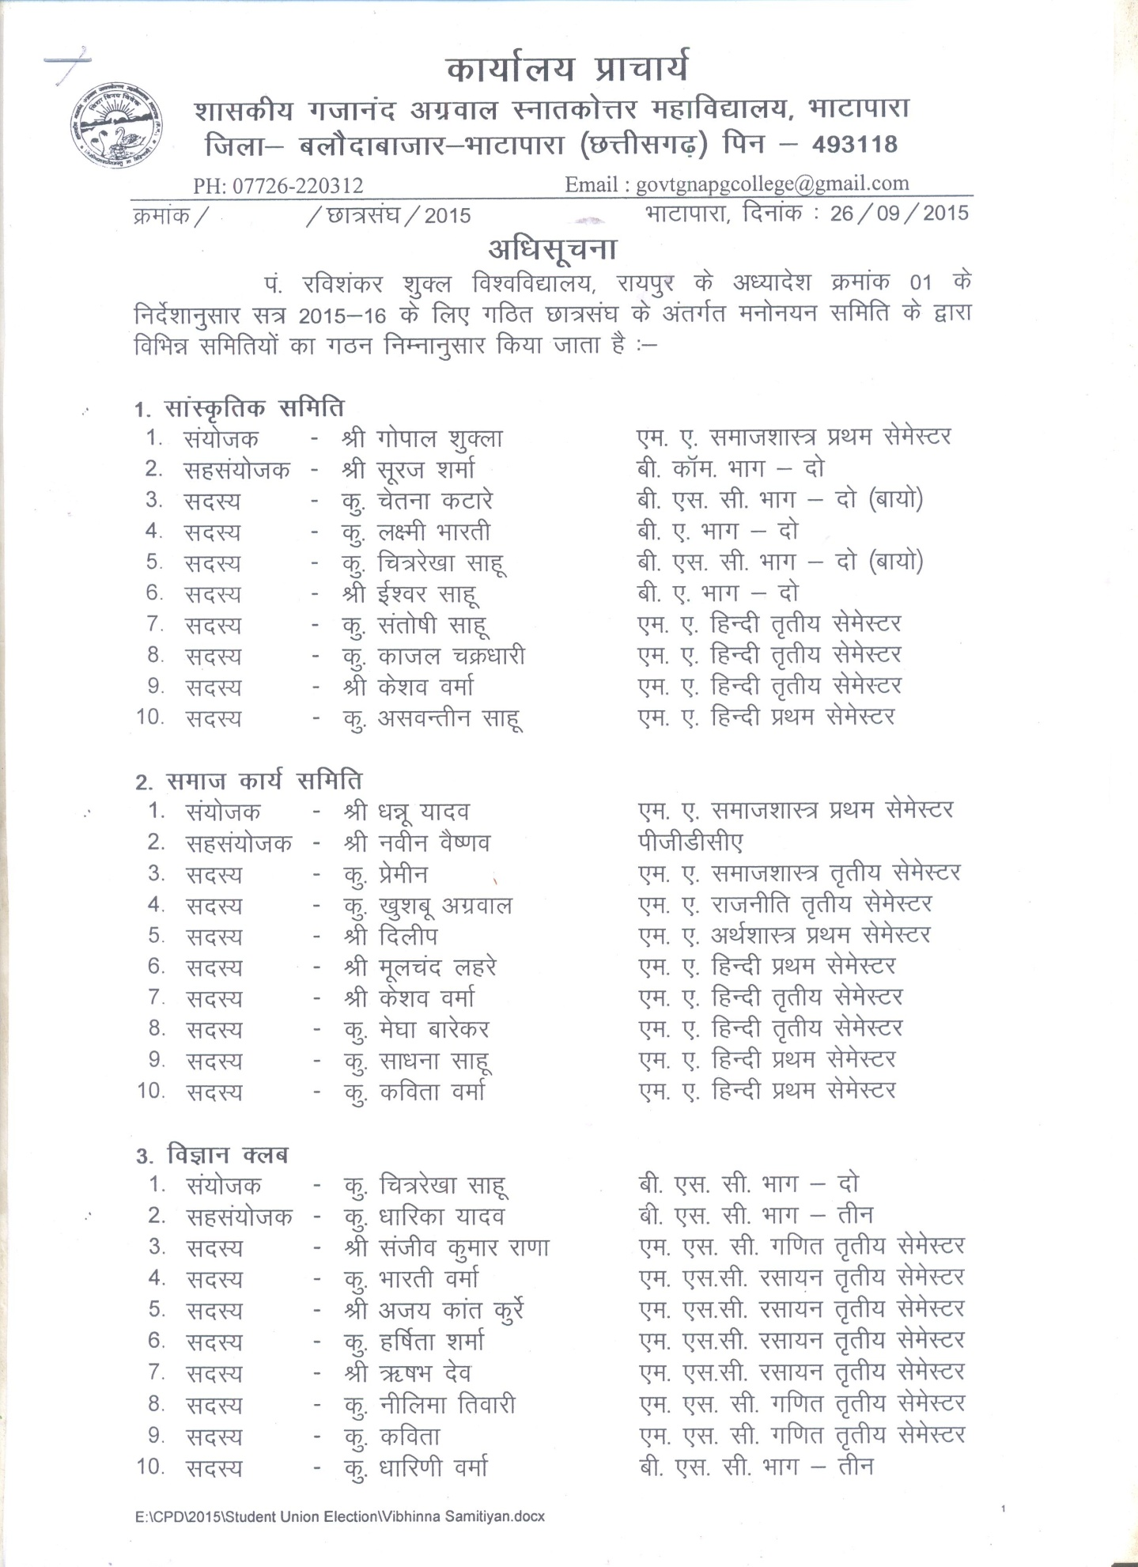

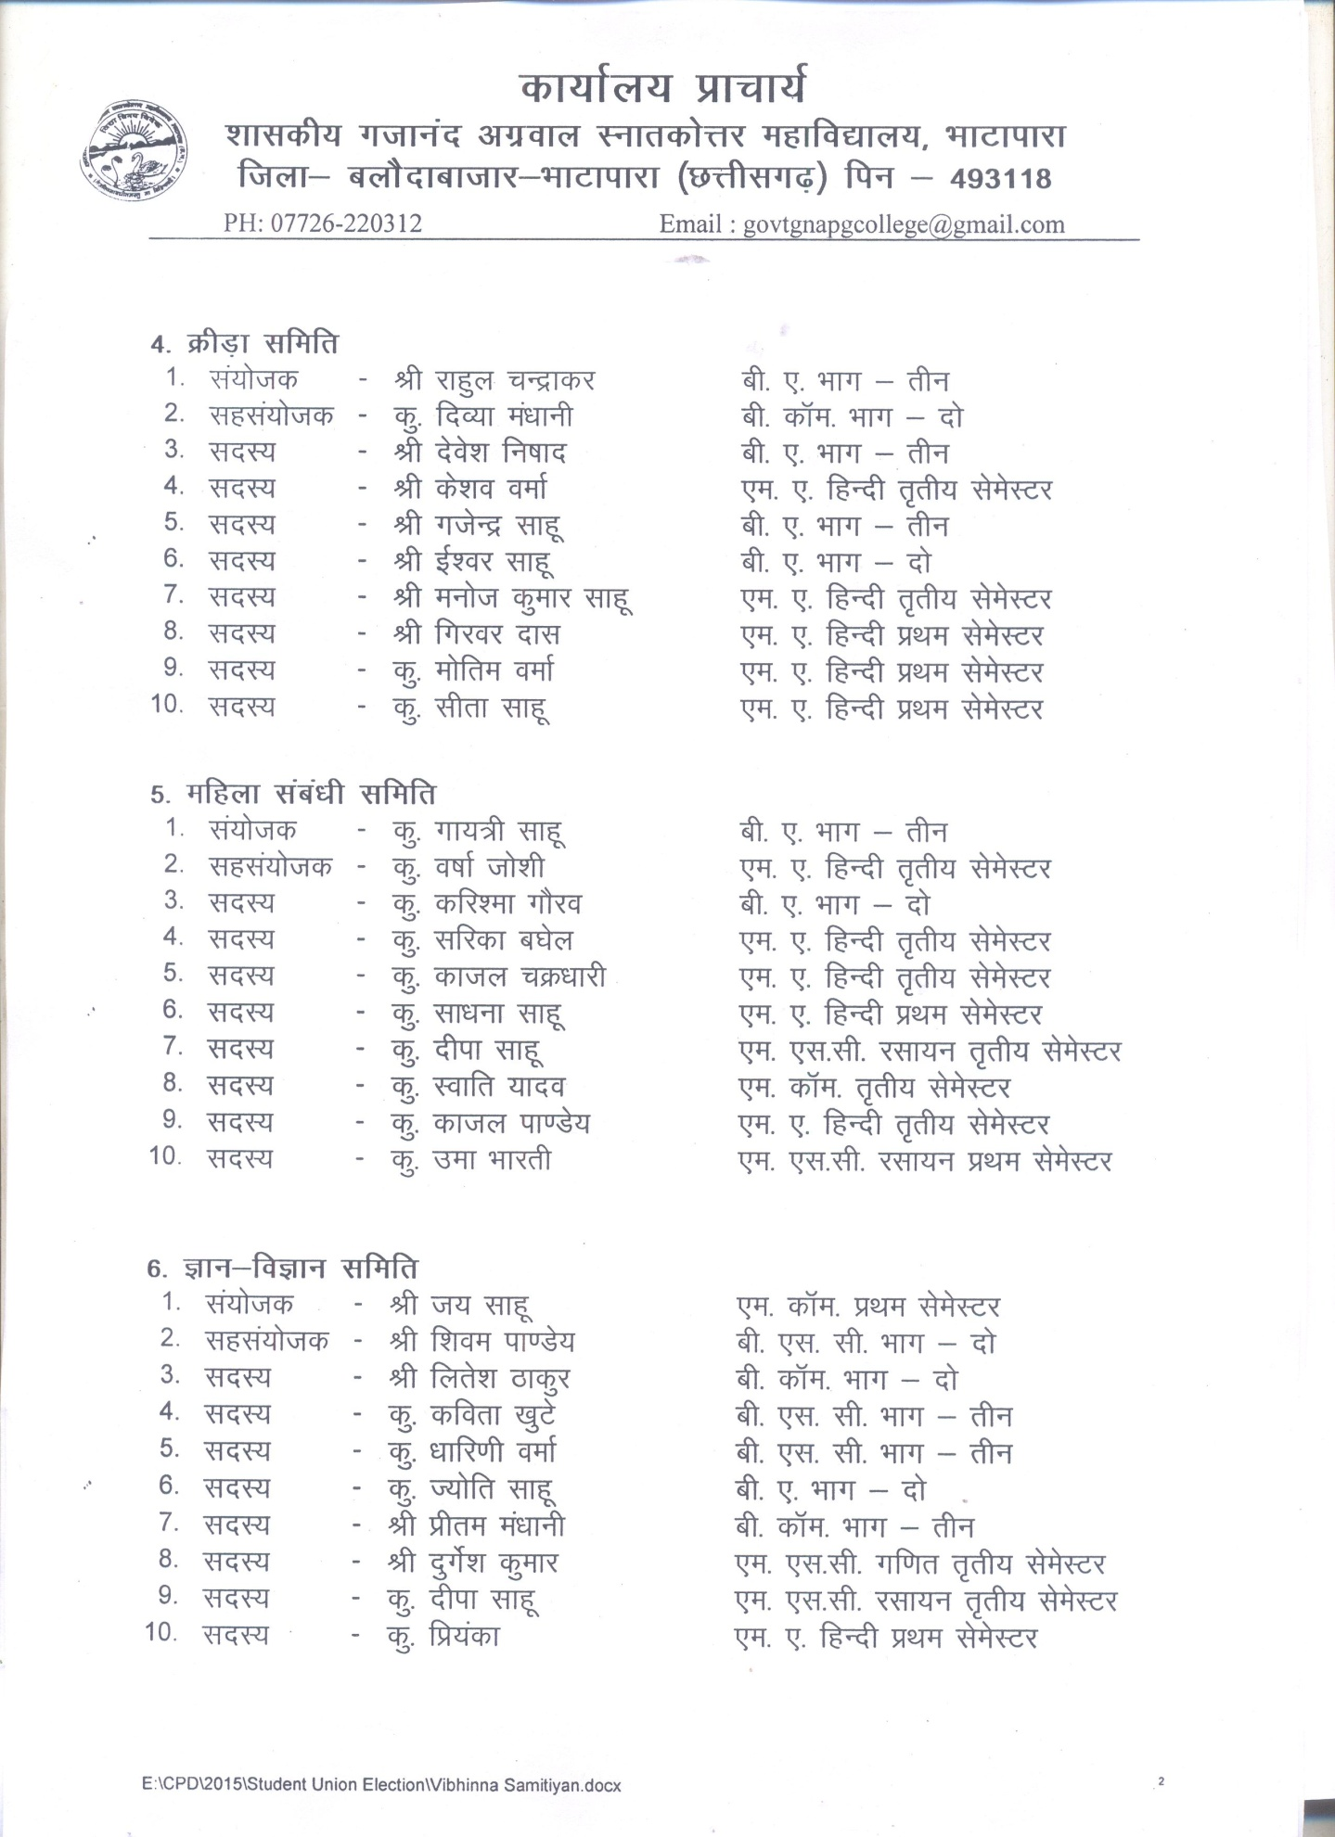

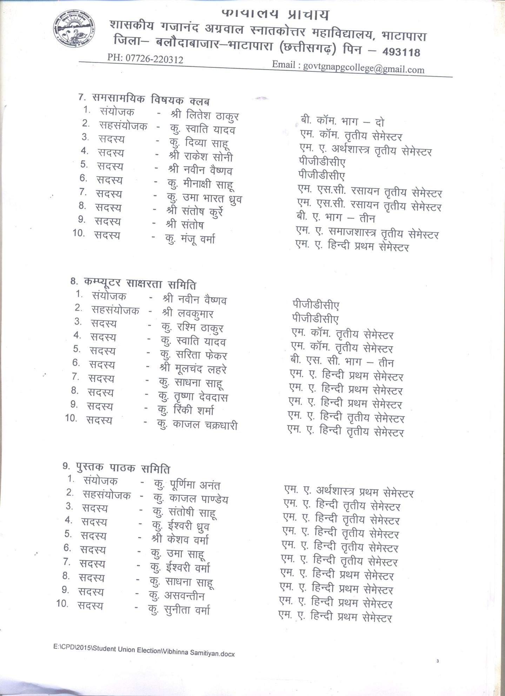

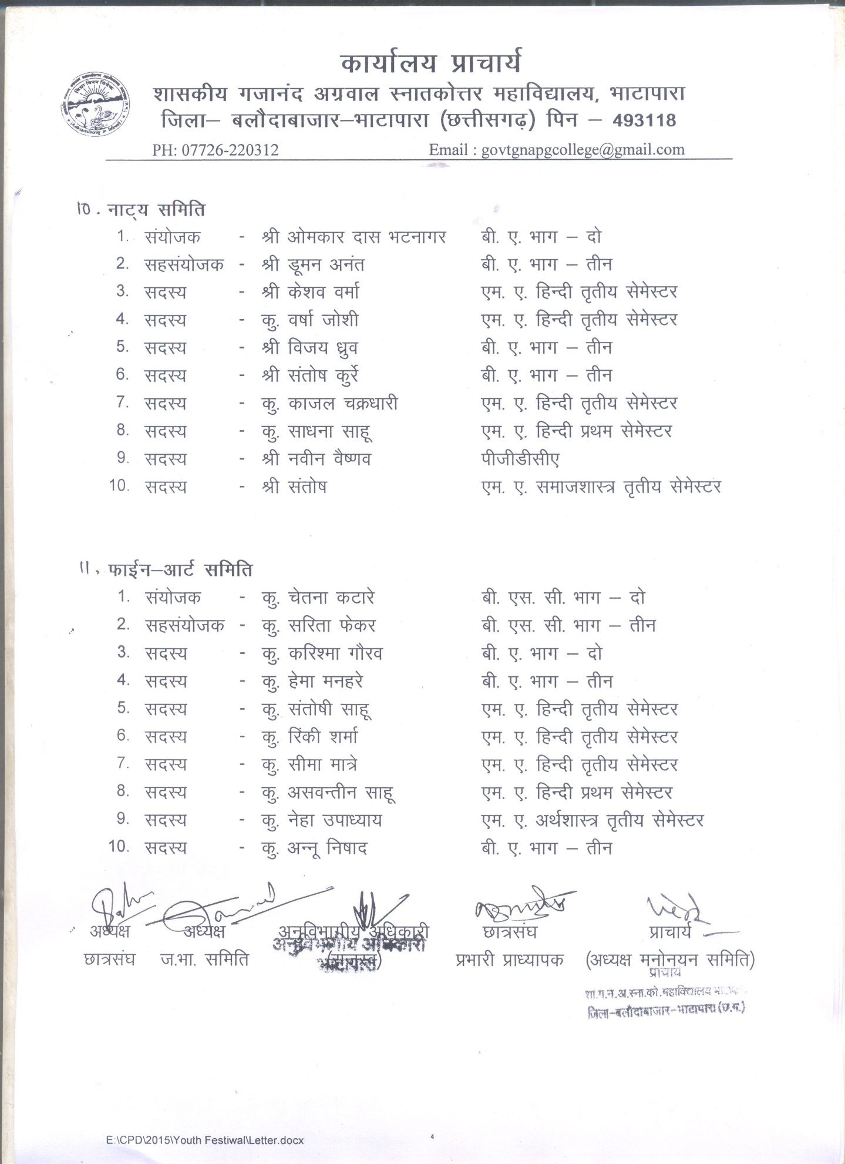

The college has constituted various academic & administrative bodies to conduct the entire achieving in which students representative has significant roles besides the student council. Students representative extend their views in meeting for academic enhancement, college development and problems and facilities for students. College administration deeply consider their suggestions and work for implementation.
5.3.7 How does the institution network and collaborate with the
Alumni and former faculty of the Institution.
- The institution invites the Alumni & former faculty of the institution to gain benefits of their experience for the development of college & students.
- We also arrange lecture of former faculty members for the students.

CRITERION VI: GOVERNANCE, LEADERSHIP AND MANAGEMENT

6.1 Institutional Vision and Leadership

6.1.1 State the vision and mission of the Institution and enumerate on how the mission statement defines the institution’s distinctive characteristics in terms of addressing the needs of the society, the students it seeks to serve, institution’s traditions and value orientations, vision for the future, etc.?
- Vision - As mention earlier our aim is to establish institution as center of excellence in all fields. It is very obvious from our college mono, in which the sentence “ tajaswinawadhitamastu ma vidvishavahai “ clearly indicates the institutional vision to be excellence along with the values.
- Mission – To groom the overall personality of students.
To improve the quality of responsibility in students.
To develop the feelings towards society.

6.1.2 What is the role of top management, Principal and Faculty in design and implementation of its quality policy and plans?
- Yes.

6.1.3 What is the involvement of the leadership in ensuring :

• the policy statements and action plans for fulfillment of the stated mission
- Through display boards and various programmes, college is trying to fulfill the statement of vision.
• formulation of action plans for all operations and incorporation of the same into the institutional strategic plan
- The institution tries strives for excellence and teaching and extracurricular activities. In past year students of college have got place in merit list of university. Students are awarded on annual day and on other significant vocation for other cultural activities for academic programmes with certificates and prizes.
• Interaction with stakeholders
- Meetings of Janbhagidari samiti are held time to time on various issues regarding improvement of the institution. Besides the principal, Staff also provide counseling to the students about various issues. These interaction help in ensuring the stakeholders participation to achieve the objective and goals.

6.1.4 What are the procedures adopted by the institution to monitor and evaluate policies and plans of the institution for effective implementation and improvement from time to time?
- For implementation of different policies different committees are formed by the principal .Committees work for the plans and their effective implementation and give report to head of the institution .For improvement suggestions are taken for next part

6.1.5 Give details of the academic leadership provided to the faculty by the top management?
- Faculties are kept free in academic field and for innovations proposed by them. Faculties are encouraged for doing research project, participate in seminars and conferences.

6.1.6 How does the college groom leadership at various levels?
- Various competitions are held to improve leadership quality at student level. Faculties are also given responsibilities of work with help of students and other staff members, Thus college provides platform for leadership through various events at local, state and national level.

6.1.7 How does the college delegate authority and provide operational autonomy to the departments / units of the institution and work towards decentralized governance system?
- College delegates authority to head of the department for academic work.

6.1.8 Does the college promote a culture of participative management? If ‘yes’, indicate the levels of participative management.
- Yes, institute promotes the culture of participative management by forming various committees including faculties, students and other stake holders.

6.2 Strategy Development and Deployment

6.2.1 Does the Institution have a formally stated quality policy? How is it developed, driven, deployed and reviewed?
- Yes, institution forms its quality policy through IQAC. In the meeting of IQAC quality policy is finalized and it is driven with the help of all stakeholders.

6.2.2 Does the Institute have a perspective plan for development? If so, give the aspects considered for inclusion in the plan.
- Yes, perspective plan includes the following expects –
- Teaching learning.
- Skill development
- Moral values
- Research and development.

6.2.3 Describe the internal organizational structure and decision making processes.
- Principal is the head of institution to take any decision bottom-up procedure is adopted in the institution as depicted in flow chart.

Principal

Incharge of various committees
HOD’S

Other faculties

Non teaching staff

Students

6.2.4 Give a broad description of the quality improvement strategies of the institution for each of the following
• Teaching & Learning
- Strategies to improve teaching and learning are – Teaching from audio visual medium, interaction, short project, are adopted in the institution.

• Research & Development
- The institute has been registered as research centre for Hindi only and trying for another. The institute encourages faculty for research projects and research activities.

• Community engagement
- Through NSS institute runs the programmes of awareness about literacy, health and hygiene, environment etc. in nearby locality.

• Industry interaction
- Students and faculties visit to industries and officials of industry also visit to college for campus selection.

6.2.5 How does the Head of the institution ensure that adequate information (from feedback and personal contacts etc.) is available for the top management and the stakeholders, to review the activities of the institution?
- Along with the written feed back head of the institution interact with particular randomly to get the reports of faculties and activities to ensure the adequacy of information.

6.2.6 How does the management encourage and support involvement of the staff in improving the effectiveness and efficiency of the institutional processes?
- The head of the institution ensures the involvement of staff in institutional processes by making committee and give responsibilities to them. After completing responsibility principal and staff analyze the work and try to remove mistakes in future.

6.2.7 Enumerate the resolutions made by the Management Council in the last year and the status of implementation of such resolutions.
- Resolutions of past year which have been done successfully are-
To create good academic atmosphere.
To celebrate golden jubilee year with active efforts.
To give the institution a conference hall.
To get achievements in academic as well as in extracurricular activities.

6.2.8 Does the affiliating university make a provision for according the status of autonomy to an affiliated institution? If ‘yes’, what are the efforts made by the institution in obtaining autonomy?
- Institutional target is to become centre of excellence with moral values. Then it will proceed for getting autonomy upto 2030.

6.2.9 How does the Institution ensure that grievances / complaints are promptly attended to and resolved effectively? Is there a mechanism to analyze the nature of grievances for promoting better stakeholder relationship?
- Committee is assigned complaint after grievances certain time period is given to committee to resolve the complaint to satisfy the student.

6.2.10 During the last four years, had there been any instances of court cases filed by and against the institute ? Provide details on the issues and decisions of the courts on these?
- No.

6.3 Faculty Empowerment Strategies

6.3.1 What are the efforts made by the institution to enhance the professional development of its teaching and non teaching staff?
- To develop the professional quality the teaching staff, faculties are sent for various orientation / refresher courses. In last two years nine faculties have been oriented and one has completed refresher course. Apart from this faculties have also been sent to attend various national/international seminars, Workshops to improve their professional quality.

6.3.2 What are the strategies adopted by the institution for faculty empowerment through training, retraining and motivating the employees for the roles and responsibility they perform?
- Institution organizes lectures of eminent personalities for faculty empowerment. The staff members are encouraged to participate in UGC sponsored capacity building programmes etc.

6.3.3 Provide details on the performance appraisal system of the staff to evaluate and ensure that information on multiple activities is appropriately captured and considered for better
appraisal.
- Performance based appraisal system is followed in the government colleges. Annually appraisal form is filled by every faculty with API marks which is checked and verified by the committee and sent to higher authorities for evaluation.

6.3.4 What is the outcome of the review of the performance appraisal reports by the management and the major decisions taken? How are they communicated to the appropriate stakeholders?
- Next senior scale of salary is sanctioned to faculty on getting the required API within a prescribed period.

6.3.5 What are the welfare schemes available for teaching and non teaching staff? What percentage of staff have availed the benefit of such schemes in the last four years?
- As per government rule partial concession to ward of college staff.

6.3.6 What are the measures taken by the Institution for attracting and retaining eminent faculty?
- Faculties are posted or transferred in the institution by order of state government but lectures of eminent facilities are organized and their valuable suggestions are also received by the college for improvement.

6.4 Financial Management and Resource Mobilization

6.4.1 What is the institutional mechanism to monitor effective and efficient use of available financial resources?
- The institution monitor the use of available financial resources with the help of internal audit committee which observes each and every purchasing and expenditure minutely.

6.4.2 What are the institutional mechanisms for internal and external audit? When was the last audit done and what are the major audit objections? Provide the details on compliance.
- The institute has both internal and external audit system.
Internal audit is done monthly were external audit is randomly done.

6.4.3 What are the major sources of institutional receipts/funding and how is the deficit managed? Provide audited income and expenditure statement of academic and administrative activities of the previous four years and the reserve fund/corpus available with Institutions, if any.
- The measure sources of institutional receipts and funding is from the
- directorate of higher education
- University Grant Commission.
- Rashtriya Uchchatar Shiksha Abhiyan
- Janbhagidari fund.

Required Information is Enclosed.
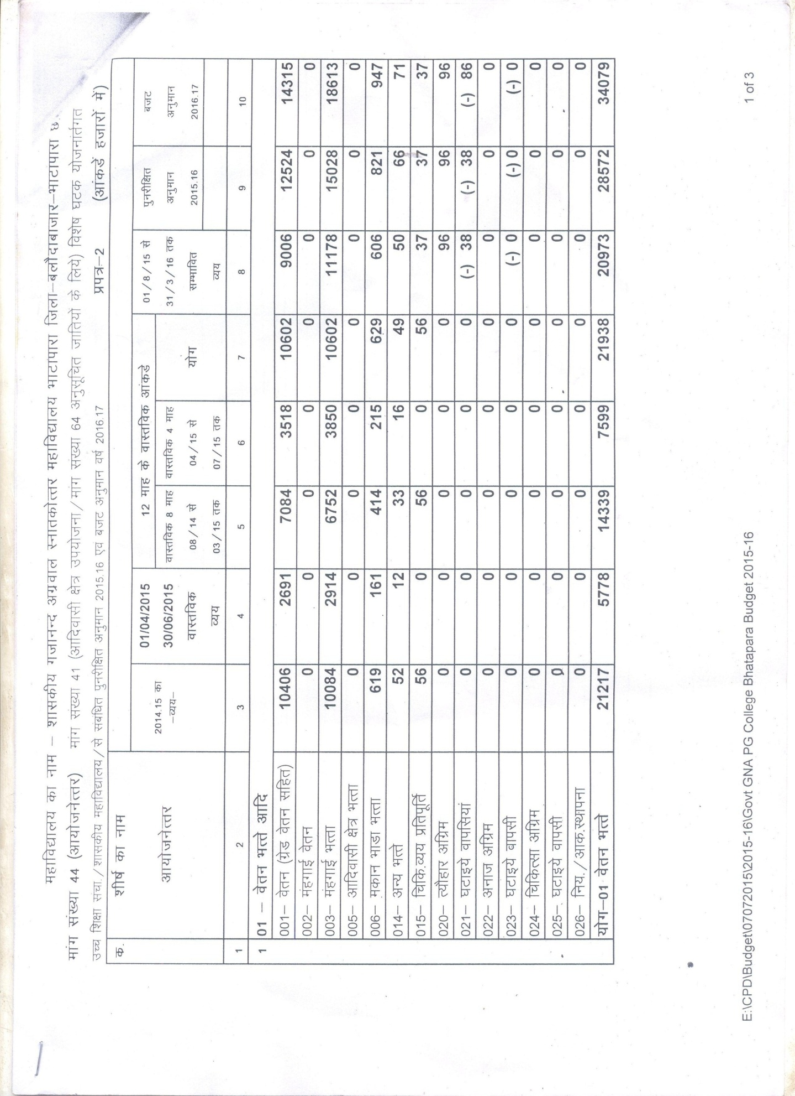

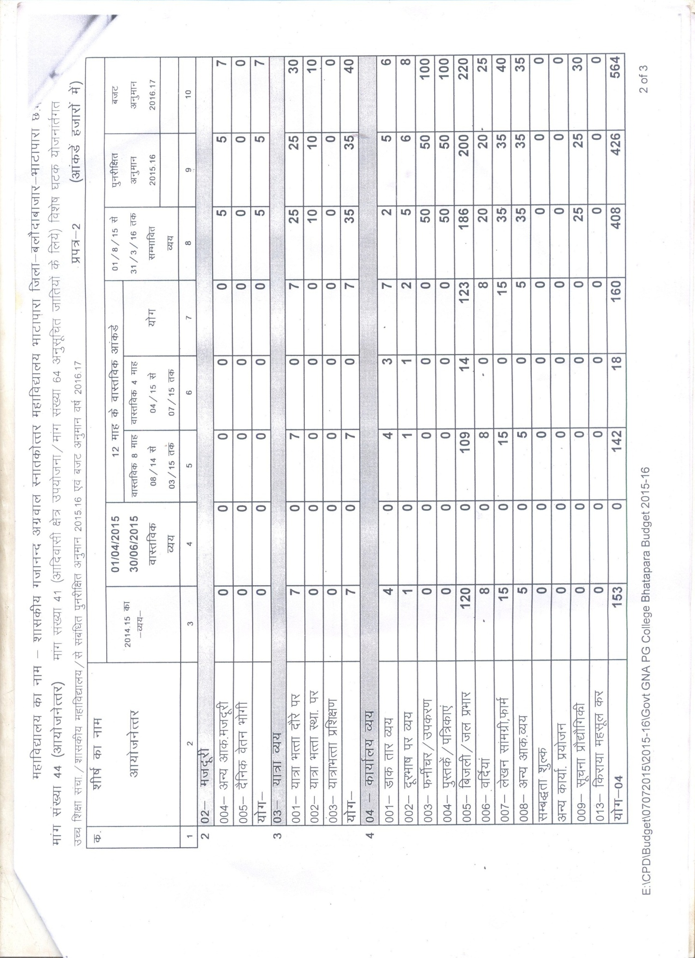

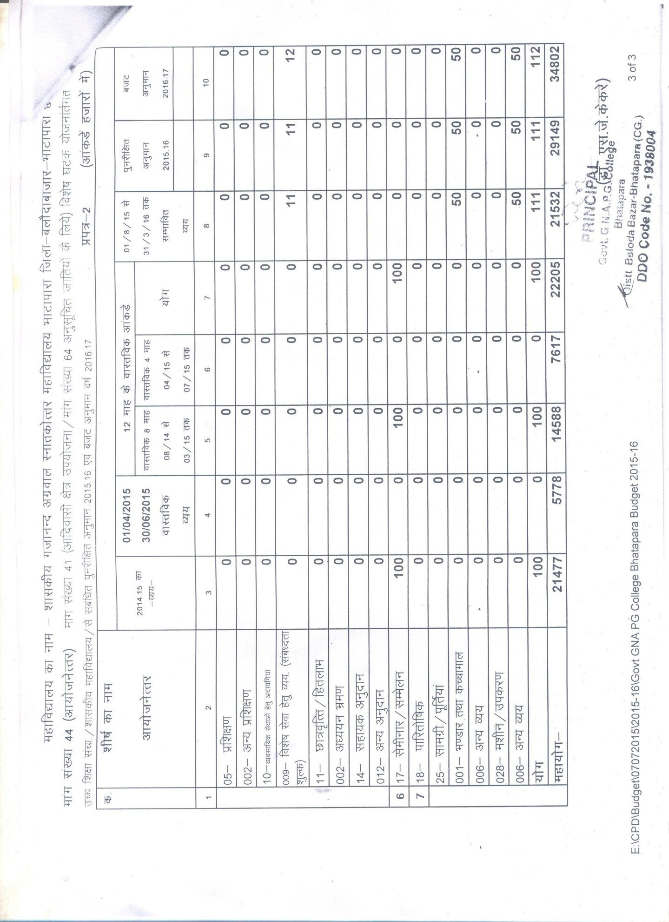

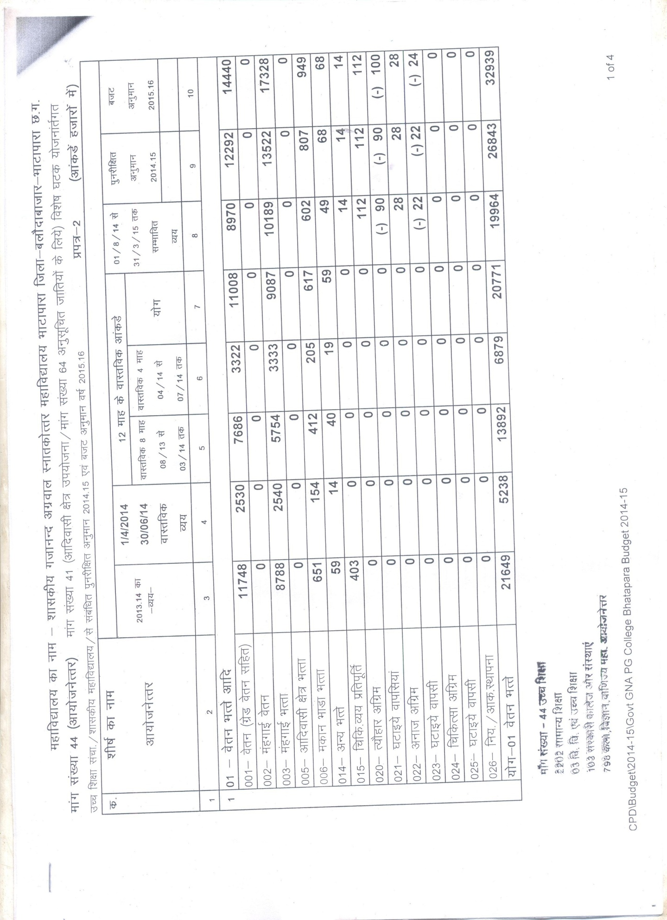

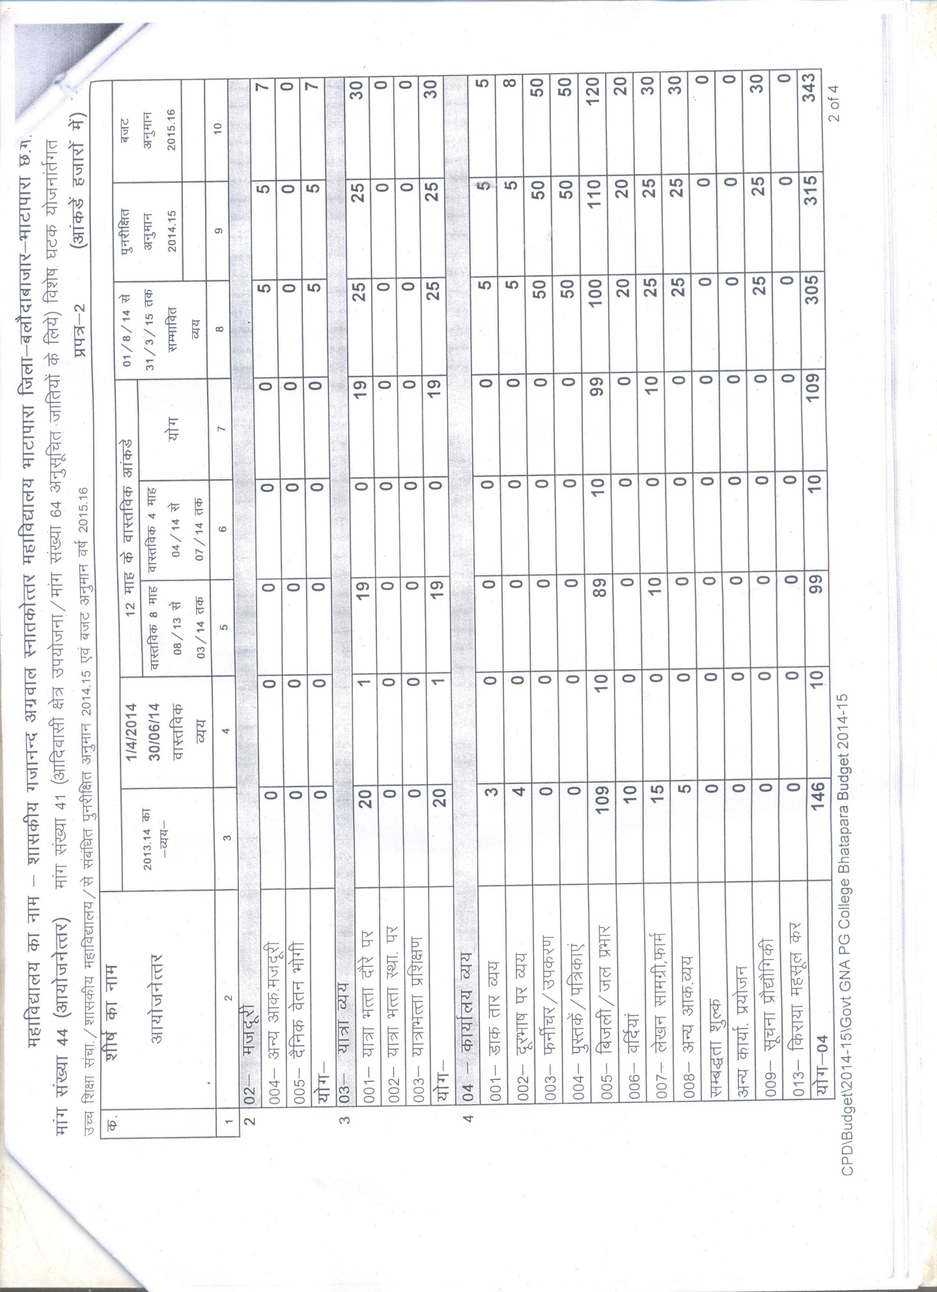

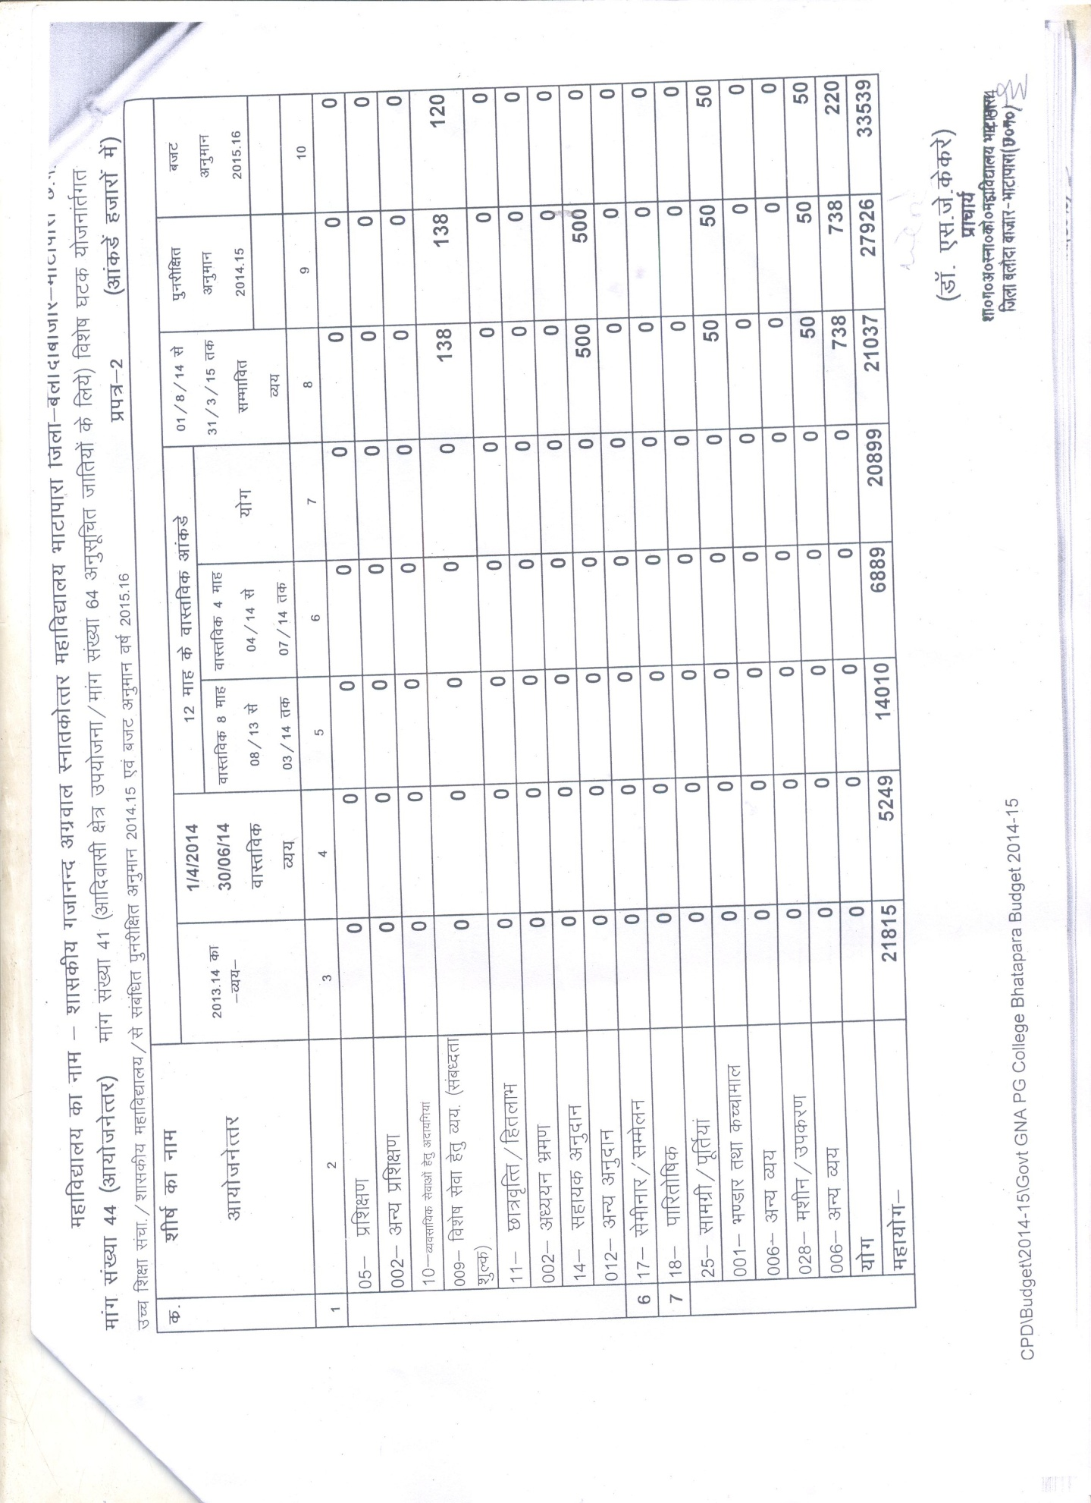

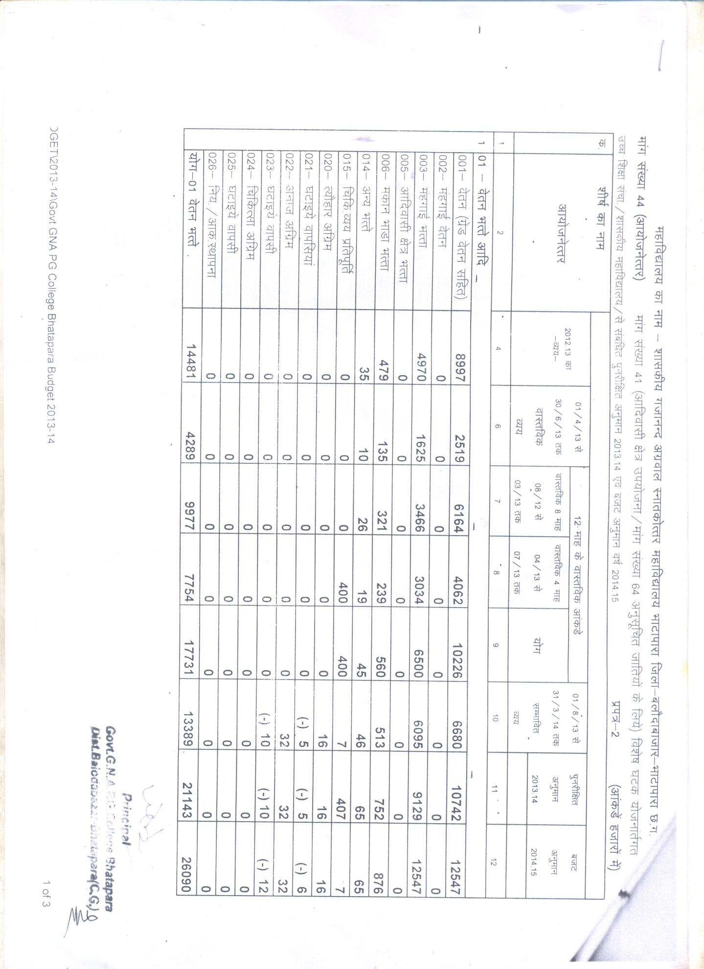

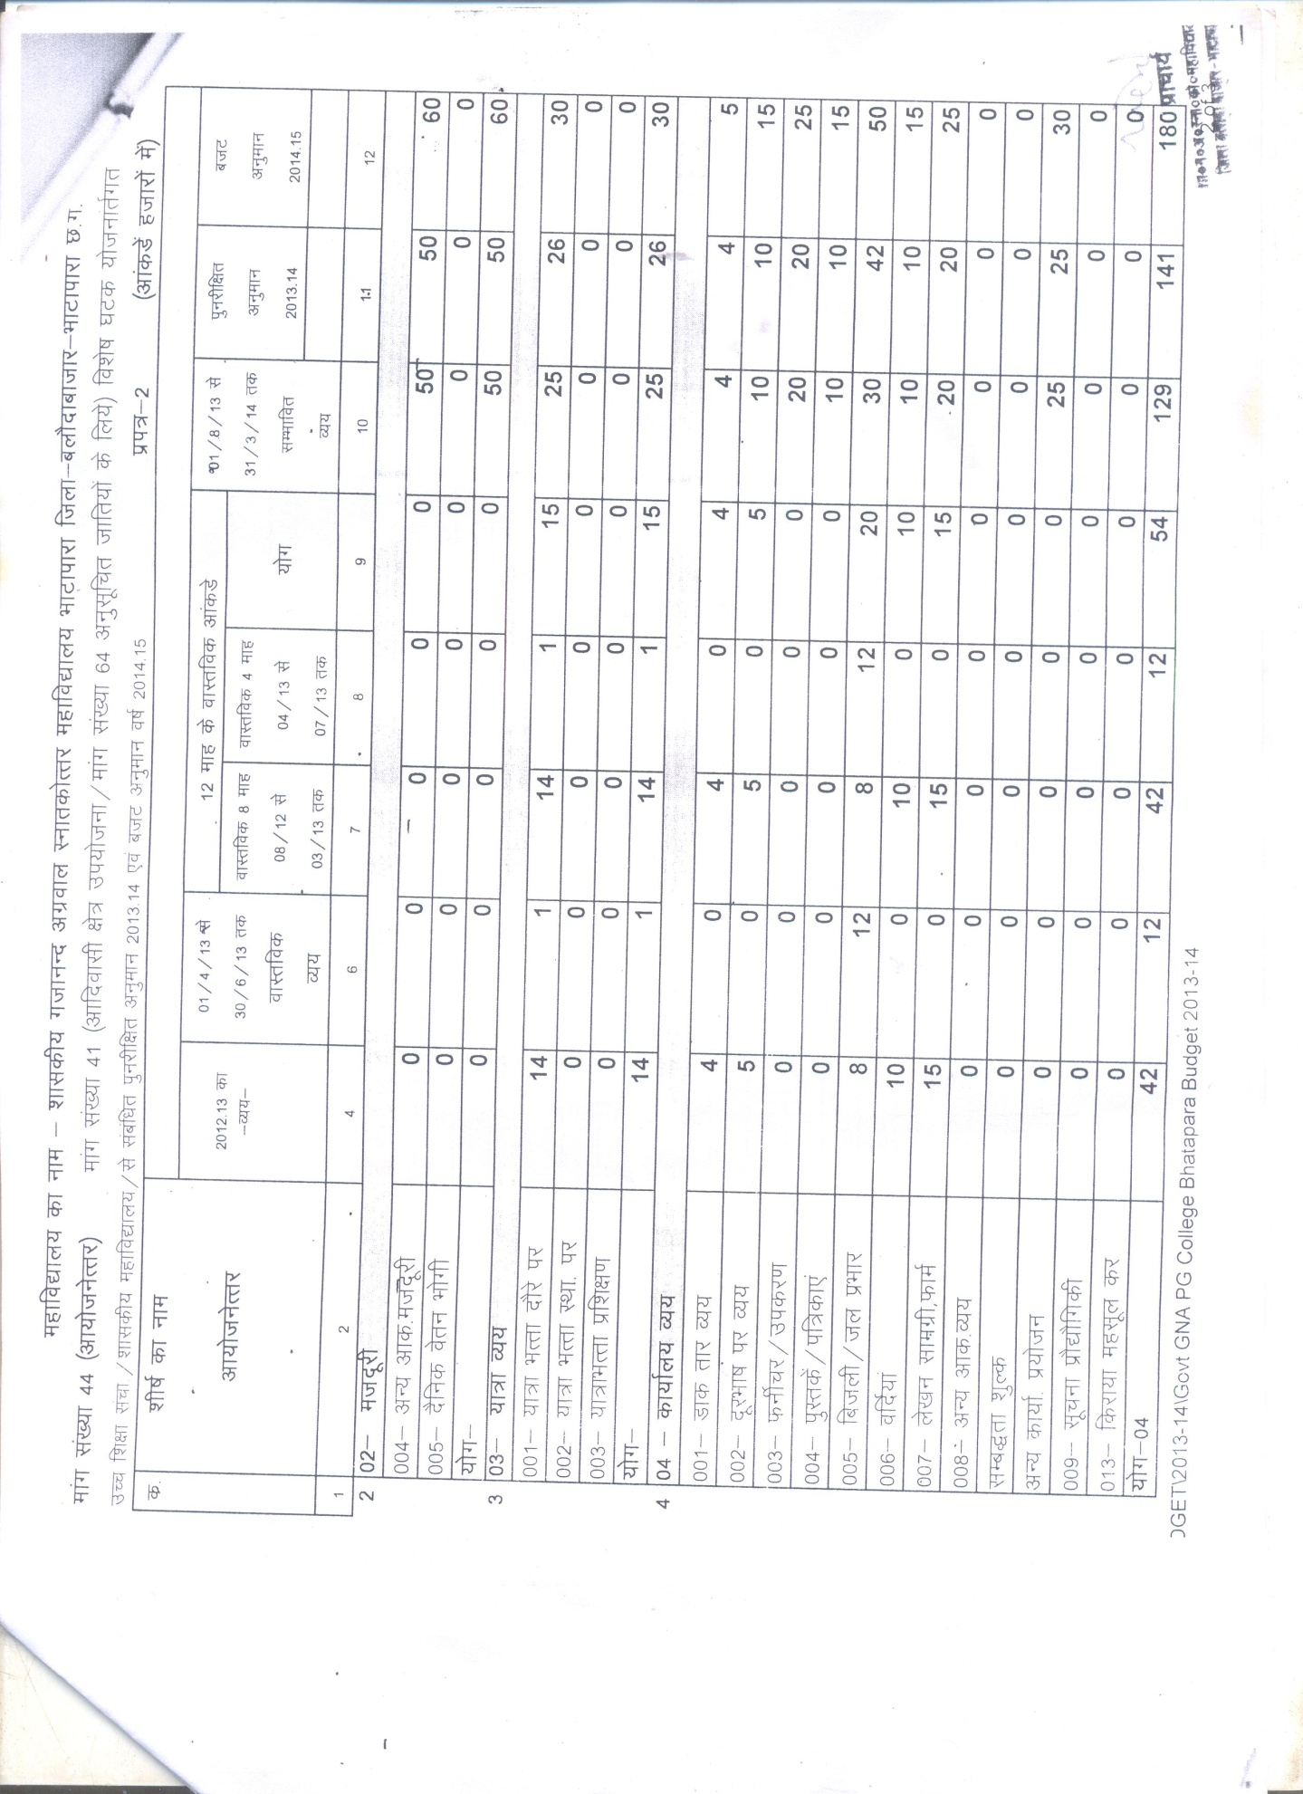

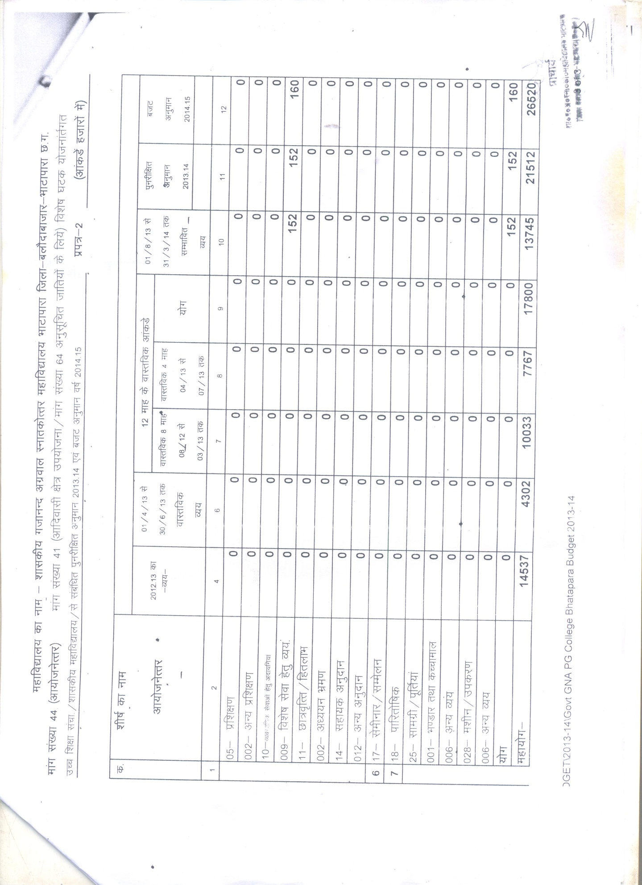

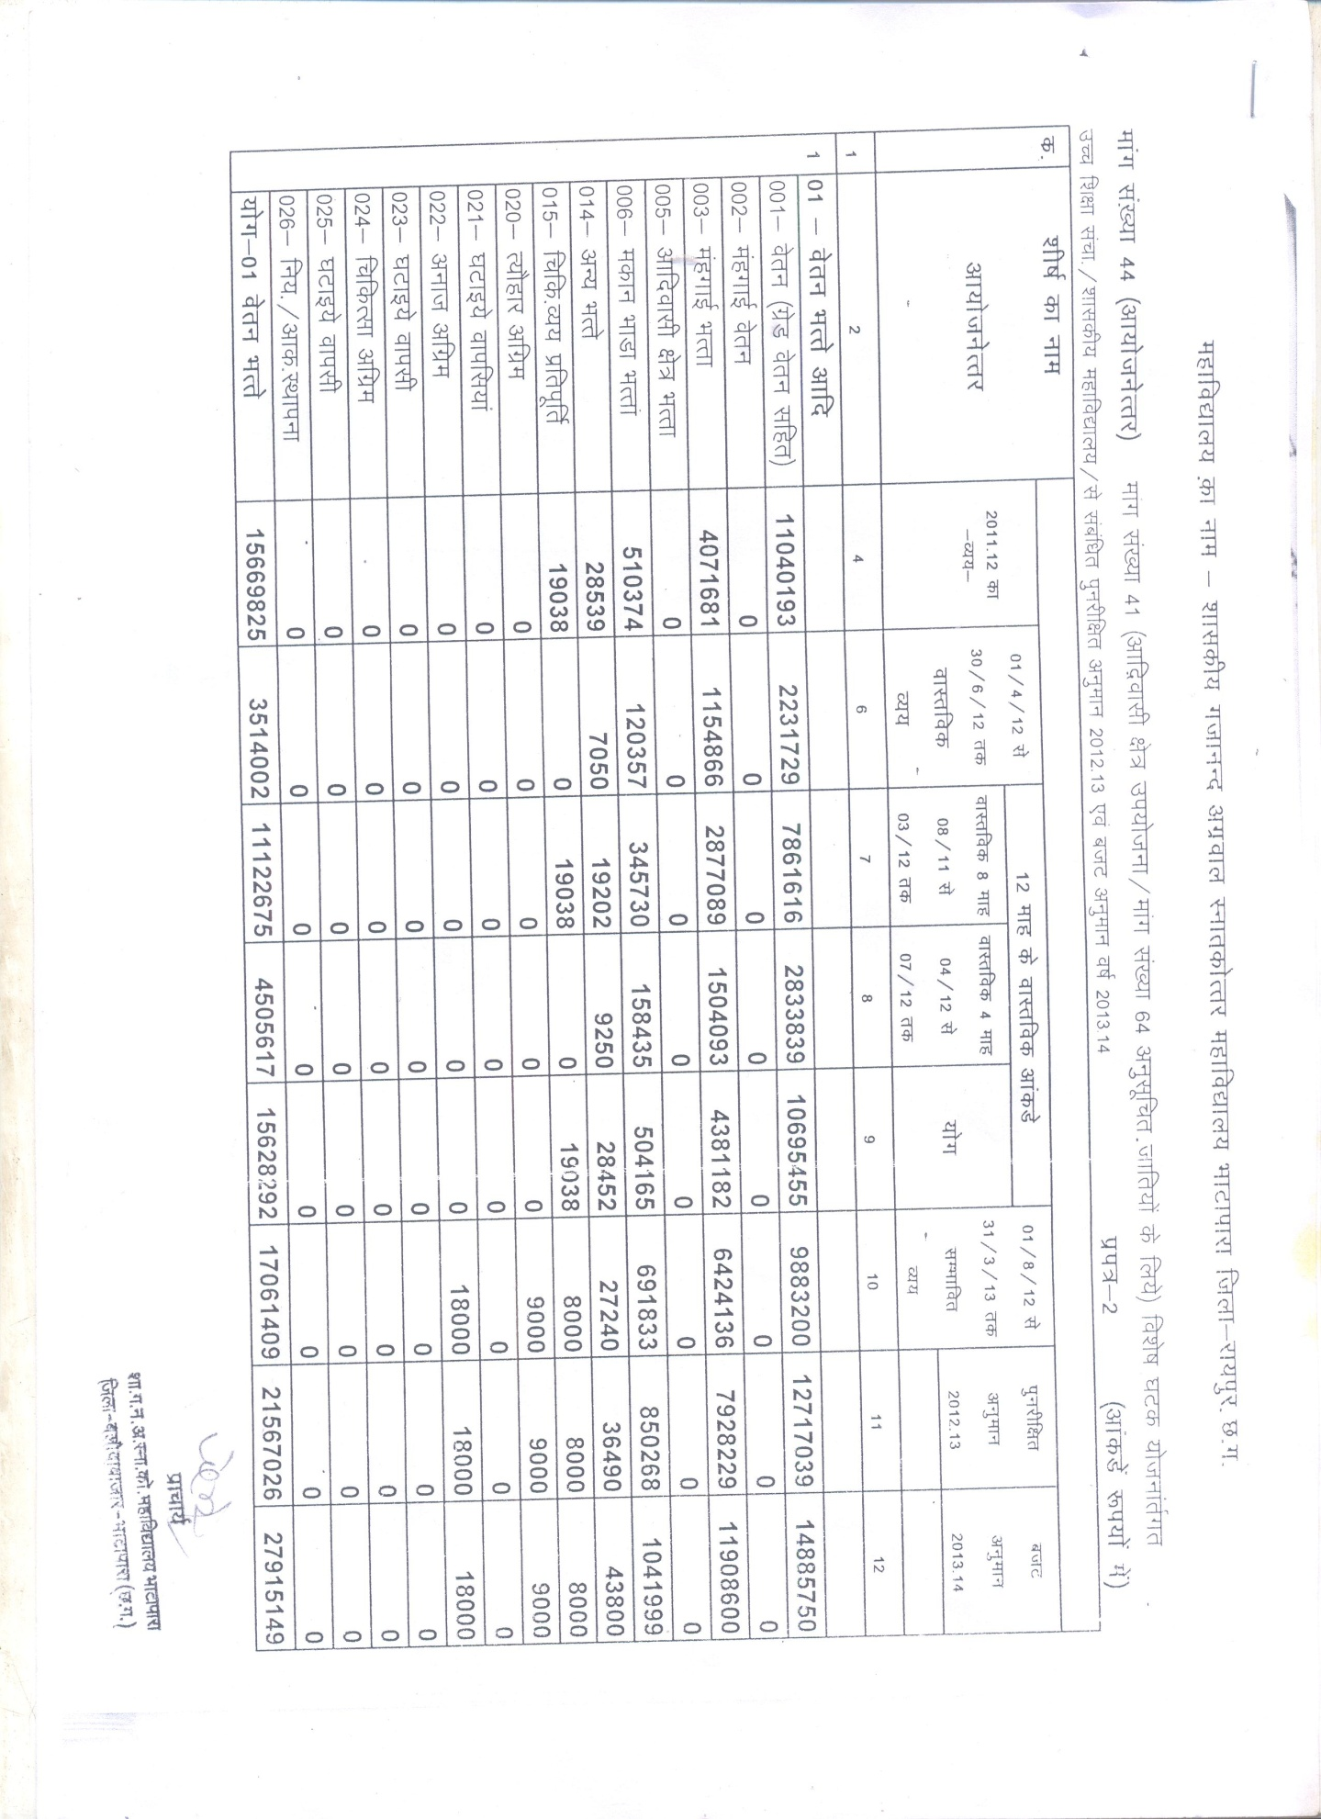

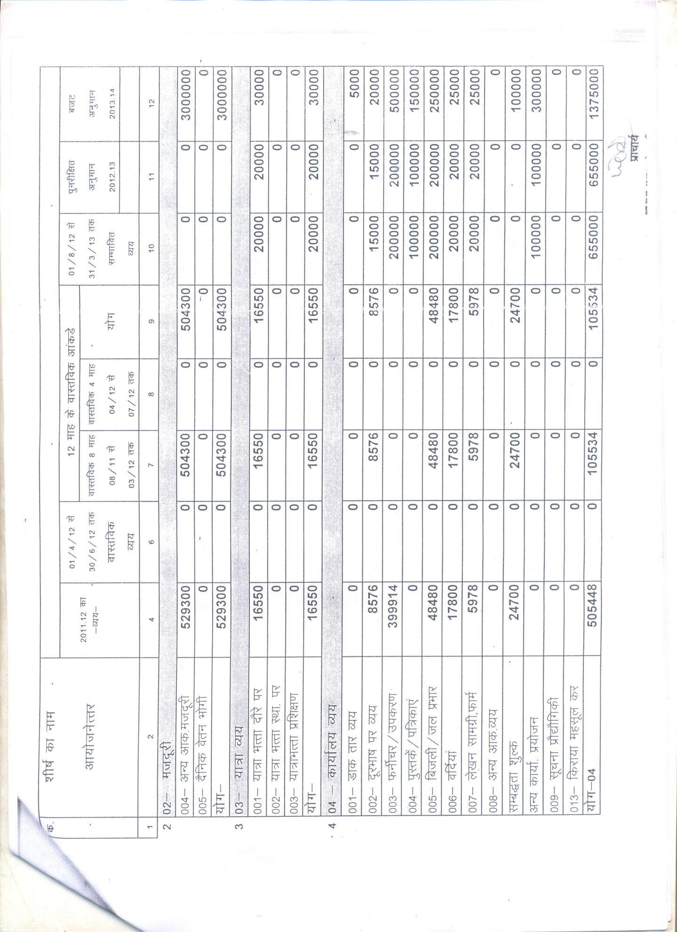

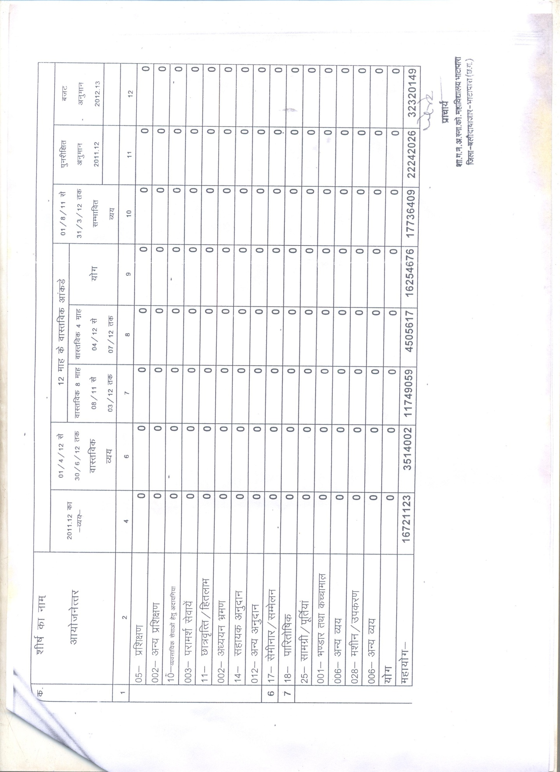

6.4.4 Give details on the efforts made by the institution in securing additional funding and the utilization of the same (if any).
- There is no other source of funding in the institution.

6.5 Internal Quality Assurance System (IQAS)

6.5.1 Internal Quality Assurance Cell (IQAC)

- Has the institution established an Internal Quality Assurance Cell (IQAC)? .6 If ‘yes’, what is the institutional policy with regard to quality assurance and how has it contributed in institutionalizing the quality assurance processes?
- Yes, the institute has establish Internal Quality Assurance Cell to improve the quality of institutional programme IQAC of our institution contributed in.
- Quality of education by ICT based classes / presentation.
- Research proposals of two department have been applied both are accepted and sanctioned.
- One minor research project have been started.
- Teachers of our institute help the students of nearby schools by taking class in the schools.
- Trying to tie-up with different industries / Job sectors for employing/ counselors of students.
- Feedback is taken regularly from the students alumni’s and parents.

- How many decisions of the IQAC have been approved by the management / authorities for implementation and how many of them were actually implemented?
- The IQAC committee is reformed at 03/07/2015 with all new members, two meetings have been done since the date no significant decision are taken, only minor suggestions have been approved by the management and by to implement as.
- For seminar and conference Hall.
- For different departments up gradation.
- For awareness of science invited lectures in all science departments.

c. Does the IQAC have external members on its committee?
If so, mention any significant contribution made by them.
- Yes, IQAC have external members is its committee, but there is no significant contribution yet.

- How do students and alumni contribute to the effective functioning of the IQAC?
- The students and alumni contribution is only in the implementation of suggestions given by the IQAC committee.

- How does the IQAC communicate and engage staff from different constituents of the institution?
- IQAC arranges for the meeting with the different constitutes of the institution periodically to convey them about their goals and engage them in different duties and direct them to support IQAC.

6.5.2 Does the institution have an integrated framework for Quality assurance of the academic and administrative activities? If ‘yes’, give details on its operationalisation.
- Yes, The institution have and integrated framework for quality assurance of the academic and administrative activities. It acts on –
- The promoting research among teachers and students by various extensive lectures from eminent scientists.
- To improve the infrastructure of college.
- Modernization of library.
- ICT application in teaching & learning.

6.5.3 Does the institution provide training to its staff for effective implementation of the Quality assurance procedures? If ‘yes’, give details enumerating its impact.
- No, institution does not provide training itself. But it sends the faculties in training programme like orientation, refresher, workshop, conference etc.

6.5.4 Does the institution undertake Academic Audit or other external review of the academic provisions? If ‘yes’, how are the outcomes used to improve the institutional activities?
- Self appraisal forms are submitted at the end of every year including academy and extracurricular activities. Which is checked and verified by the committee nominated.

6.5.5 How are the internal quality assurance mechanisms aligned with the requirements of the relevant external quality assurance agencies/regulatory authorities?
- IQAC works as per guidance of SQAC, which works on the policy of the state.

6.5.6 What institutional mechanisms are in place to continuously review the teaching learning process? Give details of its structure, methodologies of operations and outcome?
- IQAC monitors the academic quality through feedback and proposes suggestive measures for academic policies of particulars. Besides this teaching learning is continuously reviewed by monthly unit tests and pre examination tests.

6.5.7 How does the institution communicate its quality assurance policies, mechanisms and outcomes to the various internal and external stakeholders?

- Any other relevant information regarding Governance
Leadership and Management which the college would like to include.

CRITERIA VII: INNOVATIONS AND BEST PRACTICES

7.1 Environment Consciousness

    - Does the Institute conduct a Green Audit of its campus and facilities?
- Yes, The institute conduct a green audit by maintaining Greenery all over and around the Campus.
- A Big Lush garden garden have been created and maintained.
- Department of Botany also proposed a Botanical garden ,which is in progress in the campus .
- At present several species of plants, including a large number of trees and many species of flowering & ornamental plants/medicinal plants are also planted inside the campus.
- Periodically the plantation programme is undertaken by the NSS and staff members jointly.

7.1.2 What are the initiatives taken by the college to make the campus eco-friendly?
∗ Energy conservation
- Use of LPG gas in Laboratories instead of kerosene gas.
- Light and fan switches are made off in class rooms immediately after the class.
- Use of ISI mark electrical appliances and electronic instruments / apparatus .
- Use of LED bulbs.

∗ Use of renewable energy
- Rain water Harvesting system is proposed.
- Proposal for Solar panel had been sent to RUSA.

∗ Water harvesting
- Proposed

∗ Check dam construction
- Nil

∗ Efforts for Carbon neutrality
- No Smoking Zone, making aware by Messages and Display in the Institute.
- Strict Ban in the use of Polythene.
- Replacing Use of LED bulbs instead of tubes and Bulbs.

∗ Plantation
- Regular plantation in the campus by NSS volunteers and staff members under active supervision of professors.

∗ Hazardous waste management
- All Hazardous Materials from the Laboratories and Institute are been Disposed n treated properly.

∗ e-waste management
- All Hazardous Materials from the Laboratories and Institute are been Disposed n treated properly.
- CD’s And Floppy Disk are properly disposed.
- Tubelights ,bulbs etc. are dumped ia a proper manner.

7.2 Innovations

    - Give details of innovations introduced during the last four years which have created a positive impact on the functioning of the college.
- The college organizes blood donation camp once in a year, previous year nearly 50 units of blood is donated by faculty and students of the institute.
- The college provides free health check up for the students and the faculty twice.
- To raise the knowledge level of school students the teachers of our institute teaches in the near by schools.
- Vedic maths classes are provided the institute to the students.
- NET/PSC coaching classes are going on in the institute.
- Regular spoken English classes are taken by the department of English in the Institute.
- Placement cell provides counseling and placement to the students and has tie-up with near by industries bank and offices.
- Lecture method is supplemented with the seminar through power-point presentation by the faculties.
- Seminar through power-point presentation by the students of post graduation as speakers.

7.3 Best Practices

7.3.1 Elaborate on any two best practices in the given format at page no. 98, which have contributed to the achievement of the Institutional Objectives and/or contributed to the Quality improvement of the core activities of the college.
- The institute is trying to make the student perfect in life skills moral values, ethics, competency, to stand by own business or job opportunities into face the outer world with their skills and knowledge.
- Assistance to financially weaker students- The students of ST/SC and OBC classes get the scholarship from the government but there is no provision of any help for the financially weak students of unreserved category. Therefore all the teachers of the college collect RS 1000/- Each and help those students of unreserved class who are willing to study but lack of money became and obtained in their way. Needy students are given financial aid through students welfare fund of they are allowed to pay fees in installation.

1. Title of the practice: Free Spoken English Classes
2. Goal: Free Spoken English Classes are held :
- To meet the changing needs of the time.
- To boost the confidence of the students.
- To train the students to appear in the interviews confident.
- To improve students’ performance in various tests as well as interviews and thereby to make a successful career.
- To help students communicate effectively.
3. The context: As the students in the college come from the rural areas and hesitate in speaking English, they leg behind because of their hesitation. Even after having talent, they do not get desired success in this cut throat competition of the world. Viewing this point, English department organizes free spoken English classes from time to time. In the spoken English classes, the focus is to teach effective communication skills. A good and attractive resume is the best key to get a job therefore the students are taught to prepare their resume. This resume creates a very good first impression of students which is also regarded to be last impression. The students are also taught interview skills. The students also learn the group behavior they learn etiquettes to behave in a group. Thus the students are taught to face the challenges of the corporate sector.
4. The practice: Viewing the need of the hour, the department of English organizes English Classes from time to time. It has been giving the training since 2013-14 session. The classes are open for all, irrespective of any class, stream or college. The department circulates a notice among the students before starting the classes. If possible the department gets a press release published in the new paper.
The willing students have to fill a registration form. After filling the form students get registered. We teach them through various methods. They are taught through two way communication. They have to appear in the group discussion. They are also given power point presentation. At the end of the course, a test is conducted to evaluate their learning.
5.Evidence of success: It is true that hard work always leads to success. This is also true in case of free spoken English classes of our college. Extempore, Group Discussion boosts up the confidence of the students. They become more confident in their interaction with peers.there can be observed a clearly discernible difference in the knowledge and confidence of students from the first and the last day of classes. After starting spoken English classes the pass percentage of students has increased to a great extent. When the classes were started for the first time, only a few students got registered but in every next class the number of students is increasing. The students have become more interactive. Now the students are desirous to do post graduation in English literature after attending these classes. In the session 2014-15 when PG in English started in college, ten students sought admission immediately in English Literature and in the session 2015-16, 39 applications were received for admission in PG in English and 28 student got admission.

6.Problems Encountered and Resources Required: As most of the students are from nearby rural areas, they feel hesitation in speaking English. Even after knowing the answer, they have shame in speaking publicly. Initially the students do not make active communication with the teacher and it becomes a one way communication. In this class, the students of all classes get registered. As the attendees may be senior or junior to one another, sometimes there works superiority or inferiority complex among them. They have a psychological fear and are reluctant or hesitant to speak before others. They have a fear to be mocked at in case of any mistake. Thus in the starting classes first we have to make hard attempts to remove their hesitation and superiority or interiority complex. They have to be made believe that in such type of classes, all are at the learning stage. Only after this type of motivation to the students, they become free and friendly in the classroom and the two-way communication is possible.
Such type of classes cannot be held always due to the lack of faculty members and fund. If we wish to increase the number of classes, we will have to arrange some trainer from outside. This will need fund to pay that visitor.

7. Contact Details
Name of the Principal : Dr.S.J.Kekre
Name of the Institution: Govt. G.N.A.P.G. College Bhatapara.
City: Bhatapara
Pin Code: 493118
Accredited Status: First Cycle
Work Phone : 07726220312 Fax: 07726220312
Website: www.gnapgcollege.com E-mail : govtgnapgcollege@gmail.com
Mobile: 9827877895, 9098580128

1. Title of the practice: Extra Income Generation.
2. Goal:
- To train the students to new techniques of farming.
- To improve students’ skill in livelihood.
- To help students learn & earn
- To meet the changing demand of the time.
- To get their families benifit.

3. The context: The farmers of Chhattisgarh cultivates only rise and pulses and there is lack of information about this type of cultivation. Moringa is a costly crop in the local market and can be good source of income. As moringa can be grown twice in a year in the season of spring and summer. The production cast is very low and transportation easy and as the institute located in rural area so the farmers an our students can learn about the benefits.
4. The practice: To earn the goal for the extra income for the institute following steps have been taken-
- Over more than hundred seeds of moringa were collected from different resources and sown in a particular area decided for the cultivation of moringa in the campus.
- For more than three months proper care is taken some time to time.
- Insecticides, fertilizers are added periodically.
- After six months fruitful results are obtained.
5.Evidence of success: During the project work we have taken photographs and maintain the documents as –
- Sowing of seeds.
- New emerging plants.
- Full length trees.
- Cultivated crop of moringa.
- While selling in the market.
- Record of collecting resources.
- Record of maintenance and fertilizers used.
- Record of income.
6.Problems Encountered and Resources Required: During the project work the following resources are required –
- Books and Journals.
- Equipments
- Seeds and fertilizers.
- Labour & Time
Problems encountered are –
- Decaying of seeds.
- Decaying of small seedlings.
- Change of climate.
- Lack of Financial facility.
- Lack of labour and time.

7. Contact Details
Name of the Principal : Dr.S.J.Kekre
Name of the Institution: Govt. G.N.A.P.G. College Bhatapara.
City: Bhatapara
Pin Code: 493118
Accredited Status: First Cycle
Work Phone : 07726220312 Fax: 07726220312
Website: www.gnapgcollege.com E-mail : govtgnapgcollege@gmail.com
Mobile: 9827877895 , 9098580128

3. Evaluative Report of the Departments

Postgraduate Department

- MATHS
- CHEMISTRY
- SOCIOLOGY
- ENGLISH
- ECONOMICS
- POLITICAL SCIENCE
- HINDI
- COMMERCE

Undergraduate department

- BOTANY
- ZOOLOGY
- PHYSICS
- HOME SCIENCE
- HISTORY

Department of the Mathematics

1. Name of the department - MATHEMATICS

2. Year of Establishment - 1982

3. Names of Programmes / Courses offered (UG, PG, M.Phil., Ph.D., Integrated
Masters; Integrated Ph.D., etc.) – UG & PG programmes.

4. Names of Interdisciplinary courses and the departments/units involved – Computer programme in PG

5. Annual/ semester/choice based credit system (programme wise) – Annual exam in UG & Semester system in PG

6. Participation of the department in the courses offered by other departments - Nil

7. Courses in collaboration with other universities, industries, foreign institutions, etc. - Nil

8. Details of courses/programmes discontinued (if any) with reasons - Nil

9. Number of Teaching posts

 | Sanctioned | Filled
Professors | 01 | Nil
Associate Professors | - | -
Asst. Professors | 02 | 01
10. Faculty profile with name, qualification, designation, specialization, (D.Sc./D.Litt.
/Ph.D. / M. Phil. etc.,)

Name | Qualification | Designation | Specialization | No. of Years of Experience | No. of Ph.D.  Students  guided for the  last 4 years
Manisha Gupta | M.Sc, M.phil. | Asst.Professor Regular | Algebra | 8 Years | -
Ku.Demin verma | M.Sc. | Guest faculty |  |  | -
Anjali Sharma | PG | Janbhagidari |  |  | -

11. List of senior visiting faculty – 01 Dr.P.Jha

12. Percentage of lectures delivered and practical classes handled(programme wise)
by temporary faculty - UG : 60%
PG : 50%

13. Student -Teacher Ratio (programme wise) – 60:1 for UG Programme
25:1 for PG programme

14. Number of academic support staff (technical) and administrative staff; sanctioned and filled – Nil

15. Qualifications of teaching faculty with DSc/ D.Litt/ Ph.D/ MPhil / PG. – M.phil

16. Number of faculty with ongoing projects from a) National b) International funding agencies and grants received – Nil

17. Departmental projects funded by DST - FIST; UGC, DBT, ICSSR, etc. and total grants received – Nil

18. Research Centre /facility recognized by the University – Nil

19. Publications: - Nil

∗ a) Publication per faculty

∗ Number of papers published in peer reviewed journals (national /
international) by faculty and students
∗ Number of publications listed in International Database (For Eg: Web of Science, Scopus, Humanities International Complete, Dare Database - International Social Sciences Directory, EBSCO host, etc.)

∗ Monographs

∗ Chapter in Books

∗ Books Edited

∗ Books with ISBN/ISSN numbers with details of publishers

∗ Citation Index

∗ SNIP

∗ SJR

∗ Impact factor

∗ h-index

20. Areas of consultancy and income generated – Nil

21. Faculty as members in - Nil

a) National committees b) International Committees c) Editorial
Boards….

22. Student projects – Nil

a) Percentage of students who have done in-house projects including inter departmental/programme

b) Percentage of students placed for projects in organizations outside the institution i.e.in Research laboratories/Industry/ other agencies

23. Awards / Recognitions received by faculty and students – Nil

24. List of eminent academicians and scientists / visitors to the department – Nil

25. Seminars/ Conferences/Workshops organized & the source of funding – Nil
a) National
b) International

26. Student profile programme/course wise: - Nil

Name of the Course/programme (refer question no. 4) | Applications received | Selected | Enrolled |  | Pass percentage
 |  |  | *M | *F

*M = Male *F = Female

27. Diversity of Students

Name of the  Course | % of students from the same state | % of students from other States | % of students from abroad
B.Sc - I | 100% | - | -
B.Sc - II | 100% | - | -
B.Sc – III | 100% | - | -
M.Sc- I sem | 100% | - | -
M.Sc- III sem | 100% | - | -

28. How many students have cleared national and state competitive examinations such as NET, SLET, GATE, Civil services, Defense services, etc.? – Nil

29. Student progression

Student progression | Against % enrolled
UG to PG | 62.60%
PG to M.Phil. | -
PG to Ph.D. | -
Ph.D. to Post-Doctoral | -
Employed  • Campus selection  • Other than campus recruitment | -
Entrepreneurship/Self-employment | -

30. Details of Infrastructural facilities
a) Library – Yes, there is a common Library in the college .
b) Internet facilities for Staff & Students – Nil

c) Class rooms with ICT facility – Nil
d) Laboratories – Nil
31. Number of students receiving financial assistance from college, university,
government or other agencies – Nil

32. Details on student enrichment programmes (special lectures / workshops /
seminar) with external experts – Nil

33. Teaching methods adopted to improve student learning – By use of blackboard, LCD, over head projector

34. Participation in Institutional Social Responsibility (ISR) and Extension activities – Nil

35. SWOC analysis of the department and Future plans –

Strength –
- Availability of brilliant students.
- Increasing Number of students in every year.
Weakness –
- Lack of department room.
- Lack of mathematics lab computer lab & internet facilities.
- Lack of permanent faculty.
Opportunity –
- To establish mathematics lab.
Challenges –
- To prepare students for their professor.
- To build confidence in students.
Future Plan –
- To introduce Job oriented & still development courses.
- To boost confidence of student.

Department of the Chemistry

1. Name of the department - CHEMISTRY

2. Year of Establishment – UG : 1982, PG : 2010

3. Names of Programmes / Courses offered (UG, PG, M.Phil., Ph.D., Integrated
Masters; Integrated Ph.D., etc.) – UG & PG

4. Names of Interdisciplinary courses and the departments/units involved – Nil

5. Annual/ semester/choice based credit system (programme wise) – UG : Annual & PG : Semester

6. Participation of the department in the courses offered by other departments – Nil

7. Courses in collaboration with other universities, industries, foreign institutions, etc. – Nil

8. Details of courses/programmes discontinued (if any) with reasons – Nil

9. Number of Teaching posts

 | Sanctioned | Filled
Professors | 01 | -
Associate Professors | - | -
Asst. Professors | 02 | 01
10. Faculty profile with name, qualification, designation, specialization, (D.Sc./D.Litt.
/Ph.D. / M. Phil. etc.,)

Name | Qualification | Designation | Specialization | No. of Years of Experience | No. of Ph.D.  Students  guided for the  last 4 years
Dr.Preeti Soni | M.Sc, Ph.D | Asst. Professor | Organic chemistry | 11yrs – UG  07yrs – PG | -
Ms.Monika jain | M.Sc, NET | Guest lecturer | Chemistry | 02 years | -
Ms. Divya S.Thakur | M.Sc. | Lecturer | Chemistry | 02 years | -

11. List of senior visiting faculty – Dr. K.N.Bapat , Dr. S.K. Chatterjee

12. Percentage of lectures delivered and practical classes handled(programme wise)
by temporary faculty – As per norms , 4 period : Guest lecturer
3 period : Janbhagidari Lecturer.

13. Student -Teacher Ratio (programme wise) – 100:1

14. Number of academic support staff (technical) and administrative staff; sanctioned and filled – 01 Lab technician, 01 Support staff.

15. Qualifications of teaching faculty with DSc/ D.Litt/ Ph.D/ MPhil / PG.- 01 Ph.D.

16. Number of faculty with ongoing projects from a) National b) International funding agencies and grants received – Nil

17. Departmental projects funded by DST - FIST; UGC, DBT, ICSSR, etc. and total grants received - Nil

18. Research Centre /facility recognized by the University –Nil

19. Publications: - Nil

∗ a) Publication per faculty

∗ Number of papers published in peer reviewed journals (national /
international) by faculty and students
∗ Number of publications listed in International Database (For Eg: Web of Science, Scopus, Humanities International Complete, Dare Database - International Social Sciences Directory, EBSCO host, etc.)

∗ Monographs

∗ Chapter in Books

∗ Books Edited

∗ Books with ISBN/ISSN numbers with details of publishers

∗ Citation Index

∗ SNIP

∗ SJR

∗ Impact factor

∗ h-index

20. Areas of consultancy and income generated – Nil

21. Faculty as members in – Nil

a) National committees b) International Committees c) Editorial
Boards….

22. Student projects

a) Percentage of students who have done in-house projects including inter departmental/programme – 60%

b) Percentage of students placed for projects in organizations outside the institution i.e.in Research laboratories/Industry/ other agencies – 60%

23. Awards / Recognitions received by faculty and students – Nil

24. List of eminent academicians and scientists / visitors to the department –
1. Dr. K.N. Bapat
( Additional Director, Higher Education dept.)
2. Dr. S.K. Chatterjee.
( Principal , Govt. Girls College ,Dhamtari)
25. Seminars/ Conferences/Workshops organized & the source of funding – Nil
a) National
b) International

26. Student profile programme/course wise: - Nil

Name of the Course/programme (refer question no. 4) | Applications received | Selected | Enrolled |  | Pass percentage
 |  |  | *M | *F

*M = Male *F = Female

27. Diversity of Students

Name of the  Course | % of students from the same state | % of students from other States  (District) | % of students from abroad
UG | 90% | 10% | -
PG | 50% | 50% | -

28. How many students have cleared national and state competitive examinations such as NET, SLET, GATE, Civil services, Defense services, etc.? – 03
02 : NET & 01: SET
29. Student progression

Student progression | Against % enrolled
UG to PG | 50%
PG to M.Phil. | 20%
PG to Ph.D. | 10%
Ph.D. to Post-Doctoral | -
Employed  • Campus selection  • Other than campus recruitment | NA  √
Entrepreneurship/Self-employment | √

30. Details of Infrastructural facilities
a) Library – Institute / Department
b) Internet facilities for Staff & Students – Yes

c) Class rooms with ICT facility - Yes
d) Laboratories – Yes , UG/ PG
31. Number of students receiving financial assistance from college, university,
government or other agencies – Nil

32. Details on student enrichment programmes (special lectures / workshops /
seminar) with external experts –
- Extension Lectures.
- Soil testing camp by PG Students.
- Visit to a cement plant
- Visit to Science express for climate change.
- Participation in workshop in non chemistry.
- Participation in Environmental – Issues, Seminars.

33. Teaching methods adopted to improve student learning – ICT based

34. Participation in Institutional Social Responsibility (ISR) and Extension activities – Yes
- For frames soil testing camp is organized.
- Teaching in nearby schools for improvement of school childrens.

35. SWOC analysis of the department and Future plans –
Strength –
- UG/ PG both laboratory are well equipped.
- A system with printer to help the students.
- Lab technician and lab attendant.
- PG classes with increasing No. of students.
Weakness –
- Insufficient faculty.
- Lack of research facility.
- Limited seat in PG classes.
Opportunity –
- To register as an research center in chemistry.
- Add on / certificate courses as possible.
- More number of qualities students.
Challenges –
- To motivate students more progress in research activities.
- To promote their personality and language.

Department of the Sociology

1. Name of the department – SOCIOLOGY

2. Year of Establishment - 2013

3. Names of Programmes / Courses offered (UG, PG, M.Phil., Ph.D., Integrated
Masters; Integrated Ph.D., etc.) – PG

4. Names of Interdisciplinary courses and the departments/units involved – Nil

5. Annual/ semester/choice based credit system (programme wise) – Semester

6. Participation of the department in the courses offered by other departments – Nil

7. Courses in collaboration with other universities, industries, foreign institutions, etc. – Nil

8. Details of courses/programmes discontinued (if any) with reasons – Nil

9. Number of Teaching posts -

 | Sanctioned | Filled
Professors | 01 | Nil
Associate Professors | Nil | Nil
Asst. Professors | Nil | Nil

Dr. Rita Diwan is posted in Govt. Law college, Bhatapara. She is attached to Govt. G.N.A.P.G college Bhatapara. She gives her service to this college for 3 days 9 week – Thursday ,Friday , Saturday.
10. Faculty profile with name, qualification, designation, specialization, (D.Sc./D.Litt.
/Ph.D. / M. Phil. etc.,)

Name | Qualification | Designation | Specialization | No. of Years of Experience | No. of Ph.D.  Students  guided for the  last 4 years
Dr. Rita Diwan | Ph.D | Asst. Professor | Nil | 19 years | -
Vijay Sonwani | M.A. | Public participation | Nil | 1 Year | -

11. List of senior visiting faculty – Dr. Sachi Sapray : Retired Principal.

12. Percentage of lectures delivered and practical classes handled(programme wise)
by temporary faculty – 50%

13. Student -Teacher Ratio (programme wise) – 19/2

14. Number of academic support staff (technical) and administrative staff; sanctioned and filled – Nil

15. Qualifications of teaching faculty with DSc/ D.Litt/ Ph.D/ MPhil / PG. – Ph.D.

16. Number of faculty with ongoing projects from a) National b) International funding agencies and grants received – Nil

17. Departmental projects funded by DST - FIST; UGC, DBT, ICSSR, etc. and total grants received – Nil

18. Research Centre /facility recognized by the University – Nil

19. Publications:

∗ a) Publication per faculty - List Enclosed

∗ Number of papers published in peer reviewed journals (national /
international) by faculty and students – Nil
∗ Number of publications listed in International Database (For Eg: Web of Science, Scopus, Humanities International Complete, Dare Database - International Social Sciences Directory, EBSCO host, etc.) – Nil

∗ Monographs – Nil

∗ Chapter in Books - Nil

∗ Books Edited – Nil

∗ Books with ISBN/ISSN numbers with details of publishers – Nil

∗ Citation Index – Nil

∗ SNIP – Nil

∗ SJR – Nil

∗ Impact factor – Nil

∗ h-index – Nil

20. Areas of consultancy and income generated – Nil

21. Faculty as members in

a) National committees b) International Committees c) Editorial
Boards…. – Nil

22. Student projects

a) Percentage of students who have done in-house projects including inter departmental/programme – Nil

b) Percentage of students placed for projects in organizations outside the institution i.e.in Research laboratories/Industry/ other agencies – Nil

23. Awards / Recognitions received by faculty and students – Nil

24. List of eminent academicians and scientists / visitors to the department - 1) Dr. Sachi Sapray
25. Seminars/ Conferences/Workshops organized & the source of funding – Nil
a) National
b) International

26. Student profile programme/course wise: – Nil

Name of the Course/programme (refer question no. 4) | Applications received | Selected | Enrolled |  | Pass percentage
 |  |  | *M | *F

*M = Male *F = Female

27. Diversity of Students

Name of the  Course | % of students from the same state | % of students from other States | % of students from abroad
PG | 100% | - | -

28. How many students have cleared national and state competitive examinations such as NET, SLET, GATE, Civil services, Defense services, etc.? – NA
29. Student progression

Student progression | Against % enrolled
UG to PG | -
PG to M.Phil. | -
PG to Ph.D. | -
Ph.D. to Post-Doctoral | -
Employed  • Campus selection  • Other than campus recruitment | -
Entrepreneurship/Self-employment | -

30. Details of Infrastructural facilities a) Library – Yes
b) Internet facilities for Staff & Students – Yes

c) Class rooms with ICT facility – Nil
d) Laboratories – Nil
31. Number of students receiving financial assistance from college, university,
government or other agencies – Students receiving financial assistance from government agencies list enclosed.

32. Details on student enrichment programmes (special lectures / workshops /
seminar) with external experts – Nil

33. Teaching methods adopted to improve student learning - Projector, LCD, Net.

34. Participation in Institutional Social Responsibility (ISR) and Extension activities – Nil

35. SWOC analysis of the department and Future plans –
As Sociology is not an optional subject in U.G. in college. The sociology department is planning to start sociology in U.G. classes we also aspire to provide quality education by admitting good student in P.G.

Department of English
1. Name of the department – ENGLISH

2. Year of Establishment – UG: 1975 & PG : 2014

3. Names of Programmes / Courses offered (UG, PG, M.Phil., Ph.D., Integrated
Masters; Integrated Ph.D., etc.) - UG : General English & PG : English literature.

4. Names of Interdisciplinary courses and the departments/units involved- Nil

5. Annual/ semester/choice based credit system (programme wise) – Nil

6. Participation of the department in the courses offered by other departments – Nil

7. Courses in collaboration with other universities, industries, foreign institutions, etc. – Nil

8. Details of courses/programmes discontinued (if any) with reasons – Nil

9. Number of Teaching posts

 | Sanctioned | Filled
Professors | 01 | Nil
Associate Professors | - | -
Asst. Professors | 02 | 02
10. Faculty profile with name, qualification, designation, specialization, (D.Sc./D.Litt.
/Ph.D. / M. Phil. etc.,)

Name | Qualification | Designation | Specialization | No. of Years of Experience | No. of Ph.D.  Students  guided for the  last 4 years
Anand Miri | M.A.(English), pursuing Ph.D. | Asst. Professor (Regular) | - | - | -
Nidhi Gupta | M.A.,MP SLET,M.phil, B.Ed, PGDCA, | Asst. professor (Regular) | - | 17 years | -
Maheshwari sahu | M.A., pursing ph.D, | Asst. Professor (Guest Faculty) | - | - | -

11. List of senior visiting faculty – 01 , Professor B.P.J. Rao

12. Percentage of lectures delivered and practical classes handled(programme wise)
by temporary faculty – 40%

13. Student -Teacher Ratio (programme wise) – 115:1 in UG & 30:1 in PG.

14. Number of academic support staff (technical) and administrative staff; sanctioned and filled – Nil

15. Qualifications of teaching faculty with DSc/ D.Litt/ Ph.D/ MPhil / PG. – 01 with PG , 01 with M.phil & 02 With pursing Ph.D.

16. Number of faculty with ongoing projects from a) National b) International funding agencies and grants received – Nil

17. Departmental projects funded by DST - FIST; UGC, DBT, ICSSR, etc. and total grants received – Nil

18. Research Centre /facility recognized by the University – Nil

19. Publications:

∗ a) Publication per faculty – List Enclosed

∗ Number of papers published in peer reviewed journals (national /
international) by faculty and students – Nil
∗ Number of publications listed in International Database (For Eg: Web of Science, Scopus, Humanities International Complete, Dare Database - International Social Sciences Directory, EBSCO host, etc.) – Nil

∗ Monographs – Nil

∗ Chapter in Books – Nil

∗ Books Edited – Nil

∗ Books with ISBN/ISSN numbers with details of publishers – Nil

∗ Citation Index – Nil

∗ SNIP – Nil

∗ SJR – Nil

∗ Impact factor – Nil

∗ h-index – Nil

20. Areas of consultancy and income generated – Nil

21. Faculty as members in – Nil

a) National committees b) International Committees c) Editorial
Boards….

22. Student projects – Nil

a) Percentage of students who have done in-house projects including inter departmental/programme

b) Percentage of students placed for projects in organizations outside the institution i.e.in Research laboratories/Industry/ other agencies

23. Awards / Recognitions received by faculty and students – Nil

24. List of eminent academicians and scientists / visitors to the department – Nil
25. Seminars/ Conferences/Workshops organized & the source of funding – Nil
a) National
b) International

26. Student profile programme/course wise:

Name of the Course/programme (refer question no. 4) | Applications received | Selected | Enrolled |  | Pass percentage
 |  |  | *M | *F
M.A. previous | 39 | 28 | - | - | -

*M = Male *F = Female

27. Diversity of Students

Name of the  Course | % of students from the same state | % of students from other States | % of students from abroad
B.A. | 100% | - | -
B.com | 100% | - | -
B.Sc. | 100% | - | -
M.A. | 100% | - | -

28. How many students have cleared national and state competitive examinations such as NET, SLET, GATE, Civil services, Defense services, etc.? – Nil
29. Student progression

Student progression | Against % enrolled
UG to PG | -
PG to M.Phil. | -
PG to Ph.D. | -
Ph.D. to Post-Doctoral | -
Employed  • Campus selection  • Other than campus recruitment | -
Entrepreneurship/Self-employment | -

30. Details of Infrastructural facilities a) Library – There is common library for UG classes and for PG, There is a separate self .
b) Internet facilities for Staff & Students – Nil

c) Class rooms with ICT facility – Nil
d) Laboratories – Nil
31. Number of students receiving financial assistance from college, university,
government or other agencies – Students gets scholarships as per government rules. -------------------Enclosed

32. Details on student enrichment programmes (special lectures / workshops /
seminar) with external experts – Nil

33. Teaching methods adopted to improve student learning – We use audio visual aids, take student to computer lab, download necessary material from Net, make power-point presentation, organize seminars of students, group discussion.

34. Participation in Institutional Social Responsibility (ISR) and Extension activities – Nil

35. SWOC analysis of the department and Future plans –
As English literature is not there in UG classes in the college students from all streams seek admission in PG in English, the students are not acquainted with the fundamentally of English literature. We strive to start English literature in UG as well.
Strength –
- English is a very important subject now a days and students understand its importance.
- Enthusiastic students.
Weakness –
- No department Library.
- Lack of faculty members.
- Being a now department, English department is having very less number of books of English literature.
Opportunity –
- Through “spoken English and effective communication” classes organized by the departments the confidence of the students can be boosted up. The class can be very beneficial for the society if it is conducted at a vast level.
Challenge –
- The students are from nearby rural areas hence they have hesitation in speaking English.
- Lack of communications skills often leads to one way communication in P.G. classes.
Future Plan –
- As English literature is not available as one of the subjects in the college for UG classes, the students who seek admission in P.G. remain ignorant to basics of English literature like department plans to start English literature in UG. As well.

Department of Economics
1. Name of the department - ECONOMICS

2. Year of Establishment - 1982

3. Names of Programmes / Courses offered (UG, PG, M.Phil., Ph.D., Integrated
Masters; Integrated Ph.D., etc.) – UG & PG

4. Names of Interdisciplinary courses and the departments/units involved – Nil

- Annual/ semester/choice based credit system (programme wise) – UG : Annual
PG : Semester

6. Participation of the department in the courses offered by other departments – Nil

7. Courses in collaboration with other universities, industries, foreign institutions, etc. – Nil

8. Details of courses/programmes discontinued (if any) with reasons – Nil

9. Number of Teaching posts -

 | Sanctioned | Filled
Professors | 01 | -
Associate Professors | - | -
Asst. Professors | 02 | 01
10. Faculty profile with name, qualification, designation, specialization, (D.Sc./D.Litt.
/Ph.D. / M. Phil. etc.,)

Name | Qualification | Designation | Specialization | No. of Years of Experience | No. of Ph.D.  Students  guided for the  last 4 years
Dr. Shashi kiran kujur | Ph.D. | Asst. professor | Nil | 10 yrs | -
Dr. Sudha verma | Ph.D. | Guest faculty | Nil | 11 yrs | -

11. List of senior visiting faculty – Nil

12. Percentage of lectures delivered and practical classes handled(programme wise)
by temporary faculty – 50%

13. Student -Teacher Ratio (programme wise) - Nil

14. Number of academic support staff (technical) and administrative staff; sanctioned and filled – Nil

15. Qualifications of teaching faculty with DSc/ D.Litt/ Ph.D/ MPhil / PG.- Ph.D.

16. Number of faculty with ongoing projects from a) National b) International funding agencies and grants received – Nil

17. Departmental projects funded by DST - FIST; UGC, DBT, ICSSR, etc. and total grants received – Nil

18. Research Centre /facility recognized by the University – Nil

19. Publications:

∗ a) Publication per faculty – List enclosed

∗ Number of papers published in peer reviewed journals (national /
international) by faculty and students – Nil
∗ Number of publications listed in International Database (For Eg: Web of Science, Scopus, Humanities International Complete, Dare Database - International Social Sciences Directory, EBSCO host, etc.) – Nil

∗ Monographs – Nil

∗ Chapter in Books – Nil

∗ Books Edited – Nil

∗ Books with ISBN/ISSN numbers with details of publishers – Nil

∗ Citation Index – Nil

∗ SNIP – Nil

∗ SJR – Nil

∗ Impact factor – Nil

∗ h-index – Nil

20. Areas of consultancy and income generated – Nil

21. Faculty as members in – Nil

a) National committees b) International Committees c) Editorial
Boards….

22. Student projects

a) Percentage of students who have done in-house projects including inter departmental/programme – Nil

b) Percentage of students placed for projects in organizations outside the institution i.e.in Research laboratories/Industry/ other agencies – Nil

23. Awards / Recognitions received by faculty and students – Nil

24. List of eminent academicians and scientists / visitors to the department – Nil
25. Seminars/ Conferences/Workshops organized & the source of funding – Nil
a) National
b) International

26. Student profile programme/course wise: – Nil

Name of the Course/programme (refer question no. 4) | Applications received | Selected | Enrolled |  | Pass percentage
 |  |  | *M | *F

*M = Male *F = Female

27. Diversity of Students

Name of the  Course | % of students from the same state | % of students from other States | % of students from abroad
B.A. - I | 100% | - | -
B.A. - II | 100% | - | -
B.A. - III | 100% | - | -
PG | 100% | - | -

28. How many students have cleared national and state competitive examinations such as NET, SLET, GATE, Civil services, Defense services, etc.? – N.A.
29. Student progression

Student progression | Against % enrolled
UG to PG | -
PG to M.Phil. | -
PG to Ph.D. | -
Ph.D. to Post-Doctoral | -
Employed  • Campus selection  • Other than campus recruitment | -
Entrepreneurship/Self-employment | -

30. Details of Infrastructural facilities a) Library – Yes, we have a separate mental Library.
b) Internet facilities for Staff & Students – Nil

c) Class rooms with ICT facility – Nil
d) Laboratories – Nil
31. Number of students receiving financial assistance from college, university,
government or other agencies – Students receiving financial assistance from government agencies.

32. Details on student enrichment programmes (special lectures / workshops /
seminar) with external experts – Nil

33. Teaching methods adopted to improve student learning – Projector & Net.

34. Participation in Institutional Social Responsibility (ISR) and Extension activities – Nil

35. SWOC analysis of the department and Future plans –
Strength –
- The students are able to make presentation with OHP.
- Bright students seek admission in PG in Economics.
- Some students secure position in University merit list.
Weakness –

- Insufficient number of classroom.
- Shortage of permanent faculty in department.
- We don’t have separate department .
- We have not internet facility in department.
Opportunity –
- Research center can be open in department.
Challenge -
- To make the students perfect in economics.
Future Plan –
- Development in infrastructure in economics.
- Start research facilities to economics department.
- Opening of Job oriented course.

Department of The Political Science
1. Name of the department – POLITICAL SCIENCE

2. Year of Establishment – 1964

3. Names of Programmes / Courses offered (UG, PG, M.Phil., Ph.D., Integrated
Masters; Integrated Ph.D., etc.) – UG & PG

4. Names of Interdisciplinary courses and the departments/units involved – Nil

5. Annual/ semester/choice based credit system (programme wise) – UG : Annual & PG : Semester.

6. Participation of the department in the courses offered by other departments- – Nil

7. Courses in collaboration with other universities, industries, foreign institutions, etc. – Nil

8. Details of courses/programmes discontinued (if any) with reasons – Nil

9. Number of Teaching posts -

 | Sanctioned | Filled
Professors | 01 | Nil
Associate Professors | Nil | Nil
Asst. Professors | 02 | 01 : Regular &  01 : Guest Faculty
10. Faculty profile with name, qualification, designation, specialization, (D.Sc./D.Litt.
/Ph.D. / M. Phil. etc.,)

Name | Qualification | Designation | Specialization | No. of Years of Experience | No. of Ph.D.  Students  guided for the  last 4 years
Dr. Nisha Sharma | Ph.D. | Asst. Professor | International Politics. | 36 yrs | -
Dr. Purnima Mishra | P.hD. | Guest faculty | - | 09 yrs | -

- List of senior visiting faculty –
- Dr. Anjana Thakur – From Digvijay college Rajnandgano.
- Dr. R.K. Purohit – Principal Basana college.
- Dr. Ashok Upadhyay – Govt. college Balodabazar.
- Dr. Manisha Sharma – Govt .college Raipur.

12. Percentage of lectures delivered and practical classes handled(programme wise)
by temporary faculty – 50%

13. Student -Teacher Ratio (programme wise) – 140:1

14. Number of academic support staff (technical) and administrative staff; sanctioned and filled – Nil

15. Qualifications of teaching faculty with DSc/ D.Litt/ Ph.D/ MPhil / PG. – Ph.D.

16. Number of faculty with ongoing projects from a) National b) International funding agencies and grants received – Nil

17. Departmental projects funded by DST - FIST; UGC, DBT, ICSSR, etc. and total grants received – Nil

18. Research Centre /facility recognized by the University – Nil

19. Publications: – Nil

∗ a) Publication per faculty

∗ Number of papers published in peer reviewed journals (national /
international) by faculty and students

∗ Number of publications listed in International Database (For Eg: Web of Science, Scopus, Humanities International Complete, Dare Database - International Social Sciences Directory, EBSCO host, etc.)

∗ Monographs

∗ Chapter in Books

∗ Books Edited

∗ Books with ISBN/ISSN numbers with details of publishers

∗ Citation Index

∗ SNIP

∗ SJR

∗ Impact factor

∗ h-index

20. Areas of consultancy and income generated – Nil

21. Faculty as members in

a) National committees b) International Committees
c) Editorial Boards of LuckNow.

22. Student projects

a) Percentage of students who have done in-house projects including inter departmental/programme – Nil

b) Percentage of students placed for projects in organizations outside the institution i.e.in Research laboratories/Industry/ other agencies – Nil

23. Awards / Recognitions received by faculty and students – 02 Students received gold medal in M.A. by Pt.R.S.S.University Raipur.

24. List of eminent academicians and scientists / visitors to the department – List Enclosed
25. Seminars/ Conferences/Workshops organized & the source of funding
a) National – National Seminar is organized in 2011 on global warming, the source of funding was UGC.
b) International - Nil

26. Student profile programme/course wise: -

Name of the Course/programme (refer question no. 4) | Applications received | Selected | Enrolled |  | Pass percentage
 |  |  | *M | *F

*M = Male *F = Female

27. Diversity of Students

Name of the  Course | % of students from the same state | % of students from other States | % of students from abroad
B.A. - I | 100% | - | -
B.A. - II | 100% | - | -
B.A. - III | 100% | - | -
PG | 100% | - | -

28. How many students have cleared national and state competitive examinations such as NET, SLET, GATE, Civil services, Defense services, etc.? – N.A.

29. Student progression

Student progression | Against % enrolled
UG to PG | 20%
PG to M.Phil. | -
PG to Ph.D. | 03
Ph.D. to Post-Doctoral | -
Employed  • Campus selection  • Other than campus recruitment | -
Entrepreneurship/Self-employment | -

30. Details of Infrastructural facilities -
a) Library – Yes, we have a departmental Library
b) Internet facilities for Staff & Students – Yes, Internet Facilities for Staff & Student available.

c) Class rooms with ICT facility - Nil d) Laboratories – Nil
31. Number of students receiving financial assistance from college, university,
government or other agencies – Students received financial assessments from government in the form of Scholarships .

32. Details on student enrichment programmes (special lectures / workshops /
seminar) with external experts – List Enclosed

33. Teaching methods adopted to improve student learning – Projector, LCD, Net.

34. Participation in Institutional Social Responsibility (ISR) and Extension activities
- Member of Lions Club
- Swachchhata Jagrukta Abhiyan.
- Redcross
- Member of Aids.

35. SWOC analysis of the department and Future plans –
Our department is established in 1964 with UG classes with 50 seats. Professor T.K. Shukla was HOD. In 1968 we have started PG classes for students. Our department in gradually established . In UG now 420 Students are there in B.A.-I. In PG -30 Students are there.
- We plan to start research center for Political Science in the college.
- We wish to publish research center magazine.

Department of Hindi
1. Name of the department - HINDI

2. Year of Establishment - 1964

3. Names of Programmes / Courses offered (UG, PG, M.Phil., Ph.D., Integrated
Masters; Integrated Ph.D., etc.) – UG, PG, Ph.D.

4. Names of Interdisciplinary courses and the departments/units involved- Nil

5. Annual/ semester/choice based credit system (programme wise)- UG: Annual & PG : Semester

6. Participation of the department in the courses offered by other departments- Nil

7. Courses in collaboration with other universities, industries, foreign institutions, etc.- Nil

8. Details of courses/programmes discontinued (if any) with reasons- Nil

9. Number of Teaching posts -

 | Sanctioned | Filled
Professors | 01 | 01
Associate Professors | - | -
Asst. Professors | 02 | 02
10. Faculty profile with name, qualification, designation, specialization, (D.Sc./D.Litt.
/Ph.D. / M. Phil. etc.,)

Name | Qualification | Designation | Specialization | No. of Years of Experience | No. of Ph.D.  Students  guided for the  last 4 years
Dr. N.K. Verma | Ph.D. | Professor | Poet | 29 | 02

11. List of senior visiting faculty

12. Percentage of lectures delivered and practical classes handled(programme wise)
by temporary faculty

13. Student -Teacher Ratio (programme wise)

14. Number of academic support staff (technical) and administrative staff; sanctioned and filled

15. Qualifications of teaching faculty with DSc/ D.Litt/ Ph.D/ MPhil / PG. – Ph.D.

16. Number of faculty with ongoing projects from a) National b) International funding agencies and grants received – UGC

17. Departmental projects funded by DST - FIST; UGC, DBT, ICSSR, etc. and total grants received – Nil

18. Research Centre /facility recognized by the University- Research center.

19. Publications:

∗ a) Publication per faculty

∗ Number of papers published in peer reviewed journals (national /
international) by faculty and students

∗ Number of publications listed in International Database (For Eg: Web of Science, Scopus, Humanities International Complete, Dare Database - International Social Sciences Directory, EBSCO host, etc.)

∗ Monographs

∗ Chapter in Books

∗ Books Edited

∗ Books with ISBN/ISSN numbers with details of publishers

∗ Citation Index

∗ SNIP

∗ SJR

∗ Impact factor

∗ h-index

20. Areas of consultancy and income generated

21. Faculty as members in

a) National committees b) International Committees c) Editorial
Boards….

22. Student projects

a) Percentage of students who have done in-house projects including inter departmental/programme

b) Percentage of students placed for projects in organizations outside the institution i.e.in Research laboratories/Industry/ other agencies

23. Awards / Recognitions received by faculty and students

24. List of eminent academicians and scientists / visitors to the department
25. Seminars/ Conferences/Workshops organized & the source of funding a) National – Seminar 2013 (UGC)
b) International

26. Student profile programme/course wise:

Name of the Course/programme (refer question no. 4) | Applications received | Selected | Enrolled |  | Pass percentage
 |  |  | *M | *F
B.A. | 850 | 462
M.A. | 32 | 26

*M = Male *F = Female

27. Diversity of Students

Name of the  Course | % of students from the same state | % of students from other States | % of students from abroad

28. How many students have cleared national and state competitive examinations such as NET, SLET, GATE, Civil services, Defense services, etc.?

29. Student progression

Student progression | Against % enrolled
UG to PG | 90%
PG to M.Phil. | -
PG to Ph.D. | 02
Ph.D. to Post-Doctoral | -
Employed  • Campus selection  • Other than campus recruitment | -
Entrepreneurship/Self-employment | -

30. Details of Infrastructural facilities a) Library – Yes
b) Internet facilities for Staff & Students – Yes

c) Class rooms with ICT facility d) Laboratories – Nil
31. Number of students receiving financial assistance from college, university/government or other agencies –Nil

32. Details on student enrichment programmes (special lectures / workshops /
seminar) with external experts – Nil

33. Teaching methods adopted to improve student learning – Nil

34. Participation in Institutional Social Responsibility (ISR) and Extension activities

35. SWOC analysis of the department and Future plans-

Department of Commerce
1. Name of the department - COMMERCE

2. Year of Establishment – UG/PG : 1975

3. Names of Programmes / Courses offered (UG, PG, M.Phil., Ph.D., Integrated
Masters; Integrated Ph.D., etc.) – UG & PG programme.

4. Names of Interdisciplinary courses and the departments/units involved – Nil

5. Annual/ semester/choice based credit system (programme wise) – UG are Annually & PG are Semester.

6. Participation of the department in the courses offered by other departments– Nil

7. Courses in collaboration with other universities, industries, foreign institutions, etc. – Nil

8. Details of courses/programmes discontinued (if any) with reasons – Nil

9. Number of Teaching posts -

 | Sanctioned | Filled
Professors | 01 | 01
Associate Professors | - | -
Asst. Professors | 04 | 01
10. Faculty profile with name, qualification, designation, specialization, (D.Sc./D.Litt.
/Ph.D. / M. Phil. etc.,)

Name | Qualification | Designation | Specialization | No. of Years of Experience | No. of Ph.D.  Students  guided for the  last 4 years
Dr. O.P.  Chanrakar | M.com, Ph.D. | Professor | Income tax | 33 yrs | 08
Shri. H.L. Verma | M.com, M.phil | Asst. professor | Accounting, Taxation Economics | 30 yrs | -
Dr. Anamika Tiwari | M.com, M.phil, Ph.D. | Guest Lecturer | - | 15 yrs | -
Ku. Jyoti Bhatt | M.com | Guest Lecturer | - | 02 yrs | -

11. List of senior visiting faculty –

12. Percentage of lectures delivered and practical classes handled(programme wise)
by temporary faculty – UG : 50% & PG : 50 %

- Student -Teacher Ratio (programme wise) – 102: 1 For UG programmes
26 : 1 For PG programmes.

14. Number of academic support staff (technical) and administrative staff; sanctioned and filled – Nil

15. Qualifications of teaching faculty with DSc/ D.Litt/ Ph.D/ MPhil / PG. – Ph.D.

16. Number of faculty with ongoing projects from a) National b) International funding agencies and grants received – Nil

17. Departmental projects funded by DST - FIST; UGC, DBT, ICSSR, etc. and total grants received – Nil

18. Research Centre /facility recognized by the University – Nil

19. Publications: - Enclosed

∗ a) Publication per faculty

∗ Number of papers published in peer reviewed journals (national /
international) by faculty and students – Nil
∗ Number of publications listed in International Database (For Eg: Web of Science, Scopus, Humanities International Complete, Dare Database - International Social Sciences Directory, EBSCO host, etc.) – Nil

∗ Monographs – Nil

∗ Chapter in Books – Nil

∗ Books Edited – Nil

∗ Books with ISBN/ISSN numbers with details of publishers

∗ Citation Index – Nil

∗ SNIP – Nil

∗ SJR – Nil

∗ Impact factor – Nil

∗ h-index – Nil

20. Areas of consultancy and income generated – Nil

21. Faculty as members in – Nil

a) National committees b) International Committees c) Editorial
Boards….

22. Student projects

a) Percentage of students who have done in-house projects including inter departmental/programme – 70%

b) Percentage of students placed for projects in organizations outside the institution i.e.in Research laboratories/Industry/ other agencies – 70%

23. Awards / Recognitions received by faculty and students – Nil

24. List of eminent academicians and scientists / visitors to the department – Nil
25. Seminars/ Conferences/Workshops organized & the source of funding a) National – National seminar – Jan 2013
b) International – Nil

26. Student profile programme/course wise: – Nil

Name of the Course/programme (refer question no. 4) | Applications received | Selected | Enrolled |  | Pass percentage
 |  |  | *M | *F
M.Com. I Year | 222 | 175 | 93 | 82
M.Com. II Year | 19+ Prev.Enrol | 104 | 51 | 53
M.Com. III Year | 09+ Prev.Enrol | 66 | 29 | 37
M.Com. I Semester
M.Com. III Semester

*M = Male *F = Female

27. Diversity of Students

Name of the  Course | % of students from the same state | % of students from other States | % of students from abroad
B.com – I | 100% | - | Nil
B.com – II | 100% | - | -
B.com – III | 100% | - | -
M.com - I | 100% | 3% | -

28. How many students have cleared national and state competitive examinations such as NET, SLET, GATE, Civil services, Defense services, etc.? – 01, Mr. Rohan Agrawal.

29. Student progression

Student progression | Against % enrolled
UG to PG | 40%
PG to M.Phil. | -
PG to Ph.D. | -
Ph.D. to Post-Doctoral | -
Employed  • Campus selection  • Other than campus recruitment | 01  02
Entrepreneurship/Self-employment | 45

30. Details of Infrastructural facilities
a) Library –Yes, There is common library in the college.
b) Internet facilities for Staff & Students – Nil

c) Class rooms with ICT facility – Nil
d) Laboratories – Nil
31. Number of students receiving financial assistance from college, university,
government or other agencies –

32. Details on student enrichment programmes (special lectures / workshops /
seminar) with external experts – Nil

33. Teaching methods adopted to improve student learning – By use of Black board, LCD, Overhead, Projector.

34. Participation in Institutional Social Responsibility (ISR) and Extension activities-

35. SWOC analysis of the department and Future plans –
Strength –
- Good teachers, good environment Library facilities, Doubt classes PG level of Seminars.
Weakness –
- Lack of departmental Library.
Opportunities –
- Campus Selection
- Extra doubt classes
- Local Job/Business opportunities.
Challenges –
- To improve students levels because of they become from rural area.
Future Planning –
- We will provide, internet facility for students, departmental library.

Department of Botany
1. Name of the department - Botany

2. Year of Establishment – 1982

3. Names of Programmes / Courses offered (UG, PG, M.Phil., Ph.D., Integrated
Masters; Integrated Ph.D., etc.) – UG

4. Names of Interdisciplinary courses and the departments/units involved- Nil

5. Annual/ semester/choice based credit system (programme wise) – Annual

6. Participation of the department in the courses offered by other departments- Nil

7. Courses in collaboration with other universities, industries, foreign institutions, etc. - Nil

8. Details of courses/programmes discontinued (if any) with reasons- Nil

9. Number of Teaching posts -

 | Sanctioned | Filled
Professors | - | -
Associate Professors | - | -
Asst. Professors | 02 | 02
10. Faculty profile with name, qualification, designation, specialization, (D.Sc./D.Litt.
/Ph.D. / M. Phil. etc.,)

Name | Qualification | Designation | Specialization | No. of Years of Experience | No. of Ph.D.  Students  guided for the  last 4 years
Dr. Diksha Khare | M.Sc, Ph.D. Botany | Asst. Professor | Plant Pathology | 11 yrs | -
Jitendra Yadav | M.Sc Botany | Asst. Professor | Plant pathology | 13 yrs | -

11. List of senior visiting faculty – Nil

12. Percentage of lectures delivered and practical classes handled(programme wise)
by temporary faculty – Nil

13. Student -Teacher Ratio (programme wise) – 80:1

14. Number of academic support staff (technical) and administrative staff; sanctioned and filled – Lab tech.: 01 Sanctioned filled & Lab Atted.: 01 Sanctioned filled .

15. Qualifications of teaching faculty with DSc/ D.Litt/ Ph.D/ MPhil / PG.

16. Number of faculty with ongoing projects from a) National b) International funding agencies and grants received – Nil

17. Departmental projects funded by DST - FIST; UGC, DBT, ICSSR, etc. and total grants received – Applied for minor research project.

18. Research Centre /facility recognized by the University – Nil

19. Publications:

∗ a) Publication per faculty - 05

∗ Number of papers published in peer reviewed journals (national /
international) by faculty and students – Nil
∗ Number of publications listed in International Database (For Eg: Web of Science, Scopus, Humanities International Complete, Dare Database - International Social Sciences Directory, EBSCO host, etc.) – Nil

∗ Monographs – Nil

∗ Chapter in Books – Nil

∗ Books Edited – Nil

∗ Books with ISBN/ISSN numbers with details of publishers

∗ Citation Index – Nil

∗ SNIP – Nil

∗ SJR – Nil

∗ Impact factor – Nil

∗ h-index – Nil

20. Areas of consultancy and income generated – Nil

21. Faculty as members in – Nil

a) National committees b) International Committees c) Editorial
Boards….

22. Student projects – Nil

a) Percentage of students who have done in-house projects including inter departmental/programme

b) Percentage of students placed for projects in organizations outside the institution i.e.in Research laboratories/Industry/ other agencies

23. Awards / Recognitions received by faculty and students – Nil

24. List of eminent academicians and scientists / visitors to the department – Nil

25. Seminars/ Conferences/Workshops organized & the source of funding a) National – Nil
b) International – Nil

26. Student profile programme/course wise: – Nil

Name of the Course/programme (refer question no. 4) | Applications received | Selected | Enrolled |  | Pass percentage
 |  |  | *M | *F

*M = Male *F = Female

27. Diversity of Students -

Name of the  Course | % of students from the same state | % of students from other States | % of students from abroad
B.Sc. - I | 100% | - | -
B.Sc. – II | 100% | - | -
B.Sc. - III | 100% | - | -

28. How many students have cleared national and state competitive examinations such as NET, SLET, GATE, Civil services, Defense services, etc.? – Nil
29. Student progression – Nil

Student progression | Against % enrolled
UG to PG
PG to M.Phil.
PG to Ph.D.
Ph.D. to Post-Doctoral
Employed
• Campus selection
• Other than campus recruitment
Entrepreneurship/Self-employment

30. Details of Infrastructural facilities
a) Library – College Library for UG Student
b) Internet facilities for Staff & Students - Nil

c) Class rooms with ICT facility - Nil
d) Laboratories – Lab for UG Students well equipped.
31. Number of students receiving financial assistance from college, university,
government or other agencies – Govt. Scholarship.

32. Details on student enrichment programmes (special lectures / workshops /
seminar) with external experts - - Nil

33. Teaching methods adopted to improve student learning – By used OHP, LCD, Blackboard, Charts., Guest lectures.

34. Participation in Institutional Social Responsibility (ISR) and Extension activities - Nil

35. SWOC analysis of the department and Future plans-
Strength –
- College has its own land.
- Separate science and arts building.
- Play ground for Outdoor games.
- Computer with internet facility.
- OHP (overhead projector) present in department.
Weakness –
- In sufficient number of Classroom.
- Shortage of permanent faculty in the department.
- Inadequate research laboratories and facilities for enthusing faculty member.
- In complete boundary well through the campus.
Opportunity-
- To introduce Job oriented and skill development courses.
- Open post graduate class in some selected department ( Botany).
- Research & Extension activities in the field of local culture natural.
Challenge –
- Provide hostel facilities to all the needy student.
- Start research facilities to all the faculty member & collaboration with university and research institute.
Future Plans –
- Development in infrastructure facilities.
- Opening of Job oriented course.
- Start Hostel for Student ( Both boys & girls)
- Due the Botanical garden in campus with medicinal plant.

Department of Zoology
1. Name of the department – ZOOLOGY

2. Year of Establishment - 1982

3. Names of Programmes / Courses offered (UG, PG, M.Phil., Ph.D., Integrated
Masters; Integrated Ph.D., etc.) - UG

4. Names of Interdisciplinary courses and the departments/units involved – Nil

5. Annual/ semester/choice based credit system (programme wise) – Annual

6. Participation of the department in the courses offered by other departments – Nil

7. Courses in collaboration with other universities, industries, foreign institutions, etc. – Nil

8. Details of courses/programmes discontinued (if any) with reasons – Nil

9. Number of Teaching posts

 | Sanctioned | Filled
Professors | - | -
Associate Professors | - | -
Asst. Professors | 02 | 01: Regular &  01 : Guest faculty
10. Faculty profile with name, qualification, designation, specialization, (D.Sc./D.Litt.
/Ph.D. / M. Phil. etc.,)

Name | Qualification | Designation | Specialization | No. of Years of Experience | No. of Ph.D.  Students  guided for the  last 4 years
Uma Gupta | M.Sc, M.phil, MP SLET. | Asst. Professor | Ichthyology | 25 | -
Dipti Verma | M.Sc, PGDCA, B.Ed | Asst. Professor | Ichthyology | Ist | -

11. List of senior visiting faculty – Nil

12. Percentage of lectures delivered and practical classes handled(programme wise)
by temporary faculty : 50%

13. Student -Teacher Ratio (programme wise) – 80:1

14. Number of academic support staff (technical) and administrative staff; sanctioned and filled –
- Lab technician = 01 sac. = 01 filled.
- Lab attendant = 01 sac. = Nil

15. Qualifications of teaching faculty with DSc/ D.Litt/ Ph.D/ MPhil / PG. – M.phil & PG

16. Number of faculty with ongoing projects from a) National b) International funding agencies and grants received – Nil

17. Departmental projects funded by DST - FIST; UGC, DBT, ICSSR, etc. and total grants received – Nil

18. Research Centre /facility recognized by the University – Nil

19. Publications:

∗ a) Publication per faculty – enclosed ----

∗ Number of papers published in peer reviewed journals (national /
international) by faculty and students – Nil
∗ Number of publications listed in International Database (For Eg: Web of Science, Scopus, Humanities International Complete, Dare Database - International Social Sciences Directory, EBSCO host, etc.) – Nil

∗ Monographs – Nil

∗ Chapter in Books – Nil

∗ Books Edited – Nil

∗ Books with ISBN/ISSN numbers with details of publishers

∗ Citation Index – Nil

∗ SNIP – Nil

∗ SJR – Nil

∗ Impact factor – Nil

∗ h-index – Nil

20. Areas of consultancy and income generated – Nil

21. Faculty as members in - Nil

a) National committees b) International Committees c) Editorial
Boards….

22. Student projects – Nil

a) Percentage of students who have done in-house projects including inter departmental/programme

b) Percentage of students placed for projects in organizations outside the institution i.e.in Research laboratories/Industry/ other agencies

23. Awards / Recognitions received by faculty and students – Nil

24. List of eminent academicians and scientists / visitors to the department – Nil

25. Seminars/ Conferences/Workshops organized & the source of funding – Nil a) National
b) International

26. Student profile programme/course wise: – Nil

Name of the Course/programme (refer question no. 4) | Applications received | Selected | Enrolled |  | Pass percentage
 |  |  | *M | *F

*M = Male *F = Female

27. Diversity of Students

Name of the  Course | % of students from the same state | % of students from other States | % of students from abroad
B.Sc – I | 100% | - | -
B.Sc – II | 100% | - | -
B.Sc – III | 100% | - | -

28. How many students have cleared national and state competitive examinations such as NET, SLET, GATE, Civil services, Defense services, etc.? – N.A.

29. Student progression

Student progression | Against % enrolled
UG to PG | -
PG to M.Phil. | -
PG to Ph.D. | -
Ph.D. to Post-Doctoral | -
Employed  • Campus selection  • Other than campus recruitment | -
Entrepreneurship/Self-employment | -

30. Details of Infrastructural facilities a) Library – Yes, we use common library of college.
b) Internet facilities for Staff & Students – Nil

c) Class rooms with ICT facility – Nil
d) Laboratories – Well equipped lab in Zoology Department.
31. Number of students receiving financial assistance from college, university,
government or other agencies – Student receive financial Assistance from government in the form of scholarships.

32. Details on student enrichment programmes (special lectures / workshops /
seminar) with external experts

33. Teaching methods adopted to improve student learning – by use of overhead projector, LCD, Black board, Charts.

34. Participation in Institutional Social Responsibility (ISR) and Extension activities – Nil

35. SWOC analysis of the department and Future plans -
Zoology department is established in 1982 with 40 seats sanctioned for B.Sc – Ist year students Proff. Dr.R.K.Agrawal was HOD who established the zoology laboratory department. Only U.G. classes are there strength of the department is gradually increased. Now in B.Sc-Ist Bio group 150 seats are there for students we provide best theoretical and practical knowledge to the students.
In future we are going to start PG classes for students. We have the plan for class rooms with ICT facility. Laboratory will be well equipped and also to provide departmental library facility to students.

Department of Home Science
1. Name of the department – HOME SCIENCE

2. Year of Establishment - 1981

3. Names of Programmes / Courses offered (UG, PG, M.Phil., Ph.D., Integrated
Masters; Integrated Ph.D., etc.) -

4. Names of Interdisciplinary courses and the departments/units involved

5. Annual/ semester/choice based credit system (programme wise)

6. Participation of the department in the courses offered by other departments

7. Courses in collaboration with other universities, industries, foreign institutions, etc.

8. Details of courses/programmes discontinued (if any) with reasons

9. Number of Teaching posts

 | Sanctioned | Filled
Professors | - | -
Associate Professors | - | -
Asst. Professors | 01 | 01 Regular

10. Faculty profile with name, qualification, designation, specialization, (D.Sc./D.Litt.
/Ph.D. / M. Phil. etc.,)

Name | Qualification | Designation | Specialization | No. of Years of Experience | No. of Ph.D.  Students  guided for the  last 4 years
Smt. Purnima Sahu | M.Sc, M.phil | Asst. Professor | Resource management | 35 yrs | -

11. List of senior visiting faculty -

12. Percentage of lectures delivered and practical classes handled(programme wise)
by temporary faculty : 50%

13. Student -Teacher Ratio (programme wise) – 15:1

14. Number of academic support staff (technical) and administrative staff; sanctioned and filled –
- Lab technician – 01 Sanctioned
- Lab attendant – 01 sanctioned.

15. Qualifications of teaching faculty with DSc/ D.Litt/ Ph.D/ MPhil / PG.

16. Number of faculty with ongoing projects from a) National b) International funding agencies and grants received – Nil

17. Departmental projects funded by DST - FIST; UGC, DBT, ICSSR, etc. and total grants received – Nil

18. Research Centre /facility recognized by the University – Nil

19. Publications: – Nil

∗ a) Publication per faculty

∗ Number of papers published in peer reviewed journals (national /
international) by faculty and students

∗ Number of publications listed in International Database (For Eg: Web of Science, Scopus, Humanities International Complete, Dare Database - International Social Sciences Directory, EBSCO host, etc.)

∗ Monographs

∗ Chapter in Books

∗ Books Edited

∗ Books with ISBN/ISSN numbers with details of publishers

∗ Citation Index

∗ SNIP

∗ SJR

∗ Impact factor

∗ h-index

20. Areas of consultancy and income generated – Nil

21. Faculty as members in – Nil

a) National committees b) International Committees c) Editorial
Boards….

22. Student projects – Nil

a) Percentage of students who have done in-house projects including inter departmental/programme

b) Percentage of students placed for projects in organizations outside the institution i.e.in Research laboratories/Industry/ other agencies

23. Awards / Recognitions received by faculty and students – Nil

24. List of eminent academicians and scientists / visitors to the department – Nil
25. Seminars/ Conferences/Workshops organized & the source of funding – Nil
a) National
b) International

26. Student profile programme/course wise: – Nil

Name of the Course/programme (refer question no. 4) | Applications received | Selected | Enrolled |  | Pass percentage
 |  |  | *M | *F

*M = Male *F = Female

27. Diversity of Students

Name of the  Course | % of students from the same state | % of students from other States | % of students from abroad
B.Sc - I | 100% | - | -
B.Sc - II | 100% | - | -
B.Sc - III | 100% | - | -

28. How many students have cleared national and state competitive examinations such as NET, SLET, GATE, Civil services, Defense services, etc.? – Nil

29. Student progression – Nil

Student progression | Against % enrolled
UG to PG
PG to M.Phil.
PG to Ph.D.
Ph.D. to Post-Doctoral
Employed
• Campus selection
• Other than campus recruitment
Entrepreneurship/Self-employment

30. Details of Infrastructural facilities a) Library – Yes , there is the common library in the college for UG students.
b) Internet facilities for Staff & Students – Nil

c) Class rooms with ICT facility – Nil
d) Laboratories – Well Equipped lab in Home science
31. Number of students receiving financial assistance from college, university,
government or other agencies – Students get Scholarship from govt. on the basis of category.

32. Details on student enrichment programmes (special lectures / workshops /
seminar) with external experts – Nil

33. Teaching methods adopted to improve student learning–To use audio visual aids.

34. Participation in Institutional Social Responsibility (ISR) and Extension activities

35. SWOC analysis of the department and Future plans – To start Home science in PG.

Department of Physics
1. Name of the department – PHYSICS

2. Year of Establishment - 1982

3. Names of Programmes / Courses offered (UG, PG, M.Phil., Ph.D., Integrated
Masters; Integrated Ph.D., etc.) - UG

4. Names of Interdisciplinary courses and the departments/units involved

5. Annual/ semester/choice based credit system (programme wise) - Annual

6. Participation of the department in the courses offered by other departments

7. Courses in collaboration with other universities, industries, foreign institutions, etc.

8. Details of courses/programmes discontinued (if any) with reasons

9. Number of Teaching posts

 | Sanctioned | Filled
Professors | - | -
Associate Professors | - | -
Asst. Professors | 02 | 02

10. Faculty profile with name, qualification, designation, specialization, (D.Sc./D.Litt.
/Ph.D. / M. Phil. etc.,)

Name | Qualification | Designation | Specialization | No. of Years of Experience | No. of Ph.D.  Students  guided for the  last 4 years
Dr. Raginee Pandey | Ph.D. | Assistance professor | Electronics | 05 years | -
Dr. Vikas Gulhare | M.phil, Ph.D. PGDCA | Assistance professor | Electronics | 13 years | -
- | - | - | - | - | -

11. List of senior visiting faculty

12. Percentage of lectures delivered and practical classes handled(programme wise)
by temporary faculty - Nil

13. Student -Teacher Ratio (programme wise)- UG (B.Sc part-I,II,III) 60 stu./01 teach.

14. Number of academic support staff (technical) and administrative staff; sanctioned and filled – (01-Lab.Tech, 01-Lab attd.) sanctioned and filled.

15. Qualifications of teaching faculty with DSc/ D.Litt/ Ph.D/ MPhil / PG.- PG, M.phil, Ph.D.

16. Number of faculty with ongoing projects from a) National b) International funding agencies and grants received - Nil

17. Departmental projects funded by DST - FIST; UGC, DBT, ICSSR, etc. and total grants received

18. Research Centre /facility recognized by the University

19. Publications:

∗ a) Publication per faculty - List Enclosed

∗ Number of papers published in peer reviewed journals (national /
international) by faculty and students
∗ Number of publications listed in International Database (For Eg: Web of Science, Scopus, Humanities International Complete, Dare Database - International Social Sciences Directory, EBSCO host, etc.)

∗ Monographs

∗ Chapter in Books

∗ Books Edited

∗ Books with ISBN/ISSN numbers with details of publishers

∗ Citation Index

∗ SNIP

∗ SJR

∗ Impact factor

∗ h-index

20. Areas of consultancy and income generated

21. Faculty as members in

a) National committees b) International Committees c) Editorial
Boards…. - Nil

22. Student projects

a) Percentage of students who have done in-house projects including inter departmental/programme

b) Percentage of students placed for projects in organizations outside the institution i.e.in Research laboratories/Industry/ other agencies

23. Awards / Recognitions received by faculty and students

24. List of eminent academicians and scientists / visitors to the department

25. Seminars/ Conferences/Workshops organized & the source of funding a) National - Nil
b) International - Nil

26. Student profile programme/course wise:

Name of the Course/programme (refer question no. 4) | Applications received | Selected | Enrolled |  | Pass percentage
 |  |  | *M | *F
B.Sc – I | 186 | 119

*M = Male *F = Female

27. Diversity of Students

Name of the  Course | % of students from the same state | % of students from other States | % of students from abroad
B.Sc. part I | 100% cu | - | -
B.Sc. part II | 100% cu | - | -
B.Sc. part III | 100% cu | - | -

28. How many students have cleared national and state competitive examinations such as NET, SLET, GATE, Civil services, Defense services, etc.?
Priyanka kesharwani (Physical- NET)

29. Student progression

Student progression | Against % enrolled
UG to PG | Nil
PG to M.Phil. | Nil
PG to Ph.D. | Nil
Ph.D. to Post-Doctoral | Nil
Employed
• Campus selection
• Other than campus recruitment
Entrepreneurship/Self-employment

30. Details of Infrastructural facilities
a) Library - Yes
b) Internet facilities for Staff & Students - Yes

c) Class rooms with ICT facility
d) Laboratories - Yes
31. Number of students receiving financial assistance from college, university,
government or other agencies

32. Details on student enrichment programmes (special lectures / workshops /seminar) with external experts

33. Teaching methods adopted to improve student learning – By LCD, Guest lecture.

34. Participation in Institutional Social Responsibility (ISR) and Extension activities

35. SWOC analysis of the department and Future plans –

Strength –
- There are plenty of interested and enthusiastic brains which we can mould.
- Availability of qualified faculty.
Weakness –
- Less space for laboratory.
- Less number of equipments/ instruments in the laboratory.
- Lack of departmental library.
- Lack of internet facility in department.
- Over work pressure on faculties and non teaching hands.
Opportunity –
- There are number of add on courses to be included with graduation courses.
- Skill/Vocational courses can be started to make professional qualities in students.
Challenges –
- Students are hesitant to express themselves.
- To establish well equipped laboratory for students.
- To prepare the students to keep pace with the outer world.
Future Plans –
- To establish modern equipped laboratory.
- To establish departmental library.
- To get internet facility in the department.
- To Start Post Graduate course in Physics.
- To start research project in the institution.

Department of History
1. Name of the department – HISTORY

2. Year of Establishment - 1964

3. Names of Programmes / Courses offered (UG, PG, M.Phil., Ph.D., Integrated
Masters; Integrated Ph.D., etc.) - UG

4. Names of Interdisciplinary courses and the departments/units involved – Nil

5. Annual/ semester/choice based credit system (programme wise) UG : annual

6. Participation of the department in the courses offered by other departments – Nil

7. Courses in collaboration with other universities, industries, foreign institutions, etc. – Nil

8. Details of courses/programmes discontinued (if any) with reasons – Nil

9. Number of Teaching posts

 | Sanctioned | Filled
Professors | - | -
Associate Professors | - | -
Asst. Professors | 01 | 01
10. Faculty profile with name, qualification, designation, specialization, (D.Sc./D.Litt.
/Ph.D. / M. Phil. etc.,)

Name | Qualification | Designation | Specialization | No. of Years of Experience | No. of Ph.D.  Students  guided for the  last 4 years
Dr. Mahendra Sarva | M.Phil, Ph.D MPSLET, B.Ed | Asst. Professor | Medivial History | 15 Years

11. List of senior visiting faculty – Nil

12. Percentage of lectures delivered and practical classes handled(programme wise)
by temporary faculty– Nil

13. Student -Teacher Ratio (programme wise) 400 :1

14. Number of academic support staff (technical) and administrative staff; sanctioned and filled – Nil

15. Qualifications of teaching faculty with DSc/ D.Litt/ Ph.D/ MPhil / PG.- Ph.D , M.Phil

16. Number of faculty with ongoing projects from a) National b) International funding agencies and grants received – Nil

17. Departmental projects funded by DST - FIST; UGC, DBT, ICSSR, etc. and total grants received – UGC

18. Research Centre /facility recognized by the University – Nil

19. Publications:

∗ a) Publication per faculty
- 07 Published and, 02 Proposed

∗ Number of papers published in peer reviewed journals (national /
international) by faculty and students

∗ Number of publications listed in International Database (For Eg: Web of Science, Scopus, Humanities International Complete, Dare Database - International Social Sciences Directory, EBSCO host, etc.)

∗ Monographs

∗ Chapter in Books

∗ Books Edited

∗ Books with ISBN/ISSN numbers with details of publishers

∗ Citation Index

∗ SNIP

∗ SJR

∗ Impact factor

∗ h-index

20. Areas of consultancy and income generated – Nil

21. Faculty as members in

a) National committees b) International Committees c) Editorial
Boards….

22. Student projects – Nil

a) Percentage of students who have done in-house projects including inter departmental/programme

b) Percentage of students placed for projects in organizations outside the institution i.e.in Research laboratories/Industry/ other agencies

23. Awards / Recognitions received by faculty and students – Gold medal in M.Phil.

24. List of eminent academicians and scientists / visitors to the department – Nil
25. Seminars/ Conferences/Workshops organized & the source of funding a) National – Proposed 01 National seminar
01 Workshop
b) International

26. Student profile programme/course wise:

Name of the Course/programme (refer question no. 4) | Applications received | Selected | Enrolled |  | Pass percentage
 |  |  | *M | *F

*M = Male *F = Female

27. Diversity of Students

Name of the  Course | % of students from the same state | % of students from other States | % of students from abroad
B.A. – I | 100 % | - | -
B.A. – II | 100 % | - | -
B.A. – III | 100 % | - | -

28. How many students have cleared national and state competitive examinations such as NET, SLET, GATE, Civil services, Defense services, etc.? - NA

29. Student progression

Student progression | Against % enrolled
UG to PG
PG to M.Phil.
PG to Ph.D.
Ph.D. to Post-Doctoral
Employed
• Campus selection
• Other than campus recruitment
Entrepreneurship/Self-employment

30. Details of Infrastructural facilities a) Library
b) Internet facilities for Staff & Students

c) Class rooms with ICT facility d) Laboratories
31. Number of students receiving financial assistance from college, university/government or other agencies

32. Details on student enrichment programmes (special lectures / workshops /
seminar) with external experts

33. Teaching methods adopted to improve student learning

34. Participation in Institutional Social Responsibility (ISR) and Extension activities

35. SWOC analysis of the department and Future plans-

